

Disaster Debris
Management Options

During times of disaster the DNR works with local, state, and federal partners to safely and efficiently manage debris and generated wastes. This document lays out the various disaster debris disposal options commonly used by a community(s) to manage debris. It is recommended you work with the local DNR field office early in the process.
Review the debris management options in this document, then complete the form at the end. Upon completion submit:
- The form and any supporting documentation to your local DNR field office for environmental review.
- The form and documents to the Iowa Department of Homeland Security and Emergency Management (HSEM) for the historic site review coordination.

For more disaster related information including links to partner agencies check the DNR’s Disaster Assistance webpage.

Emergency Solid Waste Transfer Permit
The DNR may issue an emergency solid waste transfer permit if more solid waste is produced by an extraordinary event than can be managed by a sanitary disposal project. Emergency solid waste transfer sites, also known as Temporary Debris Management Sites (TDMS), are used to temporarily store, process, and manage solid waste associated with a disaster. While selecting a TDMS can be pre-planned, a permit cannot be issued until the solid waste to be managed is known.

Once a TDMS is selected, the TDMS must:
- Visually inspect all loads brought to the TDMS. After inspection, loads shall be directed to proper areas of disposal.
- Collect spilled solid waste as soon as possible to minimize risk to public health and the environment. If spillage occurs during transportation to the site, the spilled material must be cleaned up and the DNR field office notified as soon as possible.

The DNR recommends a TDMS to follow best management practices, including but not limited to, the following:
- All areas where solid waste activities occur should be performed on an impervious surface.
- Operations should be carried out in a manner to minimize risk to public health and the environment. Steps should be taken to discourage the presence of scavengers, flies or other wildlife that can serve as a disease vector.
- Adequate staff and equipment should be on-site during operations to properly manage the site.
- Solid waste should be processed in a timely manner in accordance with the TDMS management plan.
- At the conclusion of each day’s work, all collected material should be secured in an appropriate storage/processing location.

Once a TDMS’ operations are no longer needed, the TDMS must:
- Return to its pre-permit condition following completion of site operations.
- Notify the DNR field office within 2 business days prior to the permit expiration, if a permit extension will be necessary.
- Notify the DNR field office within 1 business day of its ceasing operations per its permit.

Vegetative Debris
Burning of woody debris may be allowed in certain situations.
Open burning is any burning of combustible materials where the products of combustion are emitted into the open air without passing through a control structure (chimney or stack). During a Governor’s declared disaster, the open burning of rubbish is allowed for the duration of the declared disaster period. Burning of disaster debris may be allowed in certain situations:
- Small controlled burns are recommended versus a large single burn pile.
- Burn site should be operated by a local government entity.
- Access should be controlled and site supervised during burning.
- Conducted when weather conditions are conducive to safe burning conditions.

The following best practices are recommended:
- Open burning should be outside the 100-year flood plain.
- Open burning should be, at least, one-fourth mile from inhabited property, unless a waiver has been approved by the DNR. Please work with your local field office to assist in determining a location that will reduce impact to an inhabited property(s).
- Ash from opening burning is considered solid waste and is subject to solid waste management requirements as noted below.
- Asbestos containing material must be excluded from the rubbish per federal National Emission Standards for Hazardous Air Pollutants (NESHAP) regulations.

For more details visit http://www.iowadnr.gov/openburning.

Chipping and Grinding of non-Construction and Demolition Wastes
- Woody debris can be chipped and ground without prior approval if:
  - Final disposal is a beneficial use, or it is
  - Taken to a composting site, or
  - Taken to a landfill
- Chipped/ground woody debris can be broadcast at the site where it originated. DNR field office must be notified prior to broadcasting.

Beneficial Use
- Woody debris can be put to beneficial use as:
  - A fuel or energy source
  - Bulking agent for composting
  - Mulch
  - Animal bedding
  - Raw material in the manufacture of paper products, particle board, or similar materials

Landfilling
- While landfilling remains an option, it is discouraged in favor of beneficial uses or volume reduction (burning and chipping).
- Many landfills require disaster debris be ground prior to being taken to them for disposal.
  - During the grinding operation debris must be wetted to prevent the generation of dust.
  - Hazardous materials (household and commercial), white goods and electronics and metal must be excluded from grinding.

Ash
- Ash from burning woody debris can be managed the following ways:
  - Landfill disposal (landfill can mix with soil for daily cover with DNR approval)
  - Carbon source and bulking agent at composting sites
  - Concrete ingredient
  - Land applied to ground surface to improve soil (with prior DNR field office approval)

Household Waste
Household waste generated during a disaster has special disposal requirements.
- Curbside Collection: If curbside collection is undertaken by a community:
  - Separate wastes
    - Household Hazardous Waste - paints, solvents, cleaners, household chemicals and lawn & garden chemicals, etc.
    - White & Electronic Goods - appliances, TVs, computers, etc.
    - Metals - furniture, filing cabinets, etc.
    - Garbage - mattresses, wood or plastic furniture, etc.
    - Putrescent Waste - food (human and pet) and any other organic material capable of rotting or spoilage
  - Know when the pickup is planned and ask for assistance if needed to meet deadlines
- Drop-off Collection: If drop-off collection is planned by a community:
  - Know where and when
  - Take separate loads of materials to insure shorter drop off times
    - Household Hazardous Waste
    - White & Electronic Goods
    - Metals
    - Garbage

Soil, Mud and Sand
- Spread thinly on your property. Avoid wells and water bodies on your property.
- Local road departments can utilize the material.
- Contact the US Army Corps of Engineers before disposing of sand in the river.
- Soil, mud, and sand impacted by flood waters is NOT recommended to be used in sandboxes or playgrounds.

Other Debris
The DNR regulates a variety of wastes that can be generated during disasters. Some wastes are specific to particular disaster types while others are less common. To find information on the disposal of wastes not listed specifically in this document, contact your local environmental field office or utilize solid waste factsheets.

Some waste can be reused by other industries. When planning for a disaster, you’re encouraged to reach out to the Iowa Waste Exchange for ideas on reuse options for solid waste. During disaster recovery, the Iowa Waste Exchange can also be a partner when dealing with solid waste. To explore these options, contact the Iowa Waste Exchange for more information.
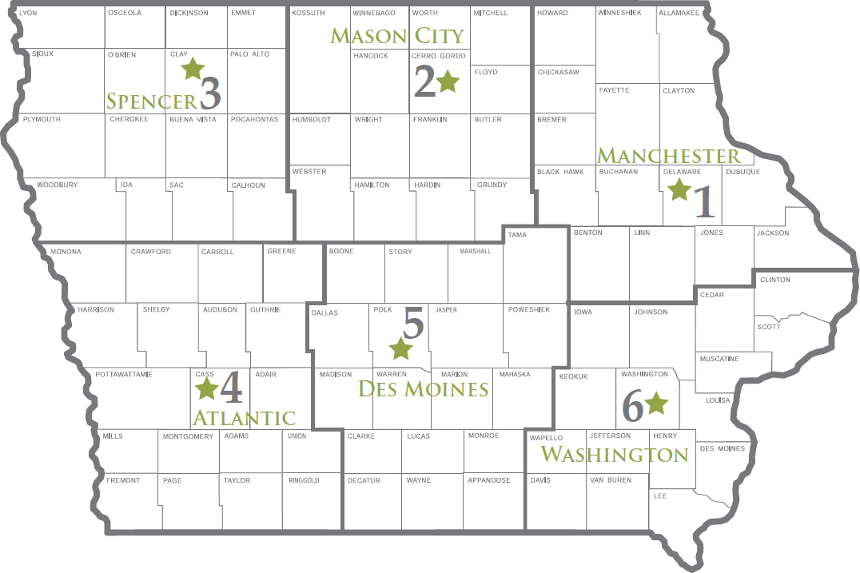

Field Office 1 (NE Iowa)
1101 Commercial Ct Ste 10
Manchester IA 52057
P: 563-927-2640

Field Office 2 (NC Iowa)
2300 15th S. SW
Mason City IA 50401
P: 641-424-4073

Field Office 3 (NW Iowa)
1900 N Grand Ave Ste E17
Spencer IA 51301
P: 712-262-4177
Field Office 4 (SW Iowa)
1401 Sunnyside Ln
Atlantic IA 50022
P: 712-243-1934

Field Office 5 (SC Iowa)
6200 Park Ave Ste 200
Des Moines IA 50321
P: 515-725-0268

Field Office 6 (SE Iowa)
1023 W Madison
Washington IA 52353
P: 319-653-2135

Important Contacts
- Environmental Field Office Duty Officer - 515-725-8694 (select option 1)
- Flood Plain Permit Assistance - 866-849-0321 or floodplain-help@dnr.iowa.gov


DEBRIS MANAGEMENT FORM
This form is intended to streamline the review process for disaster debris management. The review process requires submission of this document to two separate entities: 1) to your local Iowa DNR field office for state environmental regulatory review and 2) to the Iowa Department of Homeland Security and Emergency Management (HSEM) for historic site review. The local DNR field office will conduct the environmental review and approve as appropriate. HSEM will coordinate the historic site review and notify the applicant of review results. If additional information is needed, the applicant will be contacted.
- DNR field office contact information can be found at https://www.iowadnr.gov/fieldoffice.
- HSEM contact at HSEMDRecoveryPA@iowa.gov.

It is the applicant’s responsibility to comply with applicable federal, state, or local statutes, rules, regulations, ordinances, and orders.

Applicant: |  |  |  |  |  |  |  | County:
Primary Contact Person: |  |  |  |  |  |  |  |  | Phone:
Address:
City: |  |  |  |  |  | Zip Code: |  |  |  | Fax:
Email:

Debris Disposition (check all that apply, describe each activity, and provide location in the box below)
Temporary Debris Management Site
Burning of non-asbestos disaster debris (during Governor’s Disaster Proclamation)
Burning of vegetative debris (trees, brush, corn stalks)
Chipping/Grinding of vegetation debris for beneficial use
Chipping/Grinding of non-hazardous solid waste for landfill disposal
Emergency Solid Waste Transfer permit
Landfill (enter permit number & name):
Other Disposal Option (attach detailed explanation for review):
Ash from all burn types
Landfill (enter permit number & name):
Land application/incorporation (with DNR Field Office approval)
Reuse (method):

If activity is located within a FEMA mapped floodplain contact the DNR Floodplain Section for requirements.

Example - TYPE OF DEBRIS DISPOSAL ACTIVITY (Checked option above): |  |  |  | Vegetative Debris Chipping
 | Address/Location: | 123 E West Rd, City | GPS (decimal degrees): |  | 41.59217, -93.60735

1. TYPE OF DEBRIS DISPOSAL ACTIVITY:
 | Address/Location: |  |  | GPS (decimal degrees):
2. TYPE OF DEBRIS DISPOSAL ACTIVITY:
 | Address/Location: |  |  | GPS (decimal degrees):
3. TYPE OF DEBRIS DISPOSAL ACTIVITY:
 | Address/Location: |  |  | GPS (decimal degrees):
For additional sites, attach additional sheets

Attach Supporting Documents to this Submission

Signature and Title |  | Date

cc Becky Jolly, DNR Solid Waste Section
fc Disaster TDMS shared folder

