
Construction Design Statement (CDS)

Instructions:
- This form is for new or expanding confinement feeding operations with an AUC of more than 500 AU, not required to have a professional engineer (PE), that are proposing to construct a formed manure storage structure.
- Complete and submit Sections 1, 2 and 3 (pages 1 to 6).
- Complete and submit Section 4 (page 6) only if you are applying for a construction permit and are constructing three or more confinement feeding operation structures.
- Mail only pages 1 to 6, as instructed on page 6 and 7. Do not mail the remainder of this form.
- If the site-specific design is sealed by a PE², do not use this CDS instead use DNR Form 542-8122.

Section 1 - Information about the proposed formed manure storage structure³(s)
- Information about the operation:
Name of operation: |  |  |  |  |  |  | Facility ID No.:
Location:
 | (¼ ¼) | (¼) | (Section) | (Tier & Range) | (Name of Township) | (County)

Provide latitude and longitude coordinates of the facility driveway at the right of way (ROW) line. Go to the DNR Siting Atlas and left click (to place a teardrop) at that location. The latitude and longitude coordinates appear in the info box. Print off this page, with the info box open (as shown on sample map on Page 7) and submit with CDS.
Latitude: |  | Longitude (negative value) | -

- Description of the proposed formed manure storage structure³. Include dimensions (length, width, or diameter, depth). Indicate if it is aboveground or belowground; covered or uncovered, made of concrete or steel, address location of pit fans, if applicable, and address water line entry into buildings. If necessary attach more pages:

- Utilizing Rural Water System and Domestic Sewage Disposal
The proposed facility will utilize rural water and the providing rural water system has been notified and is aware of the proposed increase in water use.
I understand that no domestic wastewater (toilets, showers, or sinks) or laundry facilities can be discharged to the manure storage structure.

- Aerial photos: Aerial photos must be submitted that clearly show the location of all existing and proposed confinement feeding operation structures and show at least a one-mile radius around the structures. The photos must either show roads on the north and south or east and west sides of a section (so that a mile distance is apparent), or include a distance scale.

The photo(s) must show that the proposed structures comply with all statutory minimum required separation distances to the objects listed below:
- Residences (not owned by the permit applicant), churches, businesses, schools, public use areas
- Water wells (depends on type)
- Major water sources, wellhead or cistern of an agricultural drainage well or known sinkholes
- Water sources (other than major water sources) and surface intakes of an agricultural drainage well
- Designated wetlands
- Road right-of-way

The separation distance to each of the above objects must be noted with a straight line between the proposed structure(s) and the object. If any of the above objects is not located within one mile from the proposed structures, note the fact on the photo(s) or use additional pages. (Example: “No agricultural drainage wells within one mile.”)

All separation distances that are not clearly in excess of the required minimum separation distance must be measured according to 567 IAC 65.11(9) using standard survey methods. Go to the DNR Fact Sheet Page on our website and select DNR fact sheet “Distance Requirements for Construction” to find the required separation distances. Or, go directly to the Minimum Separation Distances for Construction or Expansion of Confinement Feeding Operation Structures Form. An example aerial photo can be found on pages 18 to 19 of the AFO Construction Permit Application (DNR Form 542-1428), or at the previously listed link.

Note: If a master matrix is required, the photos must also show that the additional separation distances required for any points claimed in matrix criteria one through ten will be met for the objects listed above. Note the additional separation distance by drawing a straight line between the proposed structures and the matrix item.

- Karst Determination: Go to DNR AFO Siting Atlas at http://programs.iowadnr.gov/maps/afo/. Search for your site by either scrolling into your location or entering an address or legal description in the bottom search bar. Left click on the location of your proposed structure. Make sure the karst layer box is checked on the map layers. If you cannot access the map, or if you have questions about this issue, contact the AFO Engineer at 712-262-4177. Check one of the following:
The site is not in karst or potential karst. Print and enclose the map with the name and location of the site clearly marked.
The Siting Atlas has indicated that the site is in karst. The upgraded concrete standards of 567 IAC 65.15(14)”c” must be used. Complete and sign Section 3.H (page 5).

- Alluvial Soils Determination: Go to the AFO Siting Atlas as described above. Make sure the alluvial box is checked on the map layers. If you cannot access the map, or if you have questions about this issue, contact DNR Flood Plain at 866-849-0321. Check one of the following:
The site is not in alluvial soils. Print and enclose the map with the name and location of the site clearly marked.
If the site is in alluvial soils contact DNR Flood Plain at 866-849-0321. You will be required to submit a petition for a declaratory order if less than 1000 AU or request a flood plain determination if 1000 AU or greater. After receiving Flood Plain determination, submit one of the following:
Include correspondence from the DNR showing the site is not in 100-year flood plain or does not require a Flood Plain permit.
Include copy of the Flood Plain permit if a Flood Plain permit is required.

NOTE: You may not be in a flood plain per DNR, however in a County Flood Hazard Area and need a county permit.

Section 2 - Manure management plan:
An original manure management plan (MMP) is enclosed with this form, even if a MMP was previously filed.

Owner's Name (print) |  | Owner's Signature |  | Date

Section 3 - Construction design standards: The person responsible for constructing the formed manure storage structure(s)³ must complete Section 3.

- Liquid and semi-liquid manure: The proposed formed manure storage structure³ will be (check one):
A.1 A non-circular concrete tank, belowground, with walls laterally braced or below the building concrete pit designed according to 567 IAC Chapter 65, Appendix D.
A.2 A non-circular concrete tank, belowground, walls designed according to MidWest Plan Service (MWPS), publication MWPS-36. Include design calculations.
A.3 A circular concrete tank, walls designed according to MidWest Plan Service (MWPS), publication MWPS TR-9. Include design calculations.
A.4 Will be made of steel, constructed aboveground according to the manufacturer's recommendations.

- Dry manure: The proposed formed manure storage structure³ will be (check one):
B.1 An aboveground concrete tank, with walls designed according to MWPS-36. Include design calculations.
B.2 Will be made of steel, constructed aboveground according to the manufacturer's recommendations.
B.3 Will be a belowground or partially belowground concrete tank, with walls laterally braced designed according to 567 IAC Chapter 65, Appendix D or MWPS-36. Include design calculations.

- Details of the proposed design: Submit an additional completed copy of this page 3 for each formed manure storage structure³ that have different dimensions. Complete all of the following information:
Number of buildings: |  | Building name:

Dimensions of proposed formed manure storage structure³
 | Length | Width | Height or depth | Wall thickness | Diameter (circular tanks only)
Feet
Inches

To determine the appropriate vertical steel in walls, first check one of the following boxes (must check one):
- To use Tables D-1 and D-2 (on page 9), backfilling of walls shall be performed with gravel, sand, silt, and clay mixtures (less than 50 percent fines), with coarse sand with silt or clay (less than 50 percent fines), or cleaner granular material (see page 9 for the unified soils classification). You will need to submit a copy of a USDA soil survey map with the proposed location of the formed manure storage structures³ clearly marked showing the unified soil classification; or a statement signed by a qualified organization or NRCS staff.
- Use Tables D-3 and D-4 (on page 10) if backfilling of walls will be performed with soils that are unknown or with low plasticity silts and clays with some sand or gravel (50 percent or more fines); or fine sands with silt or clay (less than 50 percent fines); or low to medium plasticity silts and clays with little sand or gravel (50 percent or more fines); or high plasticity silts and clays (see page 10 for unified soils classification). You must use Tables D-3 and D-4 if you do not submit the soils information requested in box “a”, above.

Maximum spacing of steel, in inches
Description of reinforcing steel in walls | Proposed vertical steel in walls ^{[see boxes “a” and “b”, above]} |  |  |  | Proposed horizontal steel in walls  (use Table D-5)
Description of reinforcing steel in walls | Walls where vehicles are not allowed within 5 feet (use Table D-1 )ª | All walls with pumpout ports and walls where vehicles are allowed within 5 feet (use Table D-2)ª | Walls where vehicles are not allowed within 5 feet  (use Table D-3 )^{b} | All walls with pumpout ports and walls where vehicles are allowed within 5 feet  (use Table D-4)^{b} | Proposed horizontal steel in walls  (use Table D-5)
Grade 40, No. 4
Grade 40, No. 5
Grade 60, No. 4
Grade 60, No. 5

- Aboveground tanks or partially aboveground tanks: Liquid and semi-liquid manure (check the following box):
If the proposed tank is to be constructed aboveground or partially aboveground and will have an external outlet or inlet below the liquid level, the tank will also be constructed according to the 567 IAC 65.15(20).

- Steel Tanks: Certification that the tank will be constructed according to the tank manufacturer's specifications:
Name of tank manufacturer company:
Address:
Telephone: |  |  |  | Fax:

- Additional construction design standards:
To determine the additional requirements set forth in 567 IAC 65.15(14) that would apply to the proposed formed manure storage structure³, check any of the following 3 boxes based on the information entered on Sections 3.A or 3.B (page 2):
If you checked boxes A.1, A.2, A.3 or B.3 (on page 2) all of the following 15 additional requirements apply. Complete the numbered items 1 to 15 (below).
If you checked box B.1 (on page 2), only the requirements of numbered items 1, 3, 4, 5, 6, 8 and 12 apply and need to check those boxes (below).
If you checked boxes A.4 or B.2 (on page 2) and the steel tank will have a concrete floor, only the requirements of numbered items 1, 2, 3, 4, 5, 8, 9, 12, apply and need to check those boxes (below).

Additional Requirements that will be followed during construction of the formed manure storage structure(s)³:
- Site preparation (check the following box):
The finished subgrade of a formed manure storage structure shall be graded and compacted to provide a uniform and level base and shall be free of vegetation, manure and debris. For the purpose of this subrule, “uniform” means a finished subgrade with similar soils.

- Groundwater separation requirements (check one of the following boxes):
When the groundwater table, as determined in 65.15(7)“c,” is above the bottom of the formed structure, a drain tile shall be installed along the footings to artificially lower the groundwater table pursuant to 65.15(7)“b”(2). The drain tile shall be placed within 3 feet of the footings as indicated in Appendix D, Figure D-1, at the end of this chapter and shall be covered with a minimum of 2 inches of gravel, granular material, fabric or a combination of these materials to prevent plugging the drain tile. A device to allow monitoring of the water in the drainage tile lines installed to lower the groundwater table and a device to allow shutoff of the drainage tile lines shall be installed if the drainage tile lines do not have a surface outlet accessible on the property where the formed manure storage structure is located. Perimeter tiles must be tied into existing tile, day light, or have an operating sump pump installed in tile riser. Perimeter tiles CANNOT dead end at riser or monitoring port.

In lieu of the drain tile, a certification signed by a PE², a groundwater professional certified pursuant to 567 Chapter 134, or a qualified staff from NRCS, is being submitted indicating that the groundwater elevation, according to 65.15(7)“c”, is below the bottom of the formed structure.

- Minimum as-placed concrete compressive strength (check the following box):
All concrete shall have the following minimum as-placed compressive strengths and shall meet American Society for Testing and Materials (ASTM) standard ASTM C 94: 4,000 pounds per square inch (psi) for walls, floors, beams, columns and pumpouts and 3,000 psi for the footings. The average concrete strength by testing shall not be below design strength. No single test result shall be more than 500 psi less than the minimum compressive strength.

- Cement and aggregates specifications (check the following box):
Cementitious materials shall consist of Portland cement conforming to ASTM C 150. Aggregates shall conform to ASTM C 33. Blended cements in conformance with ASTM C 595 are allowed only for concrete placed between March 15 and October 15. Portland-pozzolan cement or Portland blast furnace slag blended cements shall contain at least 75 percent, by mass, of Portland cement.

- Concrete consolidation and vibration requirements (check the following box):
All concrete placed for walls shall be consolidated or vibrated, by manual or mechanical means, or a combination, in a manner which meets ACI 309.

- Minimum rebar specifications: (check the following box):
All rebar used shall be a minimum of grade 40 steel. All rebar, with the exception of rebar dowels connecting the walls to the floor or footings, shall be secured and tied in place prior to the placing of concrete.

- Wall reinforcement placement specifications (check the following box):
All wall reinforcement shall be placed so as to have a rebar cover of 2 inches from the inside face of the wall for a belowground manure storage structure. Vertical wall reinforcement should be placed closest to the inside face. Rebar placement shall not exceed tolerances specified in ACI 318.

- Minimum floor specifications. Complete part a) and b):
a) Floor thickness requirements (check the following box):
The floor slab shall be a minimum of 5 inches thick. Nondestructive methods to verify the floor slab thickness may be required by the department. The results shall indicate that at least 95 percent of the floor slab area meets the minimum required thickness. In no case shall the floor slab thickness be less than 4½ inches.

b) The floor slab reinforcement shall be located in the middle of the thickness of the floor slab (check one of the following boxes):
Formed manure storage structures with a depth of 4 feet or more shall have primary reinforcement consisting of a minimum of #4 rebar placed a maximum of 18 inches on center in each direction placed in a single mat.
Formed manure storage structure with a depth less than 4 feet shall have shrinkage reinforcement consisting of a minimum of 6 × 6-W1.4 × W1.4 welded wire fabric.

- Minimum footing specifications (check the following box):
The footing or the area where the floor comes in contact with the walls and columns shall have a thickness equal to the wall thickness, but in no case be less than 8 inches, and the width shall be at least twice the thickness of the footing. All exterior walls shall have footings below the frostline. Tolerances shall not exceed -½ inch of the minimum footing dimensions.

- Requirement to connect walls to footings (check one of the following boxes):
The vertical steel of all walls shall be extended into the footing, and be bent at 90°, OR
A separate dowel shall be installed as a #4 rebar that is bent at 90° with at least 20 inches of rebar in the wall and extended into the footing within 3 inches of the bottom of the footing and extended at least 3 inches horizontally, as indicated in Appendix D, Figure D-1 (page 12). Dowel spacing (bend or extended) shall be the same as the spacing for the vertical rebar.
As an alternative to the 90°bend, the dowel may be extended at least 12 inches into the footing, with a minimum concrete cover of 3 inches at the bottom, as indicated in Appendix D, Figure D-1 (page 12). Dowel spacing (bend or extended) shall be the same as the spacing for the vertical rebar.
In lieu of dowels, mechanical means or alternate methods may be used as anchorage of interior walls to footings. Please submit structural calculations and details of this proposal.

- Concrete forms specifications (check the following box):
All walls shall be formed with rigid forming systems and shall not be earth-formed. Form ties shall be non-removable.

- Curing of concrete requirements (check the following box):
All concrete shall be cured for at least seven days after placing, in a manner which meets ACI 308, by maintaining adequate moisture or preventing evaporation. Proper curing shall be done by ponding, spraying or fogging water; or by using a curing compound that meets ASTM C 309; or by using wet burlap, plastic sheets or similar materials.

- Construction joints and waterstops specifications (check the following box):
All construction joints in exterior walls shall be constructed to prevent discontinuity of steel and have properly spliced rebar placed through the joint. Waterstops shall be installed in all areas where fresh concrete will meet hardened concrete as indicated in Appendix D, Figures D-1 and D-2, at the end of this chapter. The waterstops shall be made of plastic, rolled bentonite or similar materials approved by the department.

- Backfilling of walls specifications (check the following box):
Backfilling of the walls shall not start until the floor slats or permanent bracing have been installed. Backfilling shall be performed with material free of vegetation, large rocks or debris.

- Additional design requirements (check the following box, if applicable):
A formed manure storage structure with a depth greater than 12 feet shall be designed by a PE or an NRCS engineer.

- Construction Certification: The person responsible for constructing the formed manure storage structure³ must sign this page. Any change(s) to the specifications of the formed manure storage structure must be first approved by DNR:

“I hereby certify that I have read and understand the minimum design and construction standards of Iowa Code chapter 459, Subchapter III, and the 567 Iowa Administrative Code (IAC) 65.15(14) “Minimum concrete standards” or 567 IAC 65 (if other than concrete).” The proposed formed manure storage structure(s)³ at the operation:
Name of operation: |  |  | County:
Owner’s name:
will be constructed in accordance with these minimum requirements. Included with this certification are:

Page 1-3, for each formed manure storage structure³ that have different dimensions
Pages 4 to 6 (applicable sections)
Other documents (specify):

(Print name) |  | (Signature) |  | (Date)
(Company) |  | (Address) |  | (Phone No.)

(See page 7 for mailing instructions)

- Upgraded Concrete Standards Certification: If the site is in karst according to Section 1.D (page 2) the person responsible for constructing the formed manure storage structure must also complete this section:
567 IAC 65.15(14)”c”. Karst terrain - upgraded standards. If the site of the proposed formed manure storage structure is located in an area that exhibits karst terrain or an area that drains into a known sinkhole, the minimum concrete standards set forth in 65.15(14)“a” or “b” shall apply. In addition, the following requirements apply to all formed manure storage structures that store nondry or dry manure (check all of the following boxes):
(1) A minimum 5-foot vertical separation distance between the bottom of a formed manure storage structure and limestone, dolomite, or other soluble rock is required if the formed manure storage structure is not designed by a PE or an NRCS engineer. (The 5-foot separation must be a continuous profile of low permeability soil directly beneath the bottom of the formed manure storage structure.
(2) If the vertical separation distance between the bottom of the proposed formed manure storage structure and limestone, dolomite, or other soluble rock is less than 5 feet, the structure shall be designed and sealed by a PE or an NRCS engineer who certifies the structural integrity of the structure. A 2-foot-thick layer of compacted clay soil shall be constructed underneath the floor of the formed manure storage structure. However, it is recommended that any formed manure storage structure be constructed aboveground if the vertical separation distance between the bottom of the structure and the limestone, dolomite, or other soluble rock is less than 5 feet.
(3) In addition, in an area that exhibits karst terrain or an area that drains into a known sinkhole, a PE, an NRCS engineer or a qualified organization shall submit a soil exploration study based on the results from soil borings or test pits to determine the vertical separation between the bottom of the formed structure and limestone, dolomite, or other soluble rock. A minimum of two soil borings, equally spaced within each formed structure, or two test pits outside of each formed structure, are required. After soil exploration is completed, each soil boring and pit shall be properly plugged with concrete grout, bentonite, or similar materials.
(4) Backfilling shall not start until the floor slats have been placed or permanent bracing has been installed, and shall be performed with material free of vegetation, large rocks, or debris.

“I have read and understand the upgraded concrete standards of IAC 65.15(14)”c”, and certify that the proposed formed manure storage structure(s)³ at the above operation will be constructed according to these standards”:
(Print name) |  | (Signature) |  | (Date)
(Company) |  | (Address) |  | (Phone No.)

Section 4 - Drainage Tile Certification: Required only if applying for a construction permit and constructing three or more confinement feeding operations structures⁴. This section must be completed and signed by the person responsible for excavating the confinement feeding operation structure⁴:
567 IAC 65.15(1) - Drainage tile removal for new construction of a manure storage structure. Prior to constructing a manure storage structure, other than storage of manure in an exclusively dry form, the site for the animal feeding operation structure shall be investigated for drainage tile lines as provided in this subrule. All applicable records of known drainage tiles shall be examined for the existence of drainage tile lines.
c. The applicant for a construction permit for a formed manure storage structure shall investigate for tile lines during excavation for the structure. Drainage tile lines discovered upgrade from the structure shall be rerouted around the formed manure storage structure to continue the flow of drainage. All other drainage tile lines discovered shall be rerouted, capped, plugged with concrete, Portland cement concrete grout or similar materials or reconnected to upgrade tile lines. Drainage tile lines installed at the time of construction to lower a groundwater table may remain where located. A device to allow monitoring of the water in the drainage tile lines and a device to allow shutoff of the drainage tile lines shall be installed if the drainage tile lines do not have a surface outlet accessible on the property where the formed manure storage structure is located.

“I certify that I have read and understand the requirements of 567 IAC 65.15(1)“c” and that to the best of my knowledge, information and belief, the proposed confinement feeding operation structures⁴ at:
Name of operation: |  | County:
Owner’s name:
will not impede the drainage of established drainage tile lines which cross their property lines and if construction disturbs drainage tile lines, I will take the necessary measures to reestablish drainage and, upon completion of construction, file a statement that those measures were taken to reestablish drainage.”
(Print name) |  | (Signature) |  | (Date)
(Company) |  | (Address) |  | (Phone No.)

Sample Map

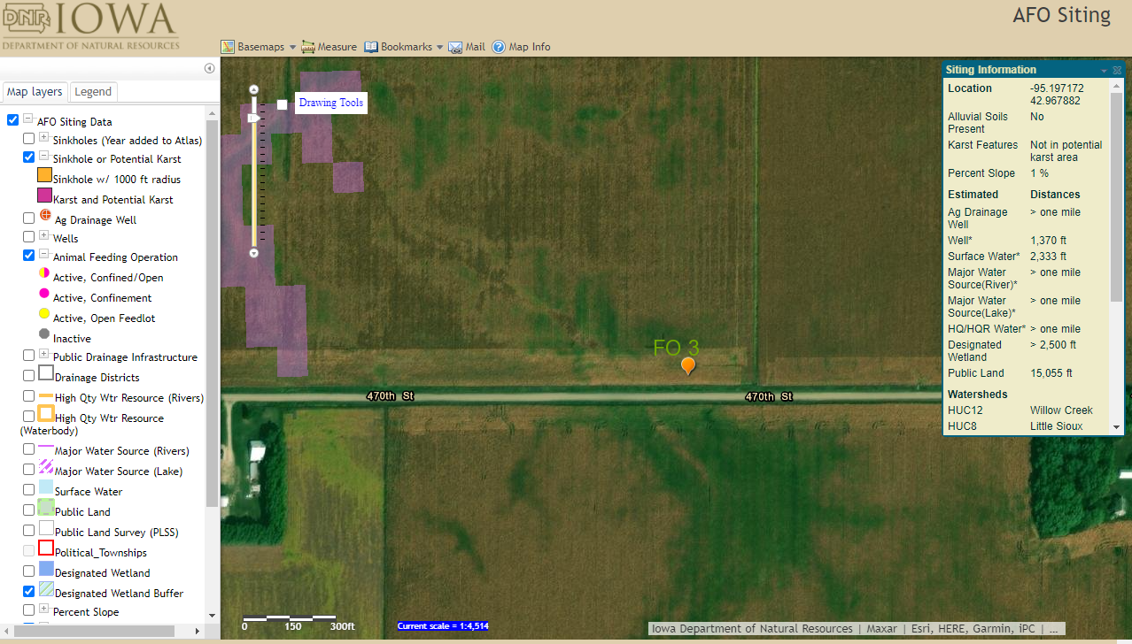

Mailing Instructions: Mail only pages 1 to 6 of this CDS according to the following:
- Operations not needing a construction permit (AUC¹ between 501 and 999 AU and constructing a formed manure storage structure³) but required to submit a manure management plan (MMP), at least 30 days prior to beginning construction must file this CDS, the required karst and alluvial soils documentation requested in Section 1,C and 1,D (page 1) along with the required MMP documents and fees with the nearest DNR Field Office:

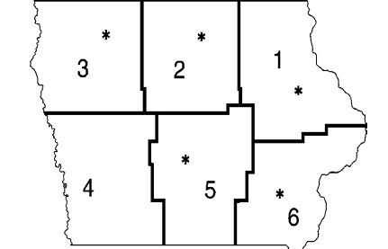 | Field Office 1  1101 Commercial Ct Ste 10  Manchester, IA 52057  (563) 927-2640 | Field Office 3  1900 N Grand Ave  Spencer, IA 51301  (712) 262-4177 | Field Office 5  502 E 9th St  Des Moines IA 50319  (515) 725-0268
 | Field Office 2  2300 15th St SW  Mason City, IA 50401  (641) 424-4073 | Field Office 4  1401 Sunnyside Ln  Atlantic, IA 50022  (712) 243-1934 | Field Office 6  1023 W Madison  Washington, IA 52353  (319) 653-2135

- If a construction permit is required (AUC¹ = 1,000 AU or more and constructing a formed manure storage structure³), mail this CDS, the required construction application documents and fees, at least 90 days prior to beginning construction, to allow for all actions required by Iowa law, to the AFO-Program (DNR Field Office 3, 1900 N Grand, Gateway North Ste E17, Spencer IA 51301). You must follow the instructions in the construction application form (DNR Form 542-1428).

If you have any questions regarding the concrete standards requirements and CDS, contact an engineer of the AFO- Program at 712-262-4177, the nearest DNR Field Office, or visit http://www.iowadnr.gov/afo.

567—Iowa Administrative Code (IAC) Chapter 65, APPENDIX D
DESIGN SPECIFICATIONS—FORMED MANURE STORAGE STRUCTURES
The following design specifications apply to a formed manure storage structure that is constructed belowground, is laterally braced and is not designed using MWPS-36 or by a PE or an NRCS engineer:
- The walls of a rectangular formed structure with a depth up to 12 feet shall be designed in accordance with the tables provided in this appendix.
- Consideration shall be given to internal and external loads including, but not limited to, lateral earth pressures, hydrostatic pressures, wind loads, and floor or cover, building and equipment loads.
- Each wall shall be braced laterally at the top of the wall.
- The walls shall be constructed above the groundwater table, or a drain tile shall be installed to artificially lower the groundwater table.
- Each wall that includes a pumpout port shall be constructed under the design consideration that vehicles will be operating within 5 feet of the wall as provided in Tables D-2 and D-4.
- Minimum wall thickness and minimum vertical steel reinforcement shall be in accordance with one of the following:
(a) Table D-1, if all of the following conditions are met:
1. There will be NO VEHICLES operating within 5 feet of the wall.
2. Backfilling is performed with gravel, sand, silt, and clay mixtures (less than 50 percent fines), with coarse sand with silt or clay (less than 50 percent fines), or cleaner granular material (see NRCS Conservation Practice Standard, “Waste Storage Facility,” Code 313, Table 2, for description and unified classification or ASTM D 2488 and D 653).

APPENDIX D, TABLE D-1 ^{[See footnote “a” on page 11]}
Minimum Wall Thickness and Vertical Steel Reinforcement
Wall height (feet) | Wall thickness (inches) | Steel Grade
Wall height (feet) | Wall thickness (inches) | Grade 40 |  | Grade 60
Wall height (feet) | Wall thickness (inches) | Bar | Space o.c. (inches) | Bar | Space o.c (inches)
4 or less | 6 | # 4 | 16.5 | # 4 | 18.0
4 or less | 6 | # 5 | 18.0 | # 5 | 18.0
4 or less | 8 | # 4 | 12.0 | # 4 | 13.5
4 or less | 8 | # 5 | 18.0 | # 5 | 18.0
6 | 6 | # 4 | 14.5 | # 4 | 18.0
6 | 6 | # 5 | 18.0 | # 5 | 18.0
6 | 8 | # 4 | 12.0 | # 4 | 13.5
6 | 8 | # 5 | 18.0 | # 5 | 18.0
8 | 8 | # 4 | 9.5 | # 4 | 13.5
8 | 8 | # 5 | 14.5 | # 5 | 18.0
8 | 10 | # 4 | 9.5 | # 4 | 11.0
8 | 10 | # 5 | 15.0 | # 5 | 17.0
10 | 8 | # 4 | 6.5 | # 4 | 9.5
10 | 8 | # 5 | 10.0 | # 5 | 13.5
10 | 10 | # 4 | 6.5 | # 4 | 9.5
10 | 10 | # 5 | 10.0 | # 5 | 15.0
12 | 10 | # 4 | 5.0 | # 4 | 7.5
12 | 10 | # 5 | 7.5 | # 5 | 11.5

(b) Table D-2, if all of the following conditions are met:
1. There will be VEHICLES operating within 5 feet of the wall.
2. Backfilling is performed with gravel, sand, silt, and clay mixtures (less than 50 percent fines), with coarse sand with silt or clay (less than 50 percent fines), or cleaner granular material (see NRCS Conservation Practice Standard, “Waste Storage Facility,” Code 313, Table 2, for description and unified classification or ASTM D 2488 and D 653).

APPENDIX D, TABLE D-2 ^{[See footnote “a” on page 11]}
Minimum Wall Thickness and Vertical Steel Reinforcement
Wall height (feet) | Wall thickness (inches) | Steel Grade
Wall height (feet) | Wall thickness (inches) | Grade 40 |  | Grade 60
Wall height (feet) | Wall thickness (inches) | Bar | Space o.c. (inches) | Bar | Space o.c. (inches)
4 or less | 6 | # 4 | 16.5 | # 4 | 18.0
4 or less | 6 | # 5 | 18.0 | # 5 | 18.0
4 or less | 8 | # 4 | 12.0 | # 4 | 13.5
4 or less | 8 | # 5 | 18.0 | # 5 | 18.0
6 | 6 | # 4 | 10.5 | # 4 | 15.5
6 | 6 | # 5 | 16.5 | # 5 | 18.0
6 | 8 | # 4 | 12.0 | # 4 | 13.5
6 | 8 | # 5 | 18.0 | # 5 | 18.0
8 | 8 | # 4 | 6.5 | # 4 | 10.0
8 | 8 | # 5 | 10.5 | # 5 | 16.0
8 | 10 | # 4 | 8.5 | # 4 | 11.0
8 | 10 | # 5 | 13.5 | # 5 | 17.0
10 | 8 | # 4 | 4.5 | # 4 | 6.5
10 | 8 | # 5 | 7.0 | # 5 | 10.5
10 | 10 | # 4 | 5.0 | # 4 | 7.5
10 | 10 | # 5 | 8.0 | # 5 | 12.0
12 | 10 | # 4 | 3.5 | # 4 | 5.5
12 | 10 | # 5 | 5.5 | # 5 | 8.5

(c) Table D-3, if all of the following conditions are met:
1. There will be NO VEHICLES operating within 5 feet of the wall.
2. Backfilling is performed with performed with low plasticity silts and clays with some sand or gravel (50 percent or more fines); or fine sands with silt or clay (less than 50 percent fines); or low to medium plasticity silts and clays with little sand or gravel (50 percent or more fines); or high plasticity silts and clays (see NRCS Conservation Practice Standard, “Waste Storage Facility,” Code 313, Table 2, for description and unified classification or ASTM D 2488 and D 653).

APPENDIX D, TABLE D-3 ^{[See footnote “b” on page 11]}
Minimum Wall Thickness and Vertical Steel Reinforcement
Wall height (feet) | Wall thickness (inches) | Steel Grade
Wall height (feet) | Wall thickness (inches) | Grade 40 |  | Grade 60
Wall height (feet) | Wall thickness (inches) | Bar | Space o.c. (inches) | Bar | Space o.c. (inches)
4 or less | 6 | # 4 | 16.5 | # 4 | 18.0
4 or less | 6 | # 5 | 18.0 | # 5 | 18.0
4 or less | 8 | # 4 | 12.0 | # 4 | 13.5
4 or less | 8 | # 5 | 18.0 | # 5 | 18.0
6 | 6 | # 4 | 10.5 | # 4 | 15.5
6 | 6 | # 5 | 16.5 | # 5 | 18.0
6 | 8 | # 4 | 12.0 | # 4 | 13.5
6 | 8 | # 5 | 18.0 | # 5 | 18.0
8 | 8 | # 4 | 6.5 | # 4 | 10.0
8 | 8 | # 5 | 10.5 | # 5 | 16.0
8 | 10 | # 4 | 9.0 | # 4 | 11.0
8 | 10 | # 5 | 14.0 | # 5 | 17.0
10 | 8 | # 4 | 4.5 | # 4 | 6.5
10 | 8 | # 5 | 7.0 | # 5 | 10.0
10 | 10 | # 4 | 5.0 | # 4 | 7.5
10 | 10 | # 5 | 8.0 | # 5 | 12.0
12 | 10 | # 4 | 3.5 | # 4 | 5.0
12 | 10 | # 5 | 5.5 | # 5 | 8.0

(d) Table D-4, if all of the following conditions are met:
1. There will be VEHICLES operating within 5 feet of the wall.
2. Backfilling is performed with performed with low plasticity silts and clays with some sand or gravel (50 percent or more fines); or fine sands with silt or clay (less than 50 percent fines); or low to medium plasticity silts and clays with little sand or gravel (50 percent or more fines); or high plasticity silts and clays (see NRCS Conservation Practice Standard, “Waste Storage Facility,” Code 313, Table 2, for description and unified classification or ASTM D 2488 and D 653).

APPENDIX D, TABLE D-4 ^{[See footnote “b” on page 11]}
Minimum Wall Thickness and Vertical Steel Reinforcement
Wall height (feet) | Wall thickness (inches) | Steel Grade
Wall height (feet) | Wall thickness (inches) | Grade 40 |  | Grade 60
Wall height (feet) | Wall thickness (inches) | Bar | Space o.c. (inches) | Bar | Space o.c. (inches)
4 or less | 6 | # 4 | 16.5 | # 4 | 18.0
4 or less | 6 | # 5 | 18.0 | # 5 | 18.0
4 or less | 8 | # 4 | 12.0 | # 4 | 13.5
4 or less | 8 | # 5 | 18.0 | # 5 | 18.0
6 | 6 | # 4 | 8.0 | # 4 | 12.0
6 | 6 | # 5 | 12.5 | # 5 | 16.5
6 | 8 | # 4 | 9.5 | # 4 | 13.5
6 | 8 | # 5 | 15.0 | # 5 | 18.0
8 | 8 | # 4 | 6.0 | # 4 | 9.0
8 | 8 | # 5 | 9.0 | # 5 | 11.5
8 | 10 | # 4 | 6.0 | # 4 | 9.0
8 | 10 | # 5 | 9.5 | # 5 | 14.0
10 | 8 | # 4 | 3.0 | # 4 | 4.5
10 | 8 | # 5 | 4.5 | # 5 | 7.0
10 | 10 | # 4 | 4.5 | # 4 | 6.5
10 | 10 | # 5 | 6.5 | # 5 | 10.0
12 | 10 | # 4 | 2.5 | # 4 | 4.0
12 | 10 | # 5 | 4.0 | # 5 | 6.0

- Minimum horizontal steel for a rectangular tank shall be selected and placed according to Table D-5, regardless of wall height, and shall be tied to the soil side of vertical steel:

APPENDIX D, TABLE D-5
Horizontal Steel Reinforcement
Wall thickness | Steel Grade
Wall thickness | Grade 40 |  | Grade 60
Wall thickness | Bar | Space o.c. (inches) | Bar | Space o.c (inches).
6 | # 4 | 16.5 | #4 | 18.0
6 | # 5 | 18.0 | # 5 | 18.0
8 | # 4 | 12.0 | # 4 | 13.5
8 | # 5 | 18.0 | # 5 | 18.0
10 | # 4 | 9.5 | # 4 | 11.0
10 | # 5 | 15.0 | # 5 | 17.0

________________________
ªTo use Tables D-1 and D-2, the backfilling of the walls will be performed with gravel, sand, silt, and clay mixtures (less than 50 percent fines), with coarse sand with silt or clay (less than 50 percent fines), or cleaner granular material. The “Unified Soil Classification” corresponds to: GP, GW, SP, SW, GM, GC, SW, SC, SM, SC-SM. You will need to submit a copy of a USDA soil survey map with the proposed location of the formed manure storage structures³ clearly marked showing the unified soil classification; or a statement signed by a qualified organization or NRCS staff.
^{b}Use Tables D-3 and D-4 if the soils to be used for backfilling the walls are unknown or performed with low plasticity silts and clays with some sand or gravel (50 percent or more fines); or fine sands with silt or clay (less than 50 percent fines); or low to medium plasticity silts and clays with little sand or gravel (50 percent or more fines); or high plasticity silts and clays. The “Unified Soils Classification” corresponds to: CL, ML, CL-ML, SC, SM, SC-SM. Tables D-3 and D-4 must be used, if a copy of a USDA soil survey map with the proposed location of the formed manure storage structures³ clearly marked showing the unified soil classification; or a statement signed by a qualified organization or NRCS staff is not submitted.

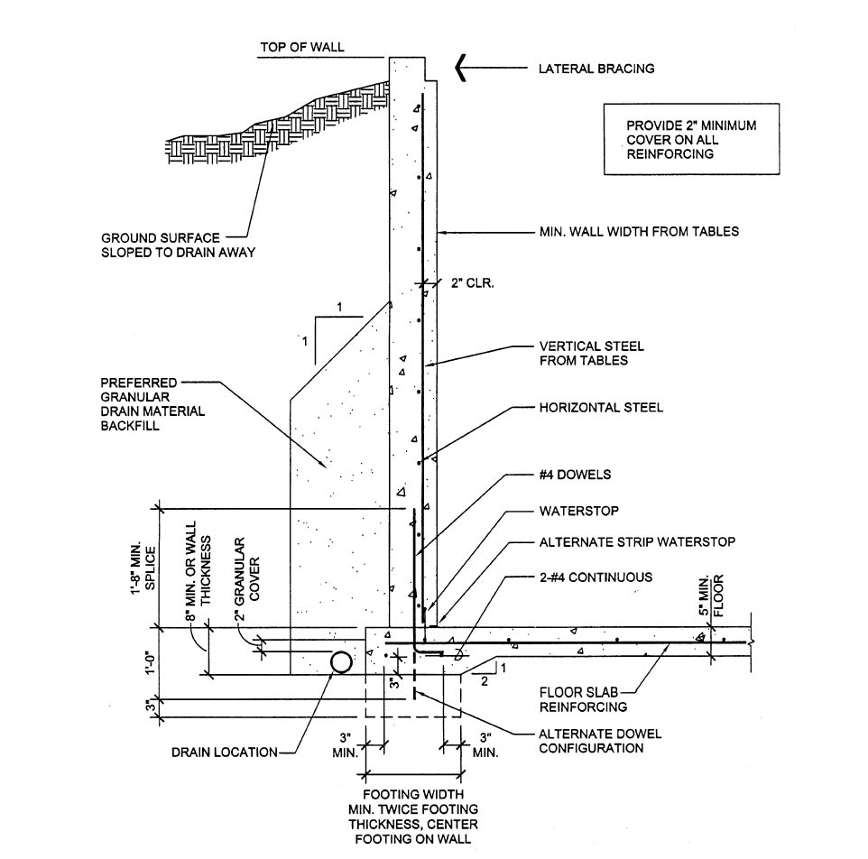
567 IAC Chapter 65, Appendix D, Figure D-1 “Monolitic footing floor detail”
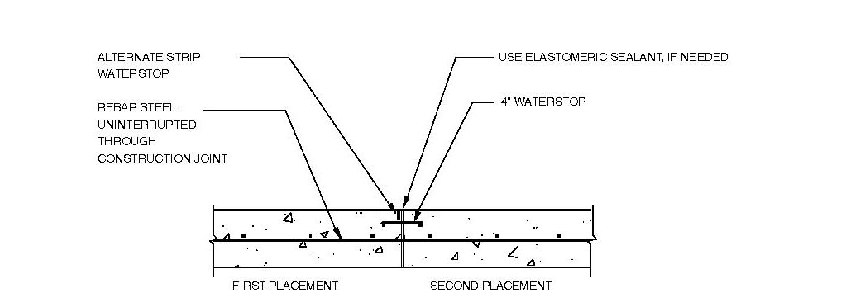
567 IAC Chapter 65, Appendix D, Figure D-2 “Wall and floor construction joint”

To determine the AUC see the 'Manure Storage Indemnity Fee' (Form 542-4021) or the 'Construction Permit Application' (Form 542-1428), or visit http://www.iowadnr.gov
PE is a professional engineer licensed in the state of Iowa or a NRCS-Engineer working for the USDA-Natural Resources Conservation Service (NRCS).
Formed manure storage structure means a covered or uncovered concrete or steel tank, including concrete pits below the floor.
Confinement feeding operation structure = A confinement building, a formed or unformed manure storage structure, or an egg washwater storage structure.

