Exhibit 3

Drinking Water SRF Intended Use Plan Application

This form may be used to apply for inclusion on the project priority list of the
Drinking Water SRF IUP at the time the Preliminary Engineering Report is
submitted. IUPs are developed on an annual basis with quarterly updates as
needed. This form is not an application for a loan. SRF loan application
materials may be obtained at www.iowasrf.com.

Instructions:
Complete the requested information in the following sections to the best of your ability. Please print or type the information on the form. If a particular item does not apply to your system, enter n/a for “not applicable.” Attach supporting documentation as needed. Keep a copy of the completed application for your records, submit a copy to your engineer, and submit the original signed form to the following address:

State Revolving Fund c/o Jennifer Bunton, P.E.
Department of Natural Resources
Wallace State Office Building, 502 E. 9th Street
Des Moines, IA 50319-0034

Section 1: Applicant Information
Applicant Name:
Applicant Address:
Authorized Representative:
Signature:
Title:
Telephone Number:
E-mail:
Consulting Engineer:
Firm:
Telephone Number:
E-mail:
Population Served: | Community: Service Area:
Number of Service
Connections:

FOR SRF USE ONLY
PWSID Number: _______________________
Date Received: _______________________
DWSRF Number: ______________________
County: ______________________________

Profit Status of the System  (for Nontransient  Noncommunity systems only): | Check one:  Not for profit system  Profit System
Percentage of Population  meeting LMI criteria: | %
Method of determining  percentage LMI | Check one:  2000 Census  Income survey (if checked, list party that conducted survey)
If the percentage of  population served by the  project is greater than 51%  LMI, this project may be  eligible for an extended loan  term (up to 30 years.) | Are you interested in an extended loan term?  Yes  No
Proposed Project Schedule | Final plan and specification date:  Construction Initiation Date:  Date You Intend to Sign a Loan Agreement:

Section 2: Brief Project Summary (Attach additional pages if necessary.)
Describe the reasons for the proposed project: (i.e. specific water quality problem or system improvement)
Describe the proposed project: (i.e., specific solution to the water quality problem, or proposed system improvement)

Which other funding programs are you considering to assist in completion of this project? | Check all that apply:  Community Development Block Grant (CDBG)  Rural Development Grant and/or Loan  Clean Water State Revolving Fund (for water system waste treatment projects)  Reserve Funds  Other:
Does your project involve a consolidation of two or more  water systems? | Check one:  Yes  No  If Yes, list systems and populations served:

Section 3: Project Cost
Cost Category | Estimated Total Cost, $
Administration, legal
Land, structures, right-of-way, appraisals | +
Relocation expenses | +
Architectural and engineering fees | +
Project inspection fees | +
Soil investigation, Site work, demolition, debris removal | +
Construction | +
Equipment | +
Miscellaneous | +
PROJECT SUBTOTAL | =
Contingencies | +
Planning and design loan proceeds, if rolling into construction loan | +
Less “funds requested from other sources” | -
LOAN SUBTOTAL | =
Loan Initiation Fee (Loan Subtotal x .005) | +
TOTAL IUP REQUEST | =

*Supporting materials may be requested to document funding requests and system needs.

Please include the following items with your application:

Two official copies of the Preliminary Engineering Report, if not already submitted.

If already submitted, date submitted:

Completed Viability Assessment Manual, available for download on our website at
http://www.iowadnr.gov/InsideDNR/RegulatoryWater/WaterSupplyEngineering/ViabilityCapacityDev.aspx

Section 4: EPA Pre-Award Compliance
FORM Approved OMB No. 2030-0020 Expires: 12-31-2011
United States Environmental Protection Agency
Washington, DC 20460
Preaward Compliance Review Report for
All Applicants Requesting EPA Financial Assistance
Note: Read Instructions on next page before completing form.
I. Applicant/Recipient (Name, Address, State, Zip Code) |  |  | DUNS No.
II. Is the applicant currently receiving EPA assistance?

III. List all civil rights lawsuits and administrative complaints pending against the applicant/recipient that allege discrimination based on race, color, national origin, sex, age, or disability. (Do not include employment complaints not covered by 40 C.F.R. Parts 5 and 7. See instructions.)

IV. List all civil rights lawsuits and administrative complaints decided against the applicant/recipient within the last year that allege discrimination based on race, color, national origin, sex, age, or disability and enclose a copy of all decisions. Please describe all corrective action taken. (Do not include employment complaints not covered by 40 C.F.R. Parts 5 and 7. See instructions.)

V. List all civil rights compliance reviews of the applicant/recipient conducted by any agency within the last two years and enclose a copy of the review and any decisions, orders, or agreements based on the review. Please describe any corrective action taken (40 C.F.R.§ 7.80(c)(3))

VI. Is the applicant requesting EPA assistance for new construction? If no, proceed to VII; if yes, answer (a) and/or (b) below.

- If the grant is for new construction, will all new facilities or alterations to existing facilities be designed and constructed to be readily accessible to and usable by persons with disabilities? If yes, proceed to VII; if no, proceed to VI(b).
- If the grant is for new construction and the new facilities or alterations to existing facilities will not be readily accessible to and usable by persons with disabilities, explain how a regulatory exception (40 C.F.R. § 7.70) applies.
VII.* Does the applicant/recipient provide initial and continuing notice that it does not discriminate on the basis of race, color, national origin, sex, age, or disability in its programs or activities? (40 C.F.R. § 5.140 and § 7.95)

- Do the methods of notice accommodate those with impaired vision or hearing?
- Is the notice posted in a prominent place in the applicant’s offices or facilities, or, for education programs and activities, in appropriate periodicals and other written communications?
- Does the notice identify a designated civil rights coordinator?
VIII.* Does the applicant/recipient maintain demographic data on the race, color, national origin, sex, age, or handicap of the population it serves? (40 C.F.R. § 7.85(a))

IX.* Does the applicant/recipient have a policy/procedure for providing access to services for persons with limited English proficiency?

X.* If the applicant/recipient is an education program or activity, or has 15 or more employees, has it designated an employee to coordinate its compliance with 40 C.F.R. Parts 5 and 7? Provide the name, title, position, mailing address, e-mail address, fax number, and telephone number of the designated coordinator.

XI.* If the applicant/recipient is an education program or activity, or has 15 or more employees, has it adopted grievance procedures that assure the prompt and fair resolution of complaints that allege a violation of 40 C.F.R. Parts 5 and 7? Provide a legal citation or Internet address for, or a copy of, the procedures.

For the Applicant/Recipient
I certify that the statements I have made on this form and all attachments thereto are true, accurate, and complete. I acknowledge that any knowingly false or misleading statement may be punishable by fine or imprisonment or both under applicable law. I assure that I will fully comply with all applicable civil rights statutes and EPA regulations.
A. Signature of Authorized Official | B. Title of Authorized Official | C. Date
For the U.S. Environmental Protection Agency
I have reviewed the information provided by the applicant/recipient and hereby certify that the applicant/recipient has submitted all preaward compliance information required by 40 C.F.R. Parts 5 and 7; that based on the information submitted, this application satisfies the preaward provisions of 40 C.F.R. Parts 5 and 7; and that the applicant has given assurance that it will fully comply with all applicable civil rights statutes and EPA regulations.
A. Signature of Authorized EPA Official  See ** note on next page. | B. Title of Authorized EPA Official | C. Date
EPA Form 4700-4 (Rev. 3/2008). Previous editions are obsolete.

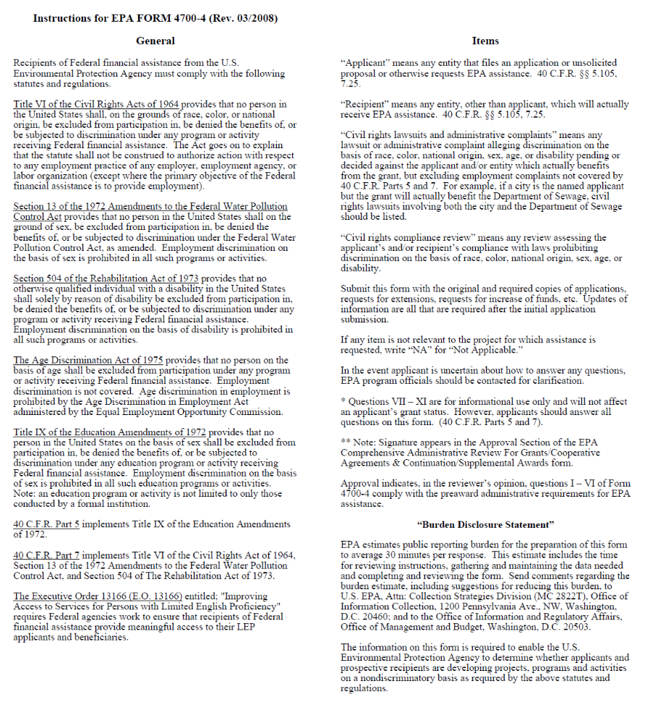
Section 5: Acquisition of Property by SRF Applicants
Note: Purchase of land may be eligible under the Drinking Water SRF. Please check with your project manager to confirm.

U.S. ENVIRONMENTAL PROTECTION AGENCY
ASSURANCE WITH RESPECT TO REAL PROPERTY ACQUISITION
OF TITLE III OF THE UNIFORM RELOCATION ASSISTANCE AND REAL PROPERTY
ACQUISITION POLICIES ACT OF 1970 AS AMENDED

The (Applicant) hereby assures that it has authority under applicable State and local law to comply with Section 213 of the Uniform Relocation Assistance and Real Property Acquisition Policies Act of 1970, Public Law 91-646, 84 Stat. 1894 (42 U.S.C. 4601) as amended by the Surface Transportation and Uniform Relocation Assistance Act of 1987, Title IV of Public Law 100-17, 101 Stat. 246-256 (42 U.S.C. 4601 note) and 49 CFR 1.48(cc); and certifies, assures and agrees that, notwithstanding any other provision set forth in the application.

1. For projects resulting in the displacement of any person:

a. It will adequately inform the public of the relocation payments and services which will be available as set forth in Subparts A, C, D and E of 49 CFR 24.

b. It will provide fair and reasonable relocation payments to displaced persons as
required by Subparts D and E of 49 CFR 24.

c. It will provide a relocation assistance program for displaced persons offering
services described in Subpart C of 49 CFR 24.

d. Comparable replacement dwellings will be available pursuant to Subpart F of
49 CFR 24, or provided if necessary, a reasonable period in advance of the time any person is displaced.

e. In acquiring real property, it will provide at least 90 days written notice to each
lawful occupant of real property acquired, stating the date such occupant is required to move from a dwelling or to move his business or farm operation.

2. For projects resulting in the acquisition of real property:

a. It will fully comply with the requirements of Subpart B of 49 CFR 24.

b. It will adequately inform the public of the acquisition policies, requirements and
payments which apply to the project.

c. It will make every effort to acquire real property expeditiously through negotiation.

d. Before the initiation of negotiations it will have the real property appraised and give the owner or his representative an opportunity to accompany the appraiser during inspection of the property, except as provided in 49 CFR 24.102(c)(2).

e. Before the initiation of negotiations it will establish an amount which it believes to be just compensation for the real property, and make a prompt offer to acquire the property for that amount; and at the same time it will provide the owner a written statement of the basis for such amount in accordance with 49 CFR 24.102.

f. Before requiring any owner to surrender possession of real property it will pay the agreed purchase price; or deposit with the court, for the benefit of the owner, an amount not less than the approved appraisal of the fair market value of the property; or pay the amount of the award of compensation in a condemnation proceeding for the property.

g. If interest in real property is to be acquired by exercise of the power of eminent domain, it will institute formal condemnation proceedings and not intentionally make it necessary for an owner to institute legal proceedings to prove the fact of the taking of this real property; and

h. It will offer to acquire the entire property, if acquisition of only part of a property would leave its owner with an uneconomic remnant.

References to 49 CFR are citations to Title 49, Code of Federal Regulations, Part 24, published in the Federal Register Vol. 54, No. 40, March 2, 1989.

This document is hereby made part of and incorporated in any contract or agreement, or any supplements and amendments thereto, relating to the above-identified application and shall be deemed to supersede any provision therein to the extent that such provisions conflict with the assurances or agreements provided therein.

(Legal Name of Applicant)

By ____________________________________________
(Signature of Authorized Representative)

_____________________________________________
(Date)

