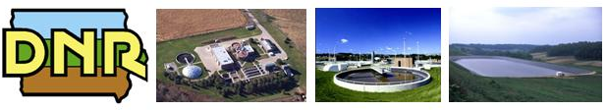

WASTEWATER ENGINEERING
Construction Permitting Process Manual
Iowa Department of Natural Resources

With instructions for participating in the Clean Water State Revolving Fund
February 2009
With instructions for participating in the Clean Water State Revolving Fund
January 2014

WASTEWATER ENGINEERING
Construction Permitting Process Manual
January 2014

CONTENTS

Introduction 1

Project Planning 2

Facility Plan Approval and Environmental Review 7

Plans and Specification Development and Construction Permitting 12

Project Construction 15

Permitting Process Flow Chart 17

Antidegradation Process Flow Chart 27

IUP Process Flow Chart 29

EXHIBITS
Exhibit 1: Planning and Design Loan Fact Sheet
Exhibit 2: Project Initiation Meeting Sample Agenda
Exhibit 3: Water Quality Based Permit Limits Form
Exhibit 4: Facility Planning Scope of Study Checklist
Exhibit 5: Environmental Review Services Checklist
Exhibit 6: Public Notice Example
Exhibit 7: Public Hearing Checklist
Exhibit 8: Intended Use Plan Application
Exhibit 9A: Preliminary Review of Antidegradation Alternatives Analysis
Exhibit 9B: Preliminary Review of Facility Plan Checklist
Exhibits 10A, B, and C: Preliminary Plan and Specification Submittal Checklists
Exhibits 11A, B, and C: Design Schedules A, F, and G
Exhibit 12: SRF Front-End Specification Instructions
Exhibit 12A: SRF Required Front-End Specifications
Exhibit 13: CWSRF Bid Document Checklist
Exhibit 14: CWSRF Extended Financing Worksheet

Exhibit 15: SRF Construction Loan Fact Sheet
With instructions for participating in the Clean Water State Revolving Fund

INTRODUCTION

Issuing wastewater construction permits is the responsibility of the Iowa Department of Natural Resources (DNR) under Iowa Administrative Code 567—Chapter 64. When a city or county decides to initiate a wastewater construction project, many parties become involved in the process, including:

The DNR’s Commitment
When the construction permitting process is followed as described in this manual, the DNR has established the following goals:

- Reviewing and approving facility plans within 4.5 months of submittal

- Issuing construction permits within 30 days of submittal of final permit application

Environmental Review Services and extended financing terms are now available to CWSRF applicants.

- Consulting engineers;
- Councils of government and economic development organizations;
- Funding agencies, including the State Revolving Fund (SRF), Department of Economic Development, or USDA Rural Development;
- DNR field offices and water resources section;
- Consulting parties for environmental and historical reviews;
- Contractors; and
- Members of the public and other interested parties.

The wastewater construction permitting process was created to foster greater coordination, communication, and cooperation among all of the parties involved. A diverse team has worked together to create the process and procedures described in this manual. Using the manual and following the process will help eliminate delays, avoid problems, and enable the success of wastewater construction projects.

The construction permitting process applies to all projects. Financing a project through programs such as Community Development Block Grants, the Clean Water State Revolving Fund (CWSRF), or Rural Development, can add other requirements. This manual discusses in detail the requirements of the CWSRF program and notes how the loan process interfaces with the construction permitting process. If other financing programs are used, the applicant should work with those program managers to determine additional requirements.

This manual contains the information needed to progress through the wastewater construction permitting process, including flow charts, detailed descriptions of the steps in the process, and required forms and instructions. If at any time there are questions about the process, however, please feel free to contact the DNR Wastewater Engineering section.

PROJECT PLANNING

The following section of the manual outlines the steps involved in project planning. A detailed description of each step in the process (decision points in the process are marked with a ) is provided, including footnotes that reference the state regulations behind each step. Also included in this manual are:

- A flow chart of the project planning phase (numbers in the flow chart correspond with the numbered steps in the process description); and
- Related exhibits.

Steps in the process that are associated with the Clean Water State Revolving Fund are italicized.

Step 1 Owner hires Engineer. Once the Owner identifies a need for wastewater construction improvements, the Owner will contract with a consulting engineer (Engineer). In some cases, the need may have been identified by the DNR, which may either advise the Owner to initiate planning or require it through a compliance/enforcement action. An owner may also identify its need for study and voluntarily proceed into the planning process. The Engineer will investigate and evaluate the issues and make recommendations for needed improvements.

More information on hiring a consulting engineer can be found on the Consulting Engineers Council of Iowa web site at http://www.iaengr.org/QBS.pdf.

Whether or not a CWSRF construction loan is sought, planning and design (P&D) loans are available through the SRF to cover the costs incurred for engineering work and fees related to project preparation and submittal. The interest rate for P&D loans is 0% for up to three years, and the P&D loan can be rolled into a CWSRF construction loan or repaid with other permanent financing. The planning and design costs must be directly related to the wastewater project and be eligible under CWSRF.

Exhibit 1: SRF Planning and Design Loan Fact Sheet

Step 2 Engineer contacts DNR and submits Work Record Request.
After engineering services has been procured by the Owner, the Engineer will contact DNR Wastewater Engineering Section and submit a completed Work Record Request to request assignment of a Project Manager (PM) and initiate a new work/project. The Work Record Request and Work Record Instructions can be found on the DNR Wastewater Engineering Section webpage.

All completed work record requests shall be submitted as an attachment and emailed to wastewater-engineering@dnr.iowa.gov. The subject line of the email shall include Work Request – Facility Name – Work Title.

An automated response will be sent to the requestor acknowledging DNR receipt of the work request. The Engineer/Owner will be notified if the Work Record Request is incomplete. If the Work Record Request is complete, proceed to Step 3.

Toll-Free Technical Assistance
A toll-free telephone helpline has been established for Owners and Engineers to contact the wastewater engineering section staff for technical assistance for new projects that have not been previously assigned to a Project Manager.

Toll-Free Long Distance Number: 855-256-9287 (855-CLN-WATR)
Local Number (515 Prefix): 515-725-9287

Step 3 DNR assigns PM. For Work Record Requests that are complete, a DNR Project Manager will be assigned and the Engineer/Owner will be notified by email. The assigned PM will be the point of contact and will manage state review of the resulting work/project.

Step 4 PM schedules meeting. The PM will work with the Owner and Engineer to schedule a Project Initiation Meeting within 30 days of the initial contact. Other parties involved in the project will also be invited, including other DNR staff, organizations assisting in application preparation, and others as appropriate.

For non-SRF projects that are considered minor, a Project Initiation Meeting may not be required. Please verify with the DNR Project Coordinator.

Step 5 PM sends monthly operating report (MOR) data to Engineer. The PM will research state files and NPDES monitoring databases to provide available facility flow and loading information to the Engineer.

Step 6 Owner sends daily monitoring report (DMR) data to Engineer. The Owner should also provide available flow and loading data to the Engineer. This data may be more extensive than DNR records and may include operational data which may be valuable to the planning process.

Step 7 Engineer does data analysis. The Engineer, to begin the evaluation and facility planning process, will use the facility flow and loading information. The Engineer should review loading data prior to the Project Initiation Conference.

Step 8 PM sends meeting agenda. The PM will provide an agenda for the meeting to enable all the parties to prepare.

Exhibit 2: Sample Project Initiation Meeting Agenda
Step 9 PROJECT INITIATION MEETING
The Project Initiation Meeting is a major event. It is important to reach an understanding by all participants as to the scope of the facility planning, the goals of the project, and the state review and permitting requirements.

The Owner should be represented by its Engineer. The PM will arrange to have appropriate DNR staff attend, including enforcement/compliance (field office) staff and NPDES personnel.

The PM will review requirements, summarize procedures, and explain checklists, guidance, and applications as shown in this manual. The PM will seek agreement on the project schedule from planning through construction. Financing options will also be discussed, and contact information for using the CWSRF loan program will be provided.

The PM will collect contact names, phone and fax numbers, and e-mail addresses to enable future communications with all the parties. The PM will also provide minutes of the meeting for review by the participants.

The PM will identify and review the following exhibits as needed:

Exhibit 3: Waste Load Allocation Request Form and Instructions
Exhibit 4: Facility Planning Scope of Study Checklist
Exhibit 5: SRF Environmental Review Checklist
Exhibit 8: CWSRF Intended Use Plan Application
Exhibit 9A: Preliminary Review of Antidegradation Alternatives Analysis
Exhibit 9B: Preliminary Review of Facility Plan Checklist
Exhibits 10A, B, and C: Preliminary Plan and Specification Submittal Checklists
Exhibits 11A, B, and C: Design Schedules A, F, and G

Step 10 Engineer submits design loading criteria and WLA request. Following the Project Initiation Meeting, the Engineer will evaluate the information gathered and submit to the PM initial facility design information including the facility design basis and any supporting information with a request for a Wasteload Allocation (WLA). The Engineer should submit Schedule G (which is Exhibit 11C in this manual) with sections 1, 2, and 3 completed.

This is an important early step in the planning process since flows, loadings, and the location of the plant outfall are critical to determining the effluent limits that will appear in the facility’s NPDES permit.

Step 11 PM reviews criteria and request. The PM will review the facility design basis provided by the Engineer, comparing it to DNR records, design standards and reference materials for reasonableness. DNR review at this point will avoid delays and major issues with project planning that could occur later when it could be more difficult to make adjustments. Agreement on design criteria to be used in the planning of new or modified facilities is important as the effluent limits may vary and affect the cost-effectiveness of decisions made by the Owner.

Step 12 PM concurs with the design criteria and moves to next step. If the PM cannot concur with the design criteria submitted by the Engineer, the PM will contact and work with the Engineer toward mutual agreement. Revisions to the design basis may be required prior to concurrence.

Step 13 PM requests WLA. The PM submits the design criteria with a request for a WLA to DNR water resources staff. Exhibit 3 in this manual shows the form for information purposes. Please use the on-line fillable form at http://www.iowadnr.com/water/wastewater/downloads.html.

Exhibit 3: Waste Load Allocation Request Form and Instructions

Step 14 WR calculates WLA. The Water Resources section calculates the WLA based on the conditions proposed by the Engineer and determines if antidegradation applies.

Step 15 PM sends WLA and antidegradation determination to Engineer. The PM will transmit the WLA and antidegradation determination to the Engineer. The PM will also notify the Engineer of concurrence with the facility design basis.

Antidegradation Review
If antidegradation applies, an antidegradation alternatives analysis must be submitted and approved prior to submittal of a facility plan. See the Antidegradation Process for Wastewater Construction Projects flow chart. The PM will initiate a preliminary review of the antidegradation alternatives analysis as soon as possible. The review will follow Exhibit 9A. If the submittal is complete, a detailed review will commence. If the submittal is submittal is incomplete, it will be returned to the Engineer/Owner. Additional antidegradation reference materials can be found at the Iowa DNR Antidegradation Implementation website: http://www.iowadnr.gov/water/standards/antidegradation.html.

For policy implementation information and technical assistance on Antidegradation contact: Larry Bryant (515-281-6759, e-mail larry.bryant@dnr.iowa.gov)

Exhibit 9A: Preliminary Review of Antidegradation Alternatives Analysis

Step 16 FACILITY PLAN PREPARATION
The Engineer will receive the WLA from DNR and continue with facility planning according to the guidance presented in the Project Initiation Meeting and subsequent information. Close coordination with the PM must be maintained if there are departures from previous agreements. The facility plan development period will depend on the complexity of the project and the Engineer’s and Owner’s schedule.

When the draft facility plan is completed by the Engineer, the Engineer will submit it to the Owner for approval.

Clearance from DNR flood plain reviewers should be sought at this point for all projects.

If antidegradation applies, the antidegradation alternatives analysis must be approved prior to completion of the facility plan.

Step 17 Owner approves facility plan. The facility owner should be involved in the planning process. The Owner must make a decision on the facility plan recommendations, either accepting them or asking for revisions from the Engineer. If the facility plan recommends capital improvements, the Owner must follow up with a decision on financing.

At this point, the facility plan will be ready to submit to the DNR for review and approval. The next phase of the process, Facility Plan Review and Approval, is outlined in the next section of this manual.

FACILITY PLAN APPROVAL AND ENVIRONMENTAL REVIEW

The following section of the manual outlines the steps involved in facility plan review and approval. A detailed description of each step in the process (decision points in the process are marked with a ) is provided, including footnotes that reference the state regulations behind each step. Also included in this manual are:

- A flow chart of the facility plan review and approval phase (numbers in the flow chart correspond with the numbered steps in the process description); and
- Related exhibits.

Steps in the process that are associated with the Clean Water State Revolving Fund are italicized.

Step 18 FACILITY PLAN SUBMITTAL
There are two major pieces that should be completed at this point:

1. The facility plan, approved by the Owner, is submitted to the DNR PM. Exhibit 9B shows the minimum criteria for submittals.

For non-SRF projects, three copies of the facility plan shall be sent to:

Wastewater Engineering Section
Iowa Department of Natural Resources
502 E. 9th Street
Des Moines, IA 50319

2. Facility modifications will also require an amendment or re-issuance of the NPDES permit for the facility. The NPDES application should be submitted at the same time as the facility plan. This will allow for adequate time for the NPDES permit to be processed prior to the issuance of a construction permit. If there are questions as to whether an NPDES application is needed, the PM can assist with contacting NPDES staff.

NPDES application submittal is to:

NPDES Permits Section
Iowa Department of Natural Resources
502 E. 9th Street
Des Moines, IA 50319

3. If the municipal owner is applying for a CWSRF loan, two additional items should be submitted:

- The Intended Use Plan (IUP) application (Exhibit 8). The project will be scored and placed on the project priority list during the next quarterly update of the CWSRF IUP. See IUP Process narrative and map following the construction permit application process map in this manual.

For SRF projects, the IUP application, including three copies of the facility plan, shall be sent to:

State Revolving Fund, Iowa Department of Natural Resources
Wallace State Office Building, 502 E. 9th Street
Des Moines, IA 50319-0034

- Information included in the Environmental Review (ER) Checklist (Exhibit 5). Using Exhibit 5, the Engineer prepares and gathers required project information. The SRF ER Specialist will determine whether a Categorical Exclusion will be possible or if a full ER is necessary.

Exhibit 8: CWSRF Intended Use Plan Application
Exhibit 5: SRF Environmental Review Checklist

Step 19 PM does preliminary review. The PM will initiate a preliminary review of the facility plan as soon as possible. The purposes of this review are to establish that a complete submittal has been received and identify major issues that need attention before proceeding with a technical review. The preliminary review will follow Exhibit 9B, the facility plan checklist.

Exhibit 9B: Preliminary Review of Facility Plan Checklist

Step 20 PM determines adequacy of facility plan. If there are no issues of concern, detailed and technical review will commence. If there are issues relative to the checklist items, the PM will return the facility plan to the Engineer so the issues can be addressed and the facility plan resubmitted.

Step 21 ER Specialist Seeks Project Clearances.

If the project does not meet the provisions for a categorical exclusion, the ER Specialist will consult with various parties (USFWS, SHPO, USACE, Tribes, etc.) in order to better determine the environmental impact of the project.

Step 22 ERS coordinates with the Engineer and Owner to determine a well-timed public hearing.
When appropriate information has been collected, the ER Specialist will discuss with the Owner the timing of a public hearing. A local public hearing on the proposed project is required for the CWSRF. The Owner will prepare and publish the notice. Exhibit 6 provides a suggested format.

Exhibit 6: SRF Public Notice Example

Step 23 Owner places a 30-day public notice prior to public hearing.
The Owner is responsible for publishing public notice 30-days prior to the public hearing date. The public notice should be published in a local newspaper or otherwise “well-publicized” such as posting in at least three public locations (City Hall, Post Office, etc.) in the city which have been permanently designated for public notice by ordinance in order to inform the affected community.

Please note: By federal regulations for CWSRF projects, the Owner must comply with a 30-day notice period, even if other funding agencies only require 4-20 days.

Step 24 PM initiates site survey. If a facility plan recommends a new facility site or the expansion of an existing site, the PM will initiate site acceptance procedures early in the facility plan review. The PM will send appropriate documentation to the DNR field office so that an on-site inspection to verify separation distances may be done.

Step 25 PM reviews facility plan. The PM will continue a technical review of the facility plan to determine compliance with state design standards and adequacy of the proposal to meet anticipated effluent limits. If necessary, comments will be provided to the Owner and its Engineer so that adjustments can be made to result in an acceptable facility plan.

Step 26 FO makes site survey contacts. The DNR field office contacts the Owner and Engineer to set up a time for the site survey investigation.

Step 27 Field Office conducts site survey. The site survey will be done in coordination with the city and the Engineer. One or both should be present to access the site and identify the proposed location with as much accuracy as possible. The field office will send the site survey report, including field findings, to the PM.

Step 28 ERS provides EID to Owner.
The ERS will assemble and send to the Owner an Environmental Information Document (EID) prior to the public hearing. This document will include reference to concurrence letters from various organizations (SHPO, USFWS, USACE, IDNR Water Resources, IDNR Conservation & Recreation, and others) and will summarize the findings of the environmental review to date. The EID and a copy of the facility plan should be made available to the public at a central repository during public notice. These documents should be presented at the public hearing for comment by the Engineer.

Step 29 Owner holds public hearing for CWSRF.
Exhibit 6 outlines the necessary components of the public hearing. The Owner will hold a public hearing where the Engineer will present a summary of the proposed project, the potential environmental and financial impacts to the community and any alternatives that were considered. The public will then be afforded an opportunity to contribute input. Resolution of any significant local concerns may be necessary.

Exhibit 7: Public Hearing Checklist

Step 30 Owner submits public hearing results.
As soon as possible after the hearing is held, Owner provides the ER Specialist with either proof of publication (including the date published and the newspaper name) or a statement of how the public notice was accomplished, as well as the minutes from the public hearing, signed by the city clerk, including any comments from the public. In addition, the Owner returns a copy of the EID with an authorized signature, stating that the project description, scope, and anticipated environmental impacts detailed above are accurate and complete to the best of the Owner’s knowledge.

Step 31 ER Specialist reviews public input.
For CWSRF projects, the ERS will review any public comments. Based on the material and comments gathered, the ERS will prepare an Environmental Assessment document (EAD) and make a decision whether or not a Finding of No Significant Impact (FNSI) is appropriate. If needed, a FNSI may require impact mitigation, such as vibrational monitoring in historical neighborhoods, wetland creation, various permits, or other actions; if any of these actions are needed, the ERS will notify the applicant. If a FNSI cannot be reached, even through mitigation, the project will be unable to obtain SRF funds.

Step 32 PM determines if facility plan is approvable. The PM evaluates the facility plan, the Environmental Information Document, the site survey, and the SHPO information and determines whether or not the facility plan will be approvable.

Step 33 ER Specialist prepares and issues FNSI.
If appropriate, the ER Specialist will issue the FNSI. The ER Specialist will distribute the FNSI to interested parties and put it out for a mandatory 30-day period to allow input or comments. During this time, interested parties may prepare comments in response to the FNSI and submit them to SRF.

Step 34 PM sends site approval letter. If the site meets siting criteria of state rules, the PM will send a site approval letter to the Owner.

Step 35 ERS evaluates comments.
The ERS will evaluate any comments received in response to the FNSI to determine if the FNSI is appropriate as written or needs revision or if there are any adjustments to the project needed to resolve any warranted concerns. If comments warrant, the ERS will revise the FNSI; if this is necessary, the ERS will reissue the FNSI and a new 30-day review period will begin.

Step 36 ERS issues FNSI clearance letter.
After the 30-day period, if there are no significant comments or issues, the FNSI is considered cleared and the project can proceed. The ER Specialist will notify Owner as well as the SRF Finance Officer, who will communicate with the Owner on how to begin the process of obtaining an SRF construction loan.

Step 37 PM approves facility plan. When the PM can concur with the technical aspects of the facility plan, the PM will send a facility plan approval letter to the Owner, identifying and describing the project being approved. The PM will notify the NPDES Permits Section that the facility plan has been approved.

The PM will notify the SRF Finance Officer that the facility plan has been approved.
Once both the facility plan has been approved and the FNSI has cleared review, SRF can begin to work with the municipal owner on loan application procedures.

Once the facility plan has been approved, the Owner and Engineer can begin the next phase of the process. The steps involved in development of plans and specifications and construction permitting are outlined in the next section of this manual.

PLANS AND SPECIFICATIONS DEVELOPMENT AND CONSTRUCTION PERMITTING

The following section of the manual outlines the steps involved in the development of plans and specifications and the issuance of construction permits. A detailed description of each step in the process (decision points in the process are marked with a ) is provided, including footnotes that reference the state regulations behind each step. Also included in this manual are:

- A flow chart of the plans and specification development and construction permitting phase (numbers in the flow chart correspond with the numbered steps in the process description); and
- Related exhibits.

Steps in the process that are associated with the Clean Water State Revolving Fund are italicized.

Step 38 Owner authorizes Engineer to start design. Once the facility plan is approved, the Owner can proceed with the next stage of the process, the development of plans and specifications and application for a construction permit.

Step 39 Engineer begins construction permit application. When the Owner provides authorization to proceed, the consulting engineer (Engineer) can begin to prepare a construction permit application. The checklists listed below should be used to assure that all necessary items are completed. The Engineer should plan to submit a preliminary construction permit application (plans, specifications and application schedules) to the DNR PM at about 60% completion. This stage should include the checklist items to allow a review to verify that the project will comply with standards and conform with the approved facility plan. The time period for development of plans and specifications (P&S) will depend on the complexity of the project and the Engineer’s and Owner’s schedules, and the Owner and Engineer should coordinate on the preparation of the preliminary submittal.

Exhibits 10A, B, or C: Preliminary Plan and Specification Submittal Checklists

Step 40 PM reviews preliminary P&S. The PM will review the preliminary P&S submittal according to Exhibit 10A, B, or C, depending on the type of project, and prepare a report.

Step 41 PM schedules design conference. The PM may schedule a design conference with the Owner and Engineer.

Step 42 DESIGN CONFERENCE
At the design conference or through other means of communication, the PM will review the findings of the review of the preliminary submittal. A plan for resolution of any issues will be worked out between the PM and the Owner and Engineer. Information relative to preparation of a complete final construction permit application package will be discussed to assure that all necessary items are included in the final submittal.

For CWSRF projects, the PM will also discuss front-end requirements.

Exhibit 12: SRF Front-End Specification Instructions
Exhibit 12A: SRF Required Front-End Specifications

Step 43 Engineer continues with design. Following the design conference, the Engineer continues with project design and prepares the final construction plans and specifications.

Step 44 Engineer submits construction permit application. The Engineer will submit a complete construction permit application package to the PM. All items addressed in the design conference should be included. At minimum, the package must include the following items:

- Three copies of the final plans and specifications certified by an engineer licensed to practice within the State of Iowa.

- Exhibit 11A (Wastewater Construction Permit Application Schedule A)

- IDNR Wastewater Disposal System Construction Permit Application Fee Form with fee.

- Any construction permit applications schedules applicable to the proposed project not previously submitted.

Construction permit application forms can be found at: http://www.iowadnr.gov/water/wastewater/downloads.html

The package should be sent to:

Wastewater Engineering Section
Iowa Department of Natural Resources
502 E. 9th Street
Des Moines, IA 50319

Step 45 PM reviews application. The PM will do a final complete review of the application package. Conformance with design standards will be checked.

For CWSRF projects, the PM will also check for required SRF front-end specifications.

Step 46 PM determines if application can be approved. If the application is approvable, the PM will verify that an appropriate NPDES permit application has been submitted. If the project is not approvable, the PM will furnish comments to the Owner and Engineer so revisions can be made.

Step 47 PM issues construction permit. The PM will then prepare and issue a construction permit and send it to the Owner with a copy to the Engineer.

For CWSRF projects, this mailing will also include a copy of the Bid Document Checklist (Exhibit 13).

Exhibit 13: CWSRF Bid Document Checklist

PROJECT CONSTRUCTION

Step 48 Owner Bids Project and Signs CWSRF Loan.
Once the construction permit is issued, the Owner goes out for bids for the project. At this point, if they haven’t done so already, the SRF Finance Officer will contact the Owner about preparing to sign the CWSRF loan.

Extended financing terms are now available for all CWSRF loans, based on the useful life of the project. Calculations in Exhibit 14: CWSRF Extended Financing Worksheet, provide the justification for setting the actual loan term. The Engineer completes the worksheet (available online at http://www.iowadnr.gov/water/wastewater/downloads.html) and submits it to the PM. The PM reviews and approves it and sends it to the SRF Finance Officer.

Exhibit 14: CWSRF Extended Financing Worksheet

Step 49 Engineer Submits Bid Document Package to DNR.
When bids are received and the Owner accepts a bid proposal, the Engineer prepares and submits to SRF a packet of documents as shown in Exhibit 13. When all the information is complete, SRF issues to the Owner a letter of concurrence in award, which also explains the amount of bid that is eligible for CWSRF reimbursement.

Step 50 During Construction, DNR Reviews Cost Eligibility.
After signing a CWSRF loan, the Owner will submit reimbursement requests to the SRF Finance Officer. The PM will review those requests to make sure all the costs claimed are eligible.

Step 51 During Construction, Owner Submits Change Orders to DNR. For non-CWSRF capital improvement projects, change orders and addenda that affect the scope or nature of the project must be submitted to the DNR project manager before enacting.

For all CWSRF projects, such change orders, as well as those that affect the project location, must be submitted before enacting. Changes could affect project eligibility or funding. All change orders and addenda must be submitted for approval within 30 days and before final loan disbursements are made.

Please note: A minimum of 3 copies should be submitted for approval. All change orders and addenda require a signature and seal from the Engineer.

Step 52 DNR Conducts Inspections.
For non-CWSRF projects, DNR may conduct interim and/or final inspections as needed.

For CWSRF projects, interim inspections at appropriate times in the construction schedule may be conducted as needed, and a final inspection will be conducted for all projects. The final inspection will be conducted after the Owner has notified the SRF Finance Officer that the construction is completed.

Step 53 Owner Submits Final SRF Loan Disbursement Request.
The Owner sends the final loan disbursement request to the SRF Finance Officer. Before payment, the following items must be submitted:

- Final construction payment estimates signed by the contractors, engineer and city showing no retainage, or provide evidence that retainage has been released
- Engineer’s certification of project completion
- City’s resolution or certification from the engineer of project completion signed by the city
- Written notification of works in operation
- Final inspection by DNR project manager
- Final minority/women owned business documentation
- Any change orders that have not been approved by DNR project manager

END OF WASTEWATER CONSTRUCTION PERMITTING PROCESS
THANK YOU!

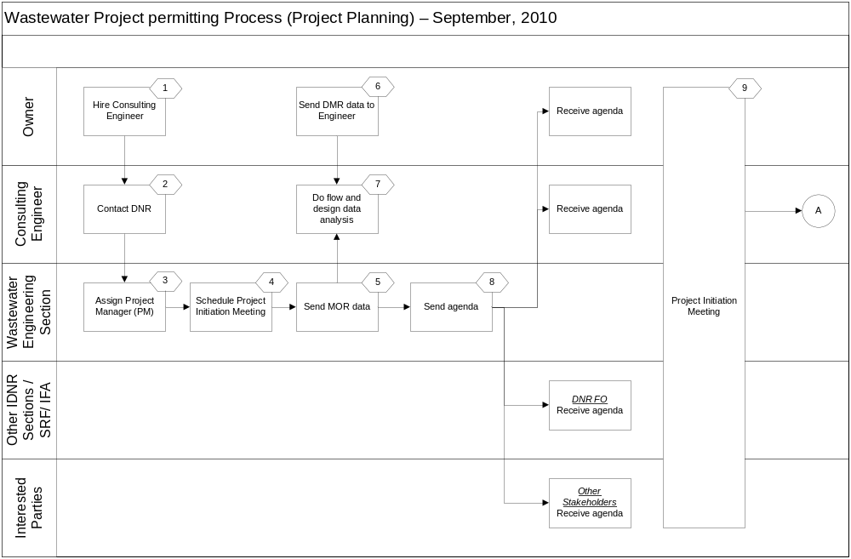

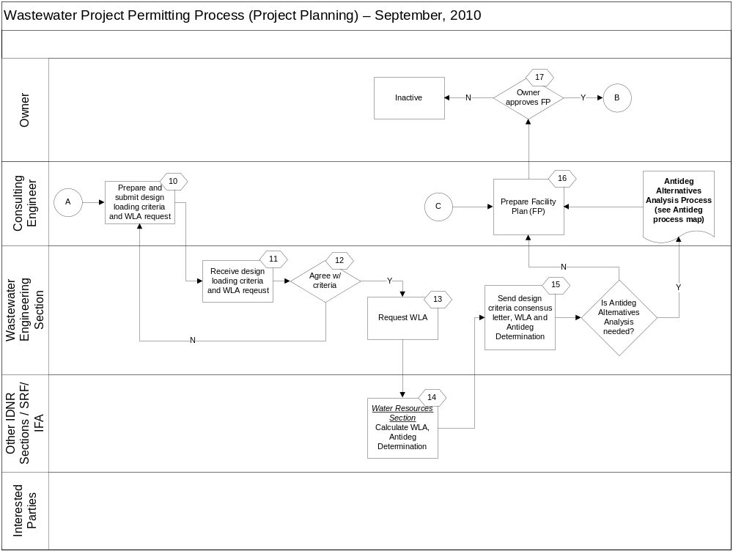
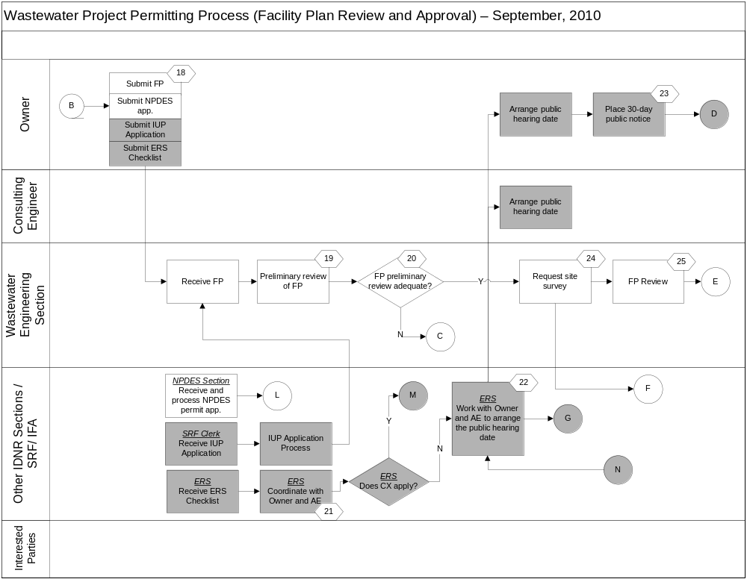
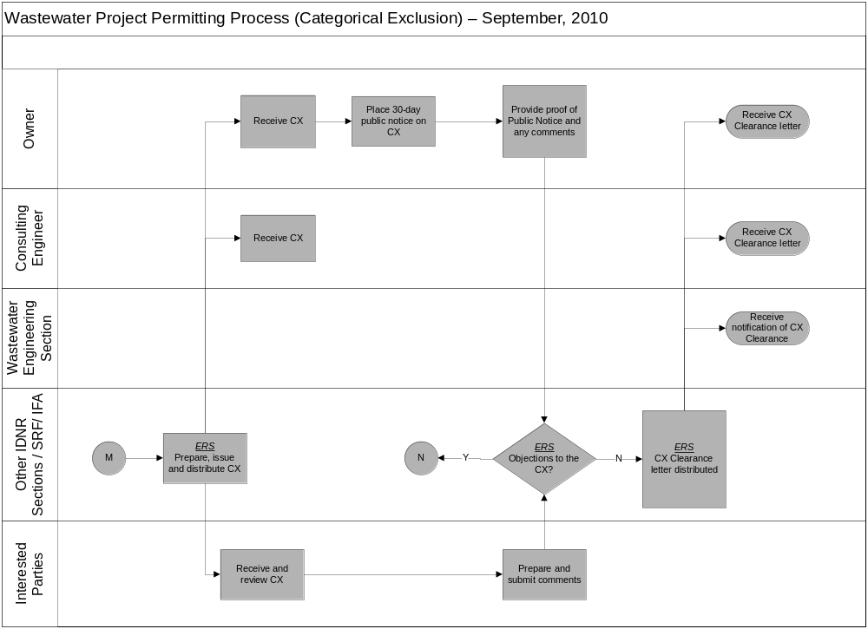
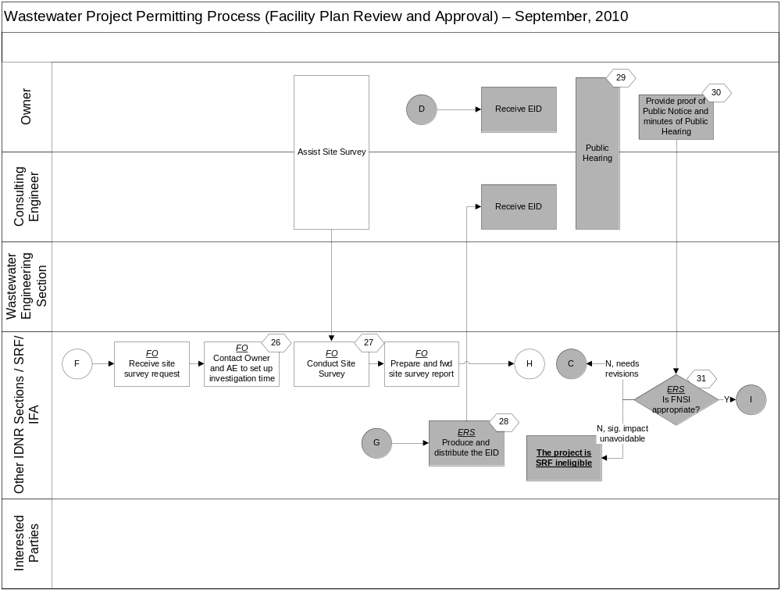
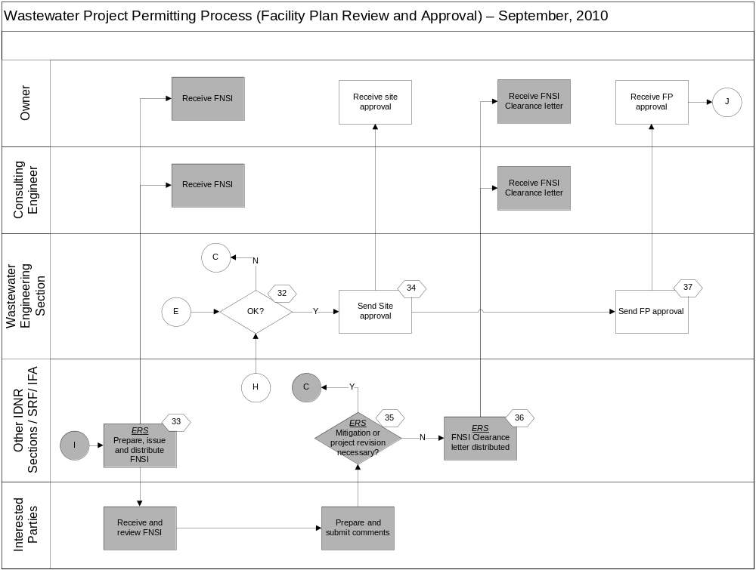

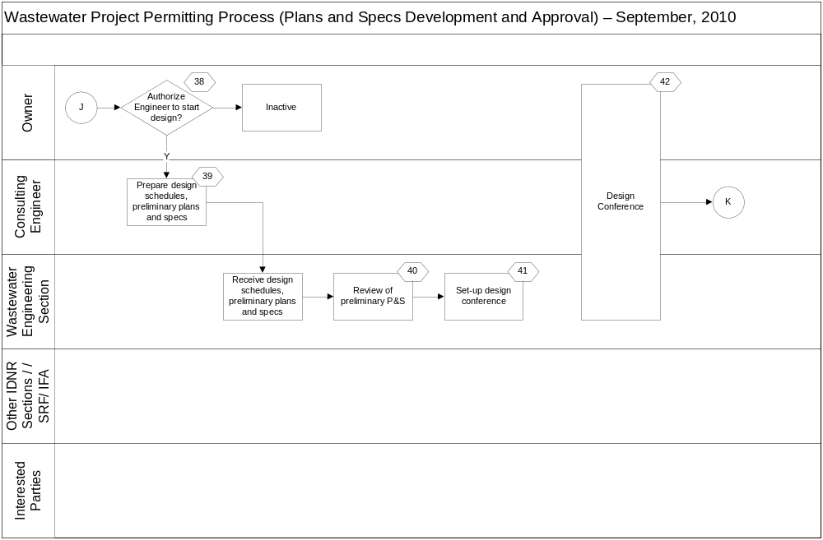

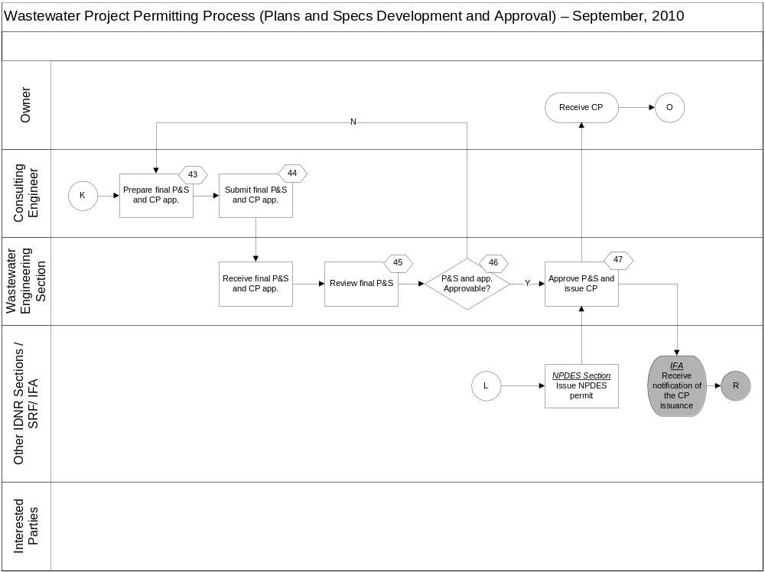
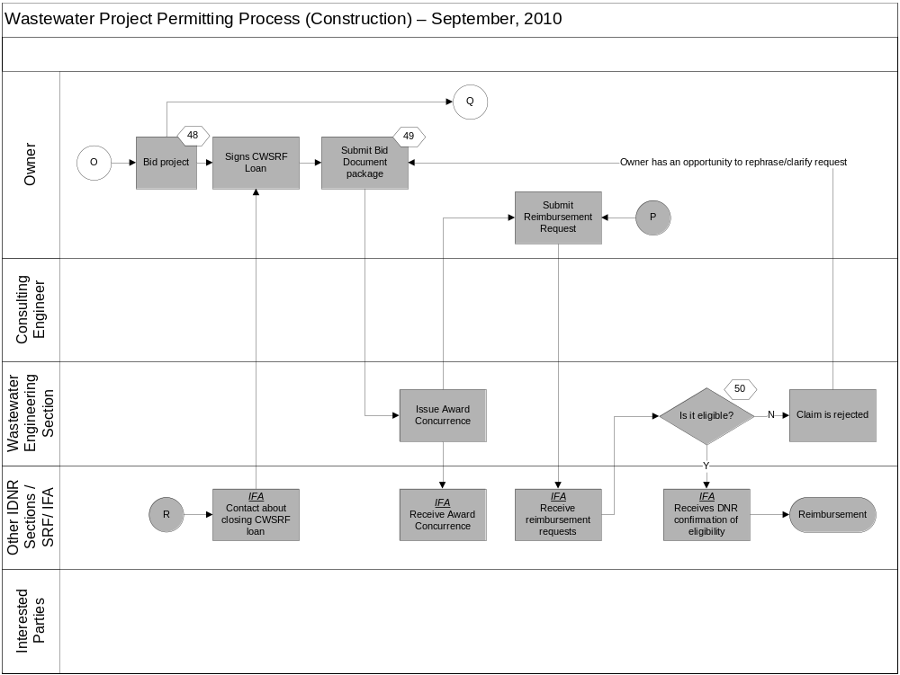
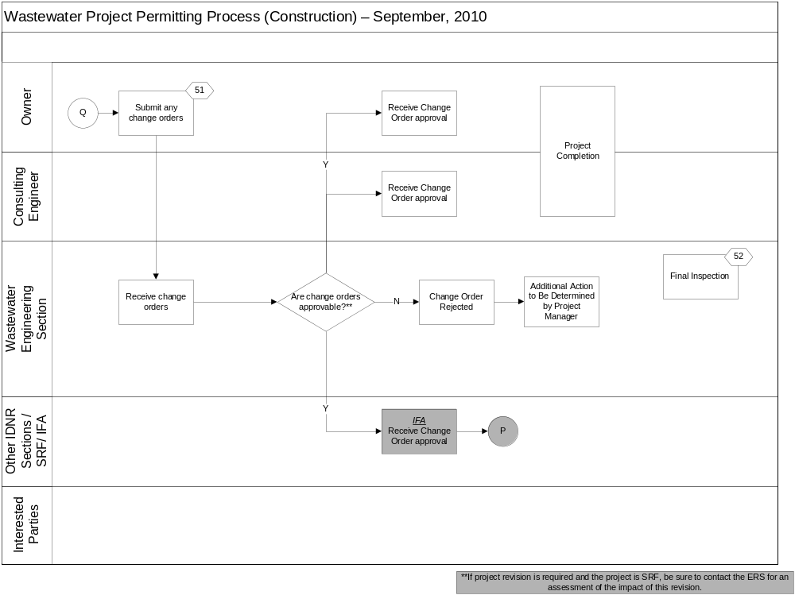
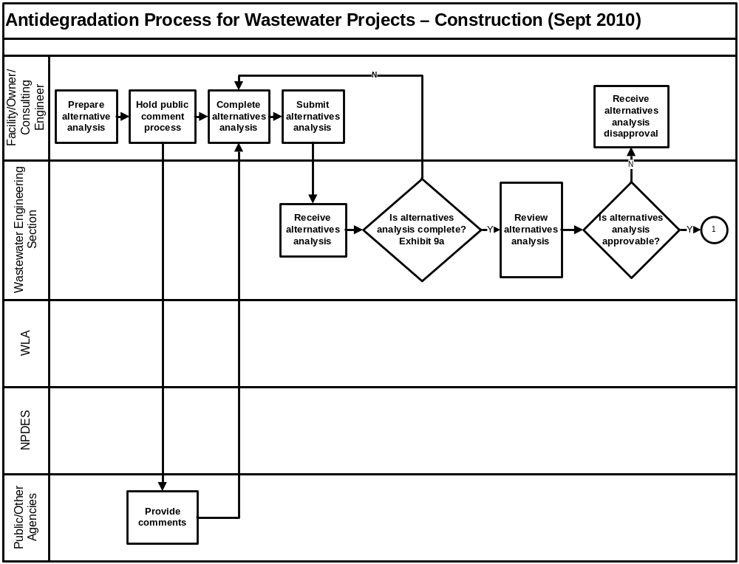
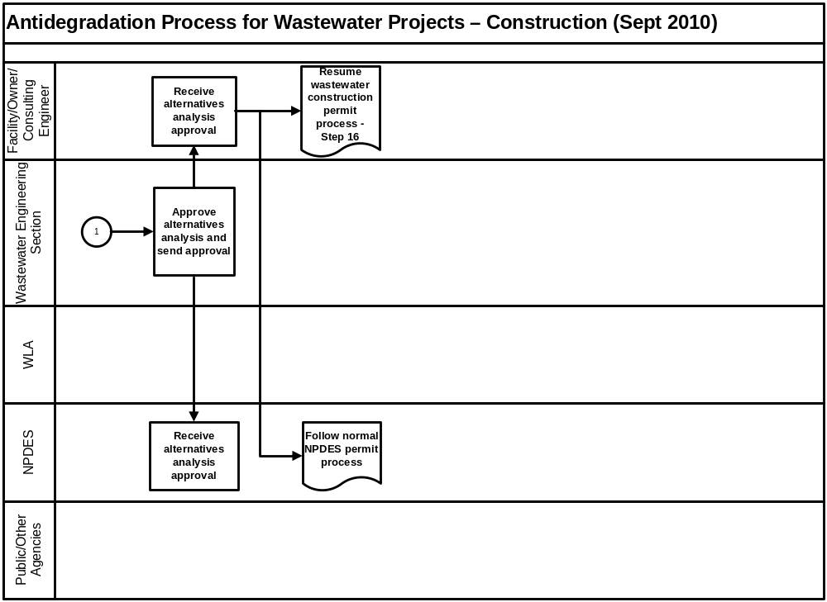

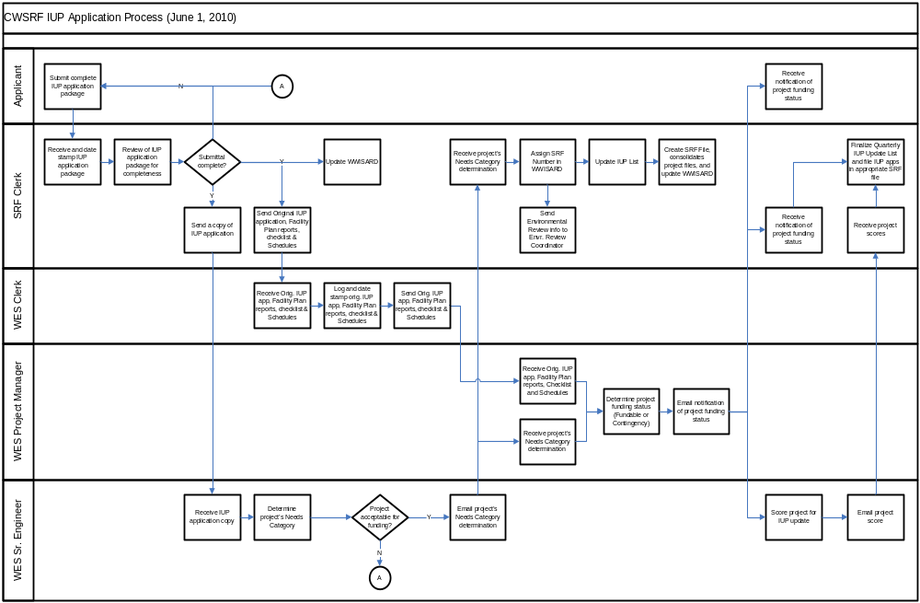


Exhibit 1
Planning & Design Loans
For
Wastewater & Storm Water

Planning & Design Loans
- Financial assistance for communities that are in the planning and design phase of a proposed water pollution control project.
- 0% interest for up to 3 years
- NO initiation fee
- NO servicing fee
- NO minimum loan amount
- NO maximum loan amount
- Eligible costs include the following: Engineering fees, archaeological surveys, environmental studies, and fees related to project plan preparation and submission.
- Loans will be rolled into a SRF construction loan OR may be repaid upon permanent financing.
- The project planning and design costs must be directly related to the proposed wastewater or storm water project.

Water pollution control projects:
- Construction of treatment plants or improvements to existing facilities
- Sewer line extensions to existing unsewered properties
- Combined sewer overflow corrections
- Infiltration/inflow projects
- Storm water projects that have an environmental benefit

Eligible Entities:
- Cities, towns, counties, regional sewer/water districts, conservancy districts and water authorities eligible for SRF loans.

Application forms are available at www.iowasrf.com.

For more information, contact:

Lori Beary 515-725-4965 800-432-7230 lori.beary@iowa.gov
Tracy Scebold 515-725-4922 800-432-7230 tracy.scebold@iowa.gov

Iowa Finance Authority 2015 Grand Avenue Des Moines, IA 50312

515.725.4900 800.432.7230 515.725.4901 (fax)

Eligible Projects and Project-Related Costs – the acquisition, construction, rehabilitation, equipping, improvement or extension of any works and facilities used for the collection, treatment and disposal of sewage and industrial waste in a sanitary manner. (IAC 567 – Ch. 90.2)

These would include:
- Treatment plant improvements and upgrades
- Sewer line extensions to existing unsewered communities
- Combined sewer overflow corrections
- Infiltration / inflow projects

Examples of Ineligible Projects and Project-Related Costs
- Land purchase, unless part of treatment process (land application)
- Service lines and in-house plumbing
- Operation and maintenance costs
- Vehicles and tools

Exhibit 2
Iowa Department of Natural Resources
Wastewater Engineering Section
Project Initiation Meeting Checklist and Sample Agenda

DNR Pre-Meeting Activities

1. ______ Assign project manager (PM) and establish a DNR project tracking number once notification of a wastewater project is received from the Owner or their consulting engineer (hereafter referred to as AE).

2. ______ Schedule project initiation meeting and location.

3. ______ Send Project Initiation Meeting Agenda and Scope of Study Checklist to the Owner, AE, DNR field office, and other interested parties.

4. ______ Transmit DNR’s electronic records of plant monitoring data to the AE.

Meeting Agenda

5. ______ Record project contacts for Owner, AE, DNR, and others, with names, mailing addresses, phone, fax, and e-mail addresses.

6. ______ Additional project information should be presented by the DNR: field office inspection reports, compliance schedules, facility compliance reports, etc.

7. ______ Discuss the proposed design flows and organic loadings as presented by the AE.

8. ______ Discuss current and future needs for added capacity.

9. ______ Discuss anticipated financing arrangements, including Planning and Design loan availability and plans for Clean Water State Revolving Fund construction loan or other financing program applications.

10.______ Provide overview of DNR Design Standards, Chapter 14 Reliability Criteria (unit process & power source) and New Process Evaluation Procedures, DNR Design Schedules and Project Management Procedures.

11.______ Discuss siting considerations:
- Probable location of facilities
- Receiving Stream and Classification
- Discharge Point Alternatives
- State Historic Preservation
- DNR Site Separation Criteria
- Flood Plain Permits
- Section 404 Requirements – Wetlands
- Important Farmlands
- Geotechnical Investigations and Coordination
- Land Acquisition – Federal requirements

12.______ Discuss on-going rule and policy changes which may impact the Waste Load Allocation or any other important design criteria.

13.______ Discuss Antidegradation implementation procedures and alternatives analysis.

14.______ Establish Scope of Study for preparation of a Facility Plan.

15.______ Discuss DNR Air Quality permitting requirements for emergency generators, if applicable (877-AIR-IOWA).

16.______ Discuss potential changes in operator certification requirements resulting from increases in design loadings and/or types of treatment (567 IAC 81).

17.______ Develop Project Schedule for Milestones.
- Preliminary Project Submittal by the AE with Design Flows and Organic Loadings
- Preliminary Concurrence with Design Flows and Organic Loadings
- If needed, issuance of a current Waste Load Allocation (WLA)
- Submit Antidegradation Alternatives Analysis (Exhibit 9A: Preliminary Review of Antidegradation Alternatives Analysis), if applicable
- *Submit Exhibit 5: SRF Environmental Review Checklist and consult with SRF Environmental Review Specialist on possible Categorical Exclusion
- *Schedule public hearing on Environmental Review
- Submittal of a complete Facility Plan, including required Design Schedules
- Procedures for applying for a CWSRF construction loan
- Submittal of application for an NPDES permit
- Preliminary Siting Approval for New or Expanded Wastewater Treatment Facilities
- *Completion of Environmental Information Document (EID) by SRF Environmental Review Specialist
- *Issuance of the Finding of No Significant Impact (FNSI)
- Facility Plan approval
- Design Conference
- 60 Percent Preliminary Plan and Specification Submittal
- Final Plan and Specification Submittal (*with Exhibit 12A: SRF Required Front-End Documents)
- Start Construction
- Completion of Construction
____________________
*May only be required for projects financed through CWSRF or other funding programs

DNR Post-Meeting Activity

18.______ Prepare meeting minutes summary and distribute to Owner, AE, DNR field office, central office sewage and project files, and others

SECTION I: BACKGROUND INFORMATION
1) Date Requested: | 2) Date Needed:
3a) Wasteload Allocation Priority Justification:

3b) Reason for Wasteload Allocation Request:

SECTION II: FACILITY INFORMATION
4) Facility Name: |  |  |  |  |  |  |  | 5) NPDES/Sewage File Number:
6) Facility Location | Section: |  |  |  | Township: |  |  | Range:
Latitude: | Degrees: |  |  |  | Minutes: |  |  | Seconds:
Longitude: | Degrees: |  |  |  | Minutes: |  |  | Seconds:
7) Field Office: |  |  |  |  | 8) County:
9) Description of Industry and Principal Products:
10) Treatment Type: |  |  |  |  |  |  |  | 11) Other Treatment:
12) UV Disinfection – (No TRC limits required): |  |  |  |  |  |  |  | 13) Design Population Equivalent (PE):  Existing: New:
14) Design Flows (mgd):  Existing – ADW: AWW-30: AWW-180 (CDL):  New – ADW: AWW-30: AWW-180 (CDL): |  |  |  |  |  |  |  | 15) Design Mass Loadings (Max. 30-day, lbs/day):  Existing – BOD₅: TSS: TKN:  New – BOD₅: TSS: TKN:
16) New or existing SIU(s) contributing new pollutants of concern to the POTW? Yes , No , or Not Applicable
If applicable, list the facility(s) and pollutant(s) of concern:

17) New processes contributing new pollutants of concern (i.e. chlorination/de-chlorination, changes in chemical additives, etc.)? Yes , No , or Not Applicable
If applicable, list the process change(s) and pollutant(s) of concern:

18) WLA is requested for: |  |  |  |  |  | 19) Map Included (Req’d for a new/proposed facility):
20) Outfall Information |  | ADW **  (MGD) | AWW**  (MGD) |  | CDL (MGD)  AWW x 10 | Latitude  (Deg/Min/Sec) |  |  |  |  | Longitude  (Deg/Min/Sec)

Outfall #
Discharge Description
Stream Network
Classification of Receiving Stream
Outfall #
Discharge Description
Stream Network
Classification of Receiving Stream
Outfall #
Discharge Description
Stream Network
Classification of Receiving Stream
21) New WLA Request Options |  | Regular |  | Diffuser |  |  | Stepwise Flow Limits |  | MZ Study:  MZ%:  ZID%: |  |  | Site Specific pH and Temperature
**Only water quality based effluent limits calculated using DNR approved design flows can be applied in NPDES permits. Proposed flows that have not been approved by the DNR may be used for informational purposes only.
SECTION III: TMDL
22) Is there an impaired stream in the watershed (check entire route of flow)? | Yes: | No:
23) If yes, list the impaired waterbody segment and impaired pollutants:

24) Status of the TMDL:

SECTION IV: PARAMETER CHECKLIST
25) Parameter |  | Frequency+ | Parameter |  | Frequency+
Common Pollutants: |  |  | Common Metals:
All Common Pollutants |  |  | All Common Metals
CBOD5 |  | -- | Cadmium
Dissolved Oxygen |  | -- | Chromium (VI)
Ammonia Nitrogen |  | -- | Copper
E. coli |  | -- | Cyanide
TRC* |  |  | Lead
Chloride |  | 1/month | Nickel
Sulfate |  | 1/month | Silver
pH |  | -- | Zinc
Priority Pollutants: |  |  | Others:
All Priority Pollutants |  |  | Iron |  | --
 |  |  | Temperature |  | --
 |  |  | COD |  | --
 |  |  | Effluent Toxicity Testing % (For Major Facilities) |  | --
*For TRC requests please provide the time of travel or distance traveled within the sewage pipe (from sampling point to outfall), if applicable (it will be assumed zero if this information is not provided).  Time of travel: or pipe length:  Velocity in pipe (ft/s): |  |  | ⁺Monitoring frequencies will be assumed as 1/week unless otherwise specified in the “Frequency” column to the right of the parameter check boxes.
26) Antidegradation Review Information - Technology Based Effluent Limits and/or Best Professional Judgment (BPJ) Limits (for DNR Use Only): Please provide as an attachment any and all applicable technology based effluent limits and/or limits based on BPJ. Attachment Included:

SECTION V: CONTACT INFORMATION AND COMMENTS
Requested By:  IDNR WW Engineer Name:  Email (for consultants): |  |  | Contact Information (for consultants):
Additional Comments:
Attachment: Technology Based Limits and/or Limits Based on BPJ
Facility Name: |  | NPDES/Sewage File Number:
Outfall No.:
Parameters | Ave. Conc. (mg/l) | Max Conc. (mg/l) |  | Ave. Mass (lbs/d) | Max Mass (lbs/d)
Comments/Additional Information

Instructions for filling out the Wasteload Allocation:
The following is a step-by-step guide for completing of the Iowa Department of Natural Resources’ Water Quality Based Permit Limits Work Request Form. If the required information is not filled out completely, it may take longer for the request to be completed by the Wasteload Allocation (WLA) staff of the Water Resources Section.

Please send all WLA requests by e-mail to Connie Dou at connie.dou@dnr.iowa.gov. Please allow for the request to take up to 30 days for completion. Varying levels of complexities may take up to 60 or more days for the completion of the wasteload allocation. If the wasteload request needs to be completed sooner than 30 days, please state the reason in part three of Section I of the form.

Instructions:
Section I

- Date Requested – Please provide the date the WLA was filled out and sent to the DNR WLA staff.

- Date Needed – Please provide the date the WLA request needs to be back to the requester.

- a)Wasteload Allocation Priority Justification (optional) – As stated above, a wasteload allocation can take up to 30 days to complete with some taking as long as 60 or more days for completion. If the wasteload allocation needs to be completed before the normal processing time, a justification statement needs to be included in the wasteload allocation priority area.
b) Provide a reason why the Wasteload Allocation is being requested.

Section II

- Facility Name – Please provide the name of the facility being requested.

- Sewage File Number (optional for consultants) – This is the number assigned to the facility as it corresponds to the sewage/NPDES file record. If this is a new/proposed facility, a number may not have been assigned to the facility yet.

- Facility Location – Please provide the description of the location of the facility (Section/Township/Range and Latitude/Longitude). This location is not the location of the discharge/outfall pipe, but the facility itself. This information can be located using the following websites:
http://ortho.gis.iastate.edu/
http://www.topozone.com/
http://mapserver.maptech.com/api/espn/index.cfm

- Field Office – There are 6 different field office regions in the State of Iowa with a corresponding number: 1-Manchester, 2-Mason City, 3-Spencer, 4-Atlantic, 5-Des Moines, and 6-Washington. Please identify the Field Office Region in which the facility is located and Field Office Number. Field Office Regions can be found at the following website: http://www.iowadnr.gov/fo/fomap.html

- County – Please provide the name of the County in which the facility is located.

- Provide a description of the Industry and Principal Products (applies only to Industrial Dischargers) - Please describe the type of industry (i.e. ethanol plant or power plant, etc.) and the plant’s principal products.

- Treatment Type –A treatment type can be one of the following: Activated Sludge, Aerated Lagoon, Controlled Discharge Lagoon, Covered Aerated Lagoon, Mechanical Plant, Industrial Facility w/ No Treatment, Trickling Filter, Septic Tank/Sand Filter, Rotating Biological Contactor, Sequencing Batch Reactor, Oxidation Ditch, Other or None. If the treatment type is not listed here, please enter the treatment type in option number 11 “other treatment”. If this is a new/proposed facility or a proposal for a facility upgrade, please indicate which type of treatment the facility plans on providing.

- Other Treatment (optional) – If the treatment type wasn’t specified in item number 10, “Treatment Type”, then use this category to fill in the treatment type being used.

- UV Disinfection – If the facility uses UV, please place a check in the box.

- Design Population Equivalent (PE) – Please provide the facility’s existing PE based on the approved design capacity for the existing facility. If the facility is going through an expansion or upgrade please provide the new/proposed PE design value in addition to the approved design capacity of the existing facility. If the facility is not expanding/upgrading please place “NA” (Not Applicable) in the box to the right of “New”. The PE value can be computed by using 0.167 pounds of BOD5 per capita per day. For example, if the facility’s design max. 30-day BOD5 is 50 lbs/day the resulting design PE value is 299 (50 lbs/day BOD5 / 0.167 lbs of BOD5 per capita per day = 299).

- Design Flows – Please provide the average dry weather (ADW) and 30-day average wet weather (AWW) flows based on the approved design capacity for the existing facility. For controlled discharge lagoons (CDLs), please provide the 180-day AWW flow. If the facility is going through an expansion or upgrade, please provide the new/proposed ADW and AWW design flows in addition to the approved design capacity of the existing facility. If the facility is not expanding/upgrading please place “NA” (Not Applicable) in the boxes to the right of “New”. ADW and AWW flows for municipal and semi-public facilities need to be approved by the Iowa Department of Natural Resources Wastewater Construction Section to be used in a wasteload allocation for an NPDES permit. The definitions for ADW and AWW flows are provided in Section 14.4.5.1 of the Iowa Wastewater Facilities Design Standards. For controlled discharge lagoons, the definition of the 180-day AWW flow is provided in Section 18C.4.1.1 of the Iowa Wastewater Facilities Design Standards.

- Design Mass Loadings (Max. 30-day, lbs/day) – Please provide the facility’s maximum 30-day BOD5, TSS and TKN loadings based on the approved design capacity of the existing facility. If the facility is going through an expansion or upgrade, please provide the new/proposed maximum 30-day BOD5, TSS and TKN design loadings in addition to the approved design capacity of the existing facility. If the facility is not expanding/upgrading please place “NA” (Not Applicable) in the boxes to the right of “New”.

Max. 30-day: The highest average organic loading received in a 30-day period.

- Significant Industrial Users (SIU) to a Publically Owned Treatment Works (POTW) – Please list any new or existing SIUs that are contributing new non-compatible (i.e. metals or other pollutants for which the treatment plant was not designed to treat) pollutants of concern to the POTW and list the pollutant(s) of concern.

- New Processes Contributing New Pollutants of Concern – Please list any processes or changes to the facility that are or will be introducing new pollutants of concern to the wastestream, such as chlorination/dechlorination processes, changes in chemical additives, etc. Please also list the pollutants being contributed.

- Reason for WLA request – By selecting one of the following categories: current existing facility, expansion/upgrade of existing facility, new/proposed industry, or new facility for unsewered community, the wasteload staff will know if the sewage/NPDES file contains any previous wasteload options that may need to be considered. Additionally, it will help to identify whether antidegradation applies to a facility.
Current Existing Facility – A treatment plant that has already been constructed and is currently in operation and is considering no changes that would change the facility’s design capacities.

Expansion/Upgrade of Existing Facility – A treatment plant that has already been constructed and is currently in operation and is implementing changes to its facility that will increase one or more of its design capacities.

New/Proposed Industry – This facility is not currently an existing facility.

New Facility for Unsewered Community – An unsewered community is constructing a new treatment plant.

- Map Included (optional for an existing facility) – A check needs to be added if a map was included with the request. A map is needed for use with a new/proposed facility. If the facility already exists, a map does not need to be provided with the request form.

- Please provide the design flows and location(s) to be used in the wasteload allocation calculations. If there are multiple outfalls, please fill out each outfall accordingly. If each outfall has different parameters, please fill out a separate wasteload allocation request form for each outfall. To find the Latitude/Longitude of the outfalls, please refer to the websites found in instruction number 6.

The ADW and AWW flows for municipal and semi-public facilities need to be approved by the Iowa Department of Natural Resources Wastewater Construction Section to be used in a wasteload allocation for an NPDES permit. All other flows will be considered, but may only be used for informational purposes. The definitions for ADW and AWW flows are provided in Section 14.4.5.1 of the Iowa Wastewater Facilities Design Standards. The ADW and AWW are discharge flows. For controlled discharge lagoons, the definition of the 180-day AWW flow is provided in Section 18C.4.1.1 of the Iowa Wastewater Facilities Design Standards.

ADW = Average Dry Weather Flow (MGD)
AWW = Average Wet Weather Flow (MGD)
MGD = Millions of Gallons per Day

For industrial discharges, such as cooling water discharges that do not usually have wastewater design flows since no wastewater treatment plant is needed, please provide the maximum monthly average flow and daily maximum flow as the ADW and AWW flows, respectively.

- New WLA Request Options – If the request is for a new/proposed facility, a check needs to be placed in the box or boxes if these options need to be included within the wasteload request. “Stepwise flow limits” refers to a facility only being permitted to discharge when stream flows are above a certain level. If the request is to include a Mixing Zone study or site-specific data, please include what mixing zone percentages need to be included along with the mixing zone study report and/or site-specific data.

Section III

- TMDL (optional) – An “X” needs to be placed in the Yes or No category. If the watershed doesn’t currently have an impairment for any stream segments along the discharge route of flow, then skip numbers 23 and 24. If there is an impaired stream, then numbers 23 and 24 should be completed. To check for impaired streams, please visit the following website:
http://www.igsb.uiowa.edu/wqm/wqa/303d/2008/303dState.html. This site presents detailed maps showing the locations of impaired streams within the six different field office regions within Iowa.

Once you click on a particular region a new map appears displaying the impaired streams for that region and a table below the map details the exact locations and causes of the impairments. Additional information on the state’s 303(d) lists can be found at the following website: http://www.igsb.uiowa.edu/wqm/wqa/303d.html. For questions regarding impaired streams and the 303(d) list, please contact John Olson, DNR Water Quality Assessment Specialist, at (515) 281-8905, or John.Olson@dnr.iowa.gov.

- Explanation of the impairment for that waterbody (optional) – This information can be gathered from the websites identified above.

- Status (optional) – Is there a TMDL completed and approved by the EPA for this stream or is there a TMDL being scheduled for this stream? Please indicate the current status of the TMDL. To find out if a stream has a completed TMDL please visit the following website: http://www.iowadnr.gov/water/watershed/pubs.html. If the TMDL has not been completed please check the following website to see when it is scheduled to be completed: http://www.iowadnr.gov/water/watershed/tmdl/schedule.html

Section IV

- An “X” needs to be placed in the checkbox to the right of the parameter if that parameter is being requested. For wastewater treatment plants that have significant industrial users, please make sure to include all pollutants established in the treatment agreement. If a sampling frequency is required (other than the sampling frequency already determined by department staff), please contact NPDES staff to discuss these options. Specific toxics (other than what was provided) need to be added in the appropriate open space (Priority Pollutants/Others). The sampling frequency is based on the population equivalent (PE) in Chapter 63 of the Iowa Administrative Code. The design PE is calculated using the 30-day design organic (BOD) loading.

- Antidegradation Review Information (for DNR use only) – NPDES permit writers, please calculate and provide the technology based effluent limits and limits based on best professional judgment (BPJ) that are applicable to the facility. Please place a check in the box to indicate that limits have been included. Please use the attached form to list the pollutants and limits.

Section V

Contact Information:
Example
Requested By: Joe Smith

Email: Joe.Smith@hotmail.com

Contact Information:
Joe Smith
M & M Engineering
Des Moines IA, 50320 – phone (515) 555-1212

Additional Comments – This section is for any other information that the requester feels should be included with the work request. Or, if the requester is looking for other options to be included with the wasteload allocation, it needs to be specified within this space.

Exhibit 4
Iowa Department of Natural Resources
Wastewater Engineering Section
Facility Plan Scope of Study Checklist

Project Name:
Meeting Location:
Date of Project Initiation Meeting:
Meeting Attendance List:

Design Standard Section |  | Subsection N/A to Scope
11.1 | General
11.2 | Engineering Reports of Facilities Plans
11.2.1 | Title of Project
11.2.2 | Letter of Transmittal
11.2.3 | Title Page
11.2.4 | Table of Contents
11.2.5 | Summary
11.2.5.1 | Findings
11.2.5.2 | Conclusion
11.2.5.3 | Recommendations
11.2.6 | Introduction
11.2.7 | Existing Conditions and Projections
11.2.7.1 | Planning Period
11.2.7.2 | Land Use
11.2.7.3 | Demographic and Economic Data
11.2.8 | Existing Facilities Evaluation
11.2.8.1 | Existing Collection System
11.2.8.2 | Existing Treatment Plant Site
11.2.8.3 | Existing Treatment Facilities
11.2.8.4 | Existing Wastewater Characteristics
11.2.9 | Proposed Facilities Evaluation
11.2.9.1 | Proposed Collection System
11.2.9.2 | Design Wastewater Characteristics
11.2.9.3 | Receiving Stream Characteristics
11.2.9.4 | Treatment Plant Site Requirements
11.2.9.5 | Alternatives
11.2.9.6 | Selected Process and Site
11.2.9.7 | Project Financing
11.2.9.8 | Legal, and Other Considerations
11.2.10 | Combined Sewer Studies
11.2.11 | Appendices: Technical Information and Design Criteria
11.2.11.1 | Collection System
11.2.11.2 | Process Facilities
11.2.11.3 | Process Diagrams
17.1 | Sludge Handling and Disposal
11.2.12 | Plans Subject to Federal Requirements
 | Environmental Information Documentation
 | Additional Items:

Exhibit 5

SRF Environmental Review Checklist

The following checklist outlines the information needed to start the SRF
Environmental Review (ER) Services. Please provide the following to the SRF
ER Specialist:

- A listing of any other planned sources of federal funding to better coordinate environmental review efforts

- An accurate map of the site with marked boundaries; if the specific area has yet to be specifically defined, please mark a larger area that will include the final project area

- A project description detailing the project scope

- A description of any ancillary impact—destruction or abandonment of current building/structures, borrow pits, staging area, new access for roads/utility lines.

- A description of the existing environment without the project including:
  - The current use(s) of the project area and immediate vicinity
  - The current habitat of the project area and immediate vicinity
  - If farmland is going to be converted to non-farmland, please provide answers to the following:
- What is the size of the farm unit(s) containing the project area?
- How much of the project area has been farmed (managed for a scheduled harvest or timber activity) more than 5 of the last 10 years?
- How much of the project area will be converted from agricultural use as a result of the proposed project?

- Photos of the project site showing current use and habitat (digital files are preferred)

- A description of the expected future environment without the project if it is expected to change from the existing environment.

- A short discussion of other feasible options (alternative locations, techniques, methods, or capacities considered) and the rationale used to select the proposed project over these other options.

- Contact information for the property landowner if an archeological survey becomes necessary.

- A listing of any expected impacts to the environment, if known, and a listing of any planned steps to minimize adverse effect.

Send materials to State Revolving Fund, Iowa Department of Natural Resources, Wallace State Office Building, 502 E. 9th Street, Des Moines, IA 50319-0034.

Exhibit 6
SRF Public Notice Example

PUBLIC HEARING NOTICE

The City of Iowaville will be holding a Public Hearing to review an application for a State Revolving Fund (SRF) loan and to make available to the public the contents of an environmental information document and the City’s Facility Plan. These documents include design and environmental information related to the proposed improvements to the City’s wastewater treatment system.

The proposed project involves the abandonment of the existing mechanical treatment plant and converting an existing flow equalization basin to an aerated lagoon system.

The purpose of this Public Hearing is to inform area residents of the community of Iowaville of this proposed action, discuss the actual cost and user fees associated with this project, and to address citizen’s concerns, if any, with the plan.

The Public Hearing location and time are as follows:

September 25, 2008 – 7:30 p.m.
Iowaville City Hall
1102 Main Street
Iowaville, Iowa 50000

All interested persons are encouraged to attend this hearing. Written comments on this proposal may also be submitted prior to the hearing. Questions regarding this hearing or the availability of documentation may be directed to the City Clerk’s Office at 515-352-3065.

Exhibit 7

SRF Public Hearing Checklist

A public hearing must be held locally if the State Revolving Fund will be
used to finance the project. The primary purpose of the hearing is to discuss
the results of the environmental review.

Adequate public notification provided to the media and all interested parties at
least 30 days prior to the hearing. The purpose of the public hearing must be
identified in the notification.

Reports, documents and data relevant to the discussion at the public hearing shall be available at the project central depository for public review generally not less than 30 days before the public hearing.

Hearings must be held at convenient times and places.

Alternative strategies, environmental impacts, and institutional arrangements including user charge estimates should be discussed.

All interested parties should be allowed adequate time to present their views. A question and answer period is recommended.

The municipality shall prepare a transcript, recording or other complete record of the hearing and make it available for public review.

A responsiveness summary (summary of public comments) and proof of publication must be submitted to the Environmental Review Specialist.

Send materials to State Revolving Fund, Iowa Department of Natural Resources, Wallace State Office Building, 502 E. 9th Street, Des Moines, IA 50319-0034.

Exhibit 8

Clean Water SRF Intended Use Plan Application

This packet includes the materials and information you need to apply for inclusion on the Clean Water State Revolving Fund (SRF) Intended Use Plan. Please use the checklist below to ensure that your application is complete before submitting it.
Instructions are included on the next page.

To Be Completed by Applicant |  | For DNR Use
Applicant Name: |  | Yes No
1. DNR Project Number (e.g. S2010-####): | S - | Yes No
2. DNR Project Manager Name: |  | Yes No
3. Project Identification (from DNR Design Schedule A): |  | Yes No
4.(a). Antidegradation review required and Alternatives Analysis submittal required? If No go to Item 4 (c) | Yes OR No | Yes No
4 (b). Alternative Analysis approved by DNR? | DNR Approval date: | Yes No
4 (c). Three copies of certified Facility Plan  If previously submitted: | Certified date:  Submitted date: | Yes No
5(a). Iowa Construction Permit Application Schedule A |  | Yes No
5(b). Schedules F and G if needed for the project: | OR N/A  If N/A, state reason | Yes No  N/A
6. Exhibit 5, SRF Environmental Review Checklist and Attachments |  | Yes No
7. EPA pre-award compliance form completed with DUNS number and authorized signature |  | Yes No
8. Property assurance form completed with authorized signature | OR N/A  If N/A, state reason | Yes No  N/A

For DNR Use: Decision
Date IUP application packet received: Application packet compete Yes No
SRF Reviewer: Date:
To Be Completed by Applicant |  | For DNR Use
9. Project initiation meeting was held on: |  | Yes No
10. Flows and loads concurrence by DNR on: | OR N/A  If N/A state reason | Yes No  N/A
11. Wasteload allocation of concurred flow was completed on: | OR N/A  If N/A state reason | Yes No  N/A

For DNR Use: Decision

The Applicant has followed DNR Construction Permitting Process (Steps 1 - 17) and submitted a Facility Plan at Step 18: Project is considered ready to be placed on the Fundable List Yes No
If No, the Project is not ready for FP review and must be placed on the Contingency List

Project Manager: _________________ Date: ___________

Exhibit 8

Clean Water SRF Intended Use Plan Application
Checklist Instructions

Item No. 1. All wastewater projects for construction are assigned unique project numbers for tracking by DNR. Projects numbers are given by Ronda Hensley when a project manager is assigned to a project and a file is created. Her telephone number is 515-281-8982.

Item No. 2. A project manager is assigned to each SRF project after an initial contact to the Department as described in Steps 2 and 3 of the wastewater construction permitting process manual.

Item No. 3. A brief description of the project is required in Design Schedule A, General Information. The project description must fall under the project scope established at the project initiation meeting. An accurate description is necessary because multiple construction contracts may have the same project number.

Item No 4 (a). At Step 14 DNR’s Water Resources Section determines the wasteload allocation. If an antidegradation review is required, the applicant is required to submit an Alternatives Analysis to the Department. Indicate the determination on the appropriate box. If it is determined that an antidegradation review and an Alternatives Analysis are not required, go to Item 4 (c).

Item No 4 (b). Include the DNR’s antidegradation Alternatives Analysis approval date. If the analysis has not been approved by DNR do not proceed any further with Intended Use Plan (IUP) application submittal. Your project is not ready for an IUP submittal.

Item No. 4 (c). At Step 18 (after completing Steps 1 through 17 of the wastewater construction permitting procedures), submit three copies of the Facility Plan (FP) certified by an Iowa licensed professional engineer along with the applicable design schedules and completed IUP application. Three copies of the FP are not required with an IUP application submittal if the FP has been submitted previously to the wastewater engineering section. However, an IUP application without the FP included must reference the actual certification and submittal dates. If a Facility Plan is not ready to be submitted, your project is not ready for an IUP submittal.

Item No. 5 (a). Design Schedule A must be certified by both the applicant and the design engineer. This form is required for all wastewater projects. Design Schedule A should indicate that CWSRF loan funds will be requested.

Item No. 5 (b). Design Schedules A, F and G are required for a site survey request, Paragraph 567 IAC 60.4(1)“c”.

Item No. 6. The environmental review checklist is provided as Exhibit 5. This checklist and information must be included as an attachment to the IUP application.

Item No. 7. The EPA Pre-Award Compliance form must be completed, signed, and submitted to DNR with the IUP application. A DUNS number for the applicant is required. If the applicant does not have a DUNS number, go to http://fedgov.dnb.com/webform to request one. This form must be approved by the U.S. Environmental Protection Agency before a CWSRF loan can be signed.

Item No. 8. Purchase of land typically is not eligible for the Clean Water SRF. Please check with your project manager to confirm. However, if land is being purchased for the project, the applicant must comply with federal property acquisition requirements and submit this form.

Item No. 9. The project initiation meeting is Step 9 of the wastewater construction permitting procedures. If CWSRF funding program requirements were not anticipated and discussed at the project initiation meeting, a second project initiation meeting is required. A second project initiation meeting also may be needed if a project has been inactive or the project scope is revised. The proposed project must be in conformance with the long range planning of the area. The project initiation meeting may include representatives from the Iowa Finance Authority and the DNR Field Office, NPDES permits section and Environmental Review (ER) services. Project coordination and a determination of readiness for FP review is intended to improve staff efficiency and should not be confused with the readiness criteria of other funding agencies (e.g., IFA, IDED, USDA, EPA, etc.). If the information requested in Items No. 1 through No. 6 has been addressed, but Steps 1-17 of the wastewater construction permitting procedures have not been followed, the project will remain on the IUP contingency list until it can be added to the fundable list.

Item No. 10. DNR concurrence with the proposed design flows and loadings is Step 12 of the wastewater construction permitting procedures. Our agreement with the proposed design criteria will be forwarded to the applicant in writing by the project manager.

Item No. 11. The waste load allocation (WLA) for preparation of the FP must be based on current rules (including all applicable TMDLs) and the DNR concurred design flows and loadings per Steps 11 and 12. A WLA might not be necessary for projects involving only sewers, pumping stations or sludge handling. Most WLAs prior to 2006 are outdated. All WLA requests after the project initiation meeting should be routed through the project manager. The WLA is calculated by the Water Resources Section (Step 14).

Clean Water SRF Intended Use Plan Application

This form may be used to apply for inclusion on the project priority list of the Clean
Water SRF IUP at the time the Facility Plan must be submitted. IUPs are
developed on an annual basis with quarterly updates as needed. This form is
not an application for a loan. SRF loan application materials may be obtained at www.iowasrf.com.

Instructions:
Complete the requested information in the following sections to the best of your ability. Please print or type the information on the form. If a particular item does not apply to your system, enter n/a for “not applicable.” Attach supporting documentation as needed. Keep a copy of the completed application for your records, submit a copy to your engineer, and submit the original signed form to the following address:

State Revolving Fund, Iowa Department of Natural Resources
Wallace State Office Building, 502 E. 9th Street
Des Moines, IA 50319-0034

Section 1: Applicant and Consultant Information
Applicant Name:
Mailing Address:
City, State, Zip + 4
Authorized Representative:
Signature:
Title:
Telephone Number:
E-mail:
Consulting Engineer:
Firm:
Firm Address: | (specify branch where consulting engineer is located)
City, State, Zip + 4
Telephone Number:
E-mail:
NPDES Facility No.:
For DNR Use | CWSRF No. Assigned: CS1920__________  Year and Quarter Project Placed on IUP: FY _______ Q ______  Status on IUP: Planning Contingency

Section 2: Proposed Project Schedule
Anticipated facility plan approval date:
Anticipated preliminary plan and specification submittal date:
Anticipated final plan and specification submittal date:
Anticipated construction notice to proceed date:
Anticipated loan agreement execution date:

Section 3: Brief Project Summary (Attach additional pages if necessary.)
Describe the reasons or the needs for the proposed project: (i.e. specific water quality problem or system improvement)
Describe the scope of the proposed project: (i.e., specific solution to the water quality problem, or proposed system improvement)

Which other funding programs are you considering to assist in completion of this project? | Check all that apply:  Community Development Block Grant (CDBG)  Rural Development Grant and/or Loan  Reserve Funds  Other:
Compliance Status | Has been referred to the Iowa Attorney General  Has received administrative order from DNR  Under compliance schedule in the NPDES permit

Section 4: Project Cost
Cost Category | Total Estimated Project Costs | Costs to be Covered from Other Funds | Allowable Loan Costs
Administrative Expenses
Legal Expenses
Land and Easements
Relocation Expenses
Engineering Planning Fees
Engineering Design Fees
Engineering Construction Fees
Construction
Equipment
Interest During Construction
Miscellaneous
Contingencies

PROJECT SUBTOTAL

Planning and design costs to be rolled into construction loan

LOAN SUBTOTAL
Loan Initiation Fee (Loan Subtotal x .005)
TOTAL IUP REQUEST | =

Supporting materials may be requested to document funding requests and system needs.

Please include the following items with your application:

- Three official copies of the Facility Plan.

- Iowa Construction Permit Application Schedules A, F and G.

- Materials included in Exhibit 5: SRF Environmental Review Checklist

Section 5: EPA Pre-Award Compliance
FORM Approved OMB No. 2030-0020 Expires: 12-31-2011
United States Environmental Protection Agency
Washington, DC 20460
Preaward Compliance Review Report for
All Applicants Requesting EPA Financial Assistance
Note: Read Instructions on next page before completing form.
I. Applicant/Recipient (Name, Address, State, Zip Code) |  |  | DUNS No.
II. Is the applicant currently receiving EPA assistance?

III. List all civil rights lawsuits and administrative complaints pending against the applicant/recipient that allege discrimination based on race, color, national origin, sex, age, or disability. (Do not include employment complaints not covered by 40 C.F.R. Parts 5 and 7. See instructions.)

IV. List all civil rights lawsuits and administrative complaints decided against the applicant/recipient within the last year that allege discrimination based on race, color, national origin, sex, age, or disability and enclose a copy of all decisions. Please describe all corrective action taken. (Do not include employment complaints not covered by 40 C.F.R. Parts 5 and 7. See instructions.)

V. List all civil rights compliance reviews of the applicant/recipient conducted by any agency within the last two years and enclose a copy of the review and any decisions, orders, or agreements based on the review. Please describe any corrective action taken (40 C.F.R.§ 7.80(c)(3))

VI. Is the applicant requesting EPA assistance for new construction? If no, proceed to VII; if yes, answer (a) and/or (b) below.

- If the grant is for new construction, will all new facilities or alterations to existing facilities be designed and constructed to be readily accessible to and usable by persons with disabilities? If yes, proceed to VII; if no, proceed to VI(b).
- If the grant is for new construction and the new facilities or alterations to existing facilities will not be readily accessible to and usable by persons with disabilities, explain how a regulatory exception (40 C.F.R. § 7.70) applies.
VII.* Does the applicant/recipient provide initial and continuing notice that it does not discriminate on the basis of race, color, national origin, sex, age, or disability in its programs or activities? (40 C.F.R. § 5.140 and § 7.95)

- Do the methods of notice accommodate those with impaired vision or hearing?
- Is the notice posted in a prominent place in the applicant’s offices or facilities, or, for education programs and activities, in appropriate periodicals and other written communications?
- Does the notice identify a designated civil rights coordinator?
VIII.* Does the applicant/recipient maintain demographic data on the race, color, national origin, sex, age, or handicap of the population it serves? (40 C.F.R. § 7.85(a))

IX.* Does the applicant/recipient have a policy/procedure for providing access to services for persons with limited English proficiency?

X.* If the applicant/recipient is an education program or activity, or has 15 or more employees, has it designated an employee to coordinate its compliance with 40 C.F.R. Parts 5 and 7? Provide the name, title, position, mailing address, e-mail address, fax number, and telephone number of the designated coordinator.

XI.* If the applicant/recipient is an education program or activity, or has 15 or more employees, has it adopted grievance procedures that assure the prompt and fair resolution of complaints that allege a violation of 40 C.F.R. Parts 5 and 7? Provide a legal citation or Internet address for, or a copy of, the procedures.

For the Applicant/Recipient
I certify that the statements I have made on this form and all attachments thereto are true, accurate, and complete. I acknowledge that any knowingly false or misleading statement may be punishable by fine or imprisonment or both under applicable law. I assure that I will fully comply with all applicable civil rights statutes and EPA regulations.
A. Signature of Authorized Official | B. Title of Authorized Official | C. Date
For the U.S. Environmental Protection Agency
I have reviewed the information provided by the applicant/recipient and hereby certify that the applicant/recipient has submitted all preaward compliance information required by 40 C.F.R. Parts 5 and 7; that based on the information submitted, this application satisfies the preaward provisions of 40 C.F.R. Parts 5 and 7; and that the applicant has given assurance that it will fully comply with all applicable civil rights statutes and EPA regulations.
A. Signature of Authorized EPA Official  See ** note on next page. | B. Title of Authorized EPA Official | C. Date
EPA Form 4700-4 (Rev. 3/2008). Previous editions are obsolete.
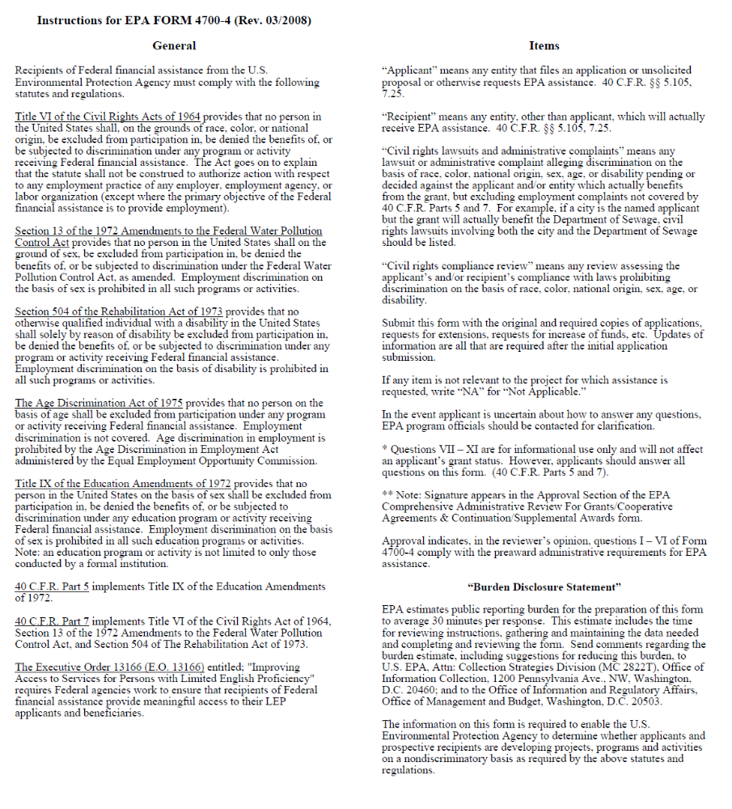
Section 6: Acquisition of Property by SRF Applicants
Note: Purchase of land typically is not eligible for the Clean Water SRF. Please check with your project manager to confirm.

U.S. ENVIRONMENTAL PROTECTION AGENCY
ASSURANCE WITH RESPECT TO REAL PROPERTY ACQUISITION
OF TITLE III OF THE UNIFORM RELOCATION ASSISTANCE AND REAL PROPERTY
ACQUISITION POLICIES ACT OF 1970 AS AMENDED

The (Applicant) hereby assures that it has authority under applicable State and local law to comply with Section 213 of the Uniform Relocation Assistance and Real Property Acquisition Policies Act of 1970, Public Law 91-646, 84 Stat. 1894 (42 U.S.C. 4601) as amended by the Surface Transportation and Uniform Relocation Assistance Act of 1987, Title IV of Public Law 100-17, 101 Stat. 246-256 (42 U.S.C. 4601 note) and 49 CFR 1.48(cc); and certifies, assures and agrees that, notwithstanding any other provision set forth in the application.

1. For projects resulting in the displacement of any person:

a. It will adequately inform the public of the relocation payments and services which will be available as set forth in Subparts A, C, D and E of 49 CFR 24.

b. It will provide fair and reasonable relocation payments to displaced persons as
required by Subparts D and E of 49 CFR 24.

c. It will provide a relocation assistance program for displaced persons offering
services described in Subpart C of 49 CFR 24.

d. Comparable replacement dwellings will be available pursuant to Subpart F of
49 CFR 24, or provided if necessary, a reasonable period in advance of the time any person is displaced.

e. In acquiring real property, it will provide at least 90 days written notice to each
lawful occupant of real property acquired, stating the date such occupant is required to move from a dwelling or to move his business or farm operation.

2. For projects resulting in the acquisition of real property:

a. It will fully comply with the requirements of Subpart B of 49 CFR 24.

b. It will adequately inform the public of the acquisition policies, requirements and
payments which apply to the project.

c. It will make every effort to acquire real property expeditiously through negotiation.

d. Before the initiation of negotiations it will have the real property appraised and give the owner or his representative an opportunity to accompany the appraiser during inspection of the property, except as provided in 49 CFR 24.102(c)(2).

e. Before the initiation of negotiations it will establish an amount which it believes to be just compensation for the real property, and make a prompt offer to acquire the property for that amount; and at the same time it will provide the owner a written statement of the basis for such amount in accordance with 49 CFR 24.102.

f. Before requiring any owner to surrender possession of real property it will pay the agreed purchase price; or deposit with the court, for the benefit of the owner, an amount not less than the approved appraisal of the fair market value of the property; or pay the amount of the award of compensation in a condemnation proceeding for the property.

g. If interest in real property is to be acquired by exercise of the power of eminent domain, it will institute formal condemnation proceedings and not intentionally make it necessary for an owner to institute legal proceedings to prove the fact of the taking of this real property; and

h. It will offer to acquire the entire property, if acquisition of only part of a property would leave its owner with an uneconomic remnant.

References to 49 CFR are citations to Title 49, Code of Federal Regulations, Part 24, published in the Federal Register Vol. 54, No. 40, March 2, 1989.

This document is hereby made part of and incorporated in any contract or agreement, or any supplements and amendments thereto, relating to the above-identified application and shall be deemed to supersede any provision therein to the extent that such provisions conflict with the assurances or agreements provided therein.

(Legal Name of Applicant)

By ____________________________________________
(Signature of Authorized Representative)

_____________________________________________
(Date)

Exhibit 9A

Iowa Department of Natural Resources

Wastewater Engineering Section

Preliminary Review of Antidegradation Alternatives Analysis

For situations where a DNR construction permit will be required for construction, installation or modification of a disposal system this document is intended to supplement Chapter 11 of the Iowa Wastewater Facilities Design Standards to satisfy the requirements of the Iowa Antidegradation Implementation Procedure. When a DNR construction permit will not be required this document may be used as guidance in development of an alternatives analysis to demonstrate compliance with Iowa’s antidegradation policy (567 IAC 61.2(2)). Where antidegradation applies and construction is required, DNR-approval of the antidegradation alternatives analysis is required prior to submittal of a facility plan.

- ____ Is the preferred alternative a non-degrading alternative as defined in the Iowa Antidegradation Implementation Procedure and agreed to by the DNR? If “yes”, the remainder of this checklist does not need to be completed.

- ____ Has the alternatives analysis been dated and certified by an engineer licensed to practice within the State of Iowa?

3. ____ Is an executive summary of the alternatives analysis provided including descriptions of the purpose(s) of the project and/or analysis, a summary of the results of the analysis and identification of the preferred alternative?

4. ____ Have public notification & intergovernmental coordination and review requirements as described in Sections 4.1 & 4.2 of the Iowa Antidegradation Implementation Procedure been fulfilled?

Public notice with 30-days notification and proof of publication

Public notice copied to applicable agencies (include date):

EPA Region VII
U.S. Fish & Wildlife Service
Iowa DNR Field Office
Industrial contributors, if applicable
County department of environmental health
Other state whose waters may be affected
Other interested parties

Summary of comments received and responsiveness summary
included?

5. ____ Are the existing and design wastewater flows and loadings for the planning period identified?

6. ____ Are the receiving stream network use designations and impairment status identified?

7. ____ Are the existing NPDES effluent limits and proposed effluent limits (based on both calculated numeric water quality criteria wasteload allocations and any applicable approved TMDL wasteload allocations) for all discharging alternatives identified?

8. ____ Are all pollutants of concern including the assigned Tier protection level for each POC identified?

9. ____ Alternatives and estimated present worth values:

Alt. No. | Description | Present Worth Value
1. |  | $
2. |  | $
3. |  | $
4. |  | $
5. |  | $
6. |  | $
7. |  | $
8. |  | $

10. ____ Were present worth values for annual operating costs developed using the discount rate published in the Federal Register per 18 CFR 704.39? One website that lists historic and current discount rates is http://www.economics.nrcs.usda.gov/cost/priceindexes/rates.html. Applicable rates are shown under the “WRDA 1974 Section 80(a)” heading and are for the Federal Fiscal Year (e.g., FY 2010 = 10/1/09 - 9/30/2010).

Discount Rate Used

11. ____ Classification and reasonableness of alternatives evaluated:

Alt. No. | BPCA, NDA or LDA? | Is the Alternative Reasonable?
Alt. No. | BPCA, NDA or LDA? | Practicable? | Economically Efficient? | Affordable? | Reasonable?
1.
2.
3.
4.
5.
6.
7.
8.

12. ____ Does the analysis include a description and schematic of each alternative evaluated?

13. ____ Does the analysis include a pollutant-by-pollutant comparison of degradation for each discharging alternative found to be reasonable?

14. ____ Preferred Alternative: ______________________________________

15. ____ Is the preferred alternative the least degrading reasonable alternative?

16. ____ For alternatives found to be practicable and economically efficient but not affordable, is the basis for the affordability determination explained and documented?

DNR Affordability Analysis worksheet included

17. ____ Is demonstration of the project Social and Economic Importance (SEI) included within the alternatives analysis?

Definitions

“Affordability” is an evaluation of the applicant’s ability to pay for a given alternative as described in Section 3.2 of the Iowa Antidegradation Implementation Procedure. Alternatives identified as practicable and economically efficient are considered affordable if the applicant does not provide an affordability analysis.

“Base Pollution Control Alternative” means the most cost-effective alternative necessary to meet the more stringent of technology-based state/federal effluent guidelines or water quality-based limits.

“Detailed Evaluation” or “Evaluated in Detail” as used in this document means an analysis of a pollution control alternative in terms of its practicability (including anticipated treatment/pollutant removal capability vs. anticipated effluent limitations, if applicable), economic efficiency and affordability.

“Economic Efficiency” is an evaluation of pollution control costs as described in Section 3.2 of the Iowa Antidegradation Implementation Procedure.

“Practicability” is the evaluation of a given alternative’s effectiveness, reliability and potential environmental impacts as described in Section 3.2 of the Iowa Antidegradation Implementation Procedure.

“Reasonable” means practicable, economically efficient and affordable.

“Screening Analysis” as used in this document means analysis of multiple pollution control alternatives that may include their practicability (including anticipated treatment/pollutant removal capability vs. anticipated effluent limitations, if applicable), economic efficiency and affordability. If the alternative is found not to be practicable then the analysis may exclude determinations of economic efficiency and affordability. Likewise, if the alternative is found to be practicable but not economically efficient, the analysis may exclude determination of affordability.

Acronyms

BPCA: The Base Pollution Control Alternative as defined above

LDA: Less-Degrading Alternative as defined in the Iowa Antidegradation Implementation Procedure

NDA: Non-Degrading Alternative as defined in the Iowa Antidegradation Implementation Procedure

POC: Pollutants of Concern as defined in the Iowa Antidegradation Implementation Procedure

Alternatives Considered

Alternatives including the Base Pollution Control Alternative (BPCA), non-degrading alternatives and less-degrading alternatives must be considered within the alternatives analysis.

- The alternatives analysis must identify and include a detailed evaluation of the BPCA.

- A screening analysis of NDAs as described in Section 3 of Iowa’s Antidegradation Implementation Procedure must be provided within the alternatives analysis.

All potentially practicable NDAs should be considered in the screening analysis. The analysis must clearly demonstrate that the NDAs are not reasonable for the department to consider allowing degradation to result from the proposed new or expanded discharge.

The applicant should be aware that further evaluation of any NDAs not evaluated within the alternatives analysis may be required as the result of DNR review.

- A screening analysis of LDAs as described in Section 3 of Iowa’s Antidegradation Implementation Procedure must be provided within the alternatives analysis. The analysis must explain how each LDA evaluated would reduce POC loading(s) to the receiving stream below levels that would be provided by the BPCA.

If more than one LDA is found to be reasonable, the alternative that results in the least degradation will be department’s preferred alternative.

The applicant should be aware that further evaluation of any LDAs not evaluated in detail within the alternatives analysis may be required as the result of DNR review.

Practicability, Economic Efficiency and Affordability

- The practicability of each alternative shall be evaluated. Potential factors affecting the practicability of any given pollution control method are generally described in Section 3.2 of the Iowa Antidegradation Implementation Procedure. Factors that may affect the practicability of a given alternative that are not enumerated in the Antidegradation Implementation Procedure must be clearly explained within the alternatives analysis and will be reviewed on a case-by-case basis.

- For alternatives found to be practicable, the economic efficiency shall be evaluated in terms of cost comparison as described in Section 3.2 of the Iowa Antidegradation Implementation Procedure.

3. For alternatives found to be both practicable and economically efficient, the affordability should be evaluated as described in Section 3.2 of the Iowa Antidegradation Implementation Procedure. If affordability is not evaluated for an alternative that is found to be both practicable and economically efficient, it will be assumed to be affordable.

Social and Economic Importance

Where the preferred alternative (the least degrading alternative that is reasonable) consists of the BPCA or an LDA, the applicant must demonstrate the Social and Economic Importance (SEI) of the project as described in Section 4.1 of the Iowa Antidegradation Implementation Procedure.

Exhibit 9B

Iowa Department of Natural Resources

Wastewater Engineering Section

Preliminary Review of Facility Plan Checklist

“Facility Plan” means a report certified by a professional engineer licensed to practice in Iowa and prepared in conformance with Chapter 11 of the Iowa Wastewater Facilities Design Standards. Those items highlighted below are minimum criteria for project submittals. A Facility Plan will not be required for non-funded minor sewer extensions, minor trunk and interceptor sewers and minor pump stations not included in comprehensive planning. Facility Plans may be returned if they are deemed incomplete by the Department.

The transmittal letter shall be bound in the report. Exhibit 9B may be used as a checklist and included in the Engineering Report or Facility Plan. This is highly recommended for all projects with compliance schedules or where other implementation schedules require timely completion of the initial stage of engineering services.

All Projects

1. _____ a project initiation meeting has been held to establish the scope of the project and project milestones.

2. _____ a project location and a recommended alternative has been proposed by the A/E and the conclusion accepted by the Owner in accordance with Step 17, Section 11.2 of the Iowa Wastewater Facilities Design Standards and Design Schedule A.

3. _____ completed and signed Design Schedules (A is required for all projects; A, F and G are required for new or expanded wastewater treatment plants) have been submitted in accordance with Section 11.1 of the Iowa Wastewater Facilities Design Standards.

4. _____ any proposed variation from the design standards contained in Chapter 64 is identified by the Engineer in accordance with Design Schedule A with justification provided to explain in accordance with DNR rules.

5. _____ all hydraulic and organic design loadings in Design Schedule G (as needed) and the Facility Plan are consistent with the preliminary design loadings concurred by the Department.

6. _____ the project has conformed to the Waste Load Allocation (WLA) determination and the effluent limits which have been established by the DNR through Steps 9, 11, 12, 13, and 14 of the wastewater construction permitting procedures.

7. _____ the location maps are prepared by the Engineer in accordance with Design Schedule F (dated April 2004), the recommended scale and provide all requested detail to conduct a site survey investigation for the proposed new or expanded wastewater treatment facilities.

8. _____ the Owner has filed an application for a new or amended NPDES permit as needed for the improvements described in the Facility Plan.

9. _____ a complete and achievable project implementation schedule has been provided identifying all project milestones in accordance with Section 11.2.5.3(k) of the Design Standards.

10. ____ the Appendix (Technical Information and Design Criteria) is provided per Design Standard 11.2.11.

11. ____ all required engineering data and design basis formulated from the data for New Process Evaluation has been approved by the Department under Section 14.4.3 and was prepared by a licensed professional engineer other than the one employed by the manufacturer or patent holder.

12. ____ a completed geotechnical investigation engineering report is provided as a supplement to the engineer’s report (required for lagoons).

13.____ where anti-degradation requirements apply, the recommended alternative is consistent with the anti-degradation alternatives analysis approved by the Department.

Additional questions (14 through 17) for Clean Water State Revolving Fund (CWSRF) Loan Projects

14. ____ the proposed project is a fundable category (Refer to Subrule 567 IAC 90.2) for receipt of a CWSRF loan.

15. ____ the Intended Use Plan application (Exhibit 8) is enclosed with the Facility Plan, including EPA Form 4700-4 and the “Assurance with Respect to Real Property Acquisition” form.

16. ____ the Property/Easement Acquisition Schedule is included.

17. ____ the Owner has submitted all required Exhibit 5 information to the Environmental Review Services Coordinator in order to initiate the SRF environmental review.

Conclusions:

Exhibit 10A

Iowa Department of Natural Resources

Wastewater Engineering Section

60 Percent Preliminary Plan and Specification

Submittal and Review Checklist

for Major Gravity Sewers and Sewer Force Mains

1. _______ Refer to Chapter 11 of the Iowa Wastewater Facilities Design Standards for submittal criteria, especially Sections 11.3 and 11.4.

2. _______ Are deviations (if any) from the project approved in the facility plan and approved design criteria noted? Has there been a change in project routing from the location in the approved facility plan? Will any variances from the design standards be required that have not already been approved?

3. _______ Submit all applicable Construction Permit Application Schedules. This will include Design Schedule A and could include Design Schedules B, C, D and E.

4. _______ Design Memorandum (if prepared).

5. _______ Geotechnical Report (if available).

6. _______ One set of Plan Drawings (half size where accepted by the review engineer or full size).

Title Sheet
Legend Sheet
Vicinity Map
Plan and Profile Sheets
Street Names
Ground Profile
Elevation Grade, Slope, Length, and Size of Sewers
Manhole Locations and Numbering System
Utilities
Streams
Manholes and Structural Details
Locations of Special Features

Exhibit 10B

Iowa Department of Natural Resources

Wastewater Engineering Section

60 Percent Preliminary Plan and Specification

Submittal and Review Checklist

for Major Wastewater Pumping Stations

1. _______ Refer to Chapter 11 of the Iowa Wastewater Facilities Design Standards for submittal criteria, especially Sections 11.3 and 11.4.

2. _______ Are deviations (if any) from the project approved in the facility plan and approved design criteria noted? Has there been a change in project routing from the location in the approved facility plan? Will any variances from the design standards be required that have not already been approved?

3. _______ Submit all applicable Construction Permit Application Schedules. This will include Design Schedules A and E and could include Design Schedule B.

4. _______ Design Memorandum, including Emergency Operation

5. _______ Geotechnical Report (if available)

6. _______ One set of Plan Drawings (half size where accepted by the review engineer or full size)

Title Sheet
Legend Sheet
Vicinity Map
Site Plan
Topography
Property Lines/Boundary Lines
100 Year and 25 Year Flood elevations if applicable
Structural Drawings
Architectural Drawings
Pumping Station Drawings (Existing and Proposed)
Unit Sizes
Piping, Valves and Force Main
Valve Chamber

7. _______ Technical Specifications for Major Process Equipment

Exhibit 10C

Iowa Department of Natural Resources

Wastewater Engineering Section

60 Percent Preliminary Plan and Specification

Submittal and Review Checklist

for Wastewater Treatment Facilities

1. _______ Refer to Chapter 11 of the Iowa Wastewater Facilities Design Standards for submittal criteria, especially Sections 11.3 and 11.4.

2. _______ Are deviations (if any) from the project approved in the facility plan and approved design criteria noted? Has there been a change in project site from the location in the approved facility plan? Will any variances from the design standards be required that have not already been approved?

3. _______ Submit all applicable Construction Permit Application Schedules. This submittal is not limited to Design Schedules A, F, and G.

4. _______ Design Memorandum, including Facility, Unit Process, and Power Source Reliability Classifications (if prepared).

5. _______ Geotechnical Report (required for lagoons).

6. _______ One Set of Plan Drawings (half size where accepted by the review engineer or full size).

Title Sheet
Legend Sheet
Vicinity Map
Site Plan with Process Piping
Topography
Unit Process and Building Locations (existing and proposed)
Property Lines/Boundary Lines/Borrow Areas
100 Year and 25 Year Flood Elevations if applicable
Area for Future Expansion
Hydraulic Profile/Schematic Flow Diagram
Minimum, average, and peak hydraulic profiles
Flow of sewage, supernatant liquor and sludge
Structural Drawings
Architectural Drawings
Process Drawings and Piping
Unit Sizes
Location
7. _______ Technical Specifications for Major Process Equipment

Exhibit 11A
Iowa Department of Natural Resources Wastewater Engineering Section
Construction Permit Application

SCHEDULE A, General Information
APPLICANT |  |  |  |  | ENGINEER
OWNER E-MAIL ADDRESS |  |  |  |  | FIRM E-MAIL ADDRESS
ADDRESS |  |  |  |  | ADDRESS
REPRESENTATIVE TELEPHONE |  |  |  |  | PROJECT OFFICER TELEPHONE
PROJECT IDENTIFICATION |  |  |  | ESTIMATED START DATE * |  |  |  |  | ESTIMATED COMPLETION DATE
PLEASE RESPOND TO ALL QUESTIONS |  |  |  |  |  |  |  |  |  | YES NO
1. Has an engineering report, facilities plan or other information previously been submitted for this project?
If Yes=> |  | PROJECT IDENTITY |  |  |  |  | DATE SUBMITTED
2. Does the project and construction permit application, as submitted, follow the recommendations, design
loadings, construction schedule, permit limits, and conclusions of the approved engineering report or
facilities plan?
If No=> Provide the design basis and technical information justifying all changes.
3. Are there three complete sets of plans and specifications accompanying this application?
For a minor gravity sewer extension within the meaning of 455B.183.3 Code of Iowa and Design
Standard 11.1, two complete sets will be adequate for expeditious approval. For more complex projects,
three sets of plans and specifications may be requested.
4. Are approved standard specifications a part of this application?
If Yes=> |  |  | APPROVED STANDARD SPECIFICATIONS OF  (municipality or firm) |  |  |  |  | DATE APPROVED
5. Does each set of plans and specifications or engineering report accompanying this application contain a
“professional engineering seal” executed in conformance with 542B.16, Code of Iowa?
If No=> Processing will be delayed pending receipt of applicable design schedules and certified plans,
specifications or engineering report.
- Is this a joint wastewater and water supply project?

If Yes=> A construction permit application for the water supply project should be submitted separately to the
Water Supply Section. A water supply permit fee may be required.
- Is the applicant to provide treatment of effluent resulting from this construction?

If No=> A Sewage Treatment Agreement (DNR Form 29) executed by the authority providing treatment must
accompany this application.
- Is a new or amended operation permit necessary to use the facilities described in this application?
If Yes=> A new or amended permit to operate may be requested prior to the receipt of a construction permit.
- Is any waterline located within 10 feet; or any private or public well, lake, or public recreation area located
within 400 feet of the proposed construction?
If Yes=> Identify and locate the facility(s) relative to the proposed construction.
10. Will construction inspection be conducted by a licensed engineer employed by the applicant?
If No=> | NAME OF ENGINEERING FIRM CONDUCTING INSPECTION
11. Will this project utilize CWSRF loan funds?

CERTIFICATION
APPLICANT  I certify that I am the authorized representative of the owner and  state that the project identified above is approved by the owner. |  |  |  |  |  | ENGINEER  I certify that all aspects of design included in this application conform to applicable standards contained in Chapter 567 IAC 64, or that an explanation and justification for any proposed variations from such standards is attached. I am familiar with the  information contained in this application, and to the best of my  knowledge, such information is complete and accurate.
SIGNATURE DATE |  |  |  |  |  | SIGNATURE DATE
* Estimated Construction Start Date: Complete applications must be submitted at least 120 days in advance of the date for
starting construction in accordance with Rules 567 IAC 60.4 and 64.2

PLEASE COMPLETE THE SCHEDULE CHECKLIST ON THE FOLLOWING PAGE OF THIS FORM
DNR form 28A (Sept 2010) 542-3129

Construction Permit Application

SCHEDULE A, General Information, page 2

DOCUMENT CHECKLIST
Identify all categories included in this project. Also, identify schedules attached to this application.
SCHEDULE | TITLE | ATTACHED | INCLUDED IN  PROJECT | SUBMITTAL  DATE
B | Collection system
C | Lateral Sewer Extension
D | Trunk & Interceptor Sewer
E | Wastewater Pump Station
F | Treatment Project Site Selection
G | Treatment Project Design Data
H1 | Schematic Flow Diagram
H2 | Treatment Process Loading and  Removal Efficiency
H3 | Mechanical Plant Reliability
I | Screening, Grit Removal and Flow  Measurement
J | Septic Tank System
K1 | Controlled Discharge Pond
K2 | Aerated Pond
K3 | Anaerobic Lagoon
L | Setting Tanks
M | Fixed Film Reactor – Stationary Media
N | Rotating Biological Contactor
O | Aeration Tanks or Basins
P | Gas Chlorination
Q | Sludge Digestion and Holding
R1 | Sludge Dewatering and Disposal
R2(A & B) | Low Rate Land Application of Sludge
R3 | Land Application of Sewage Sludge  (To be developed)
S | Land Application of Wastewater  (To be developed)
 | Sewage Treatment Agreement
Identify any categories included in this project which are not provided in the above list of schedules.

DNR form 28A (Sept 2010) 542-3129

Exhibit 11B
Iowa Department of Natural Resources Wastewater Engineering Section
Construction Permit Application

SCHEDULE F, Treatment Project Site Selection
DATE PREPARED |  |  |  | PROJECT IDENTITY |  |  |  |  |  |  |  |  |  |  |  |  |  |  |  |  |  |  |  |  |  |  |  |  |  |  |  |  |  |  |  |  |  |  | DNR USE
 |  |  |  |  |  |  |  |  |  |  |  |  |  |  |  |  |  |  |  |  |  |  |  |  |  |  |  |  |  |  |  |  |  |  |  |  |  |  | PROJECT NO.
DATE REVISED

 |  |  |  |  |  |  |  |  |  |  |  |  |  |  |  |  |  |  |  |  |  |  |  |  |  |  |  |  |  |  |  |  |  |  |  |  |  |  | PERMIT NO.
1. Project Location: County |  |  |  |  |  |  |  |  |  |  |  |  |  |  | Section |  |  |  |  |  |  |  |  |  |  |  | Township |  |  |  |  |  |  |  |  |  |  | Range
Is this a new site? |  |  |  |  |  |  |  |  |  |  |  | Existing site? |  |  |  |  |  |  |  |  |  |  |  |  |  | or Expansion of existing site?
2. Provide the following as attachments (minimum of three each needed):
(a) General plat layout of area within a five mile radius of the project, noting all important features.
(U.S.G.S. map may be used).
- Site layout of area within a 1,500 foot radius of the project with a scale of approximately 1 inch equal to 200 feet, noting project and all features listed in Subrule 567 IAC 64.2(3): inhabitable residences, commercial buildings, inhabitable structures, public shallow wells, public deep wells, private wells, lakes and public impoundments, property lines and rights-of-way, etc.

3. Does the project lie in a floodplain? Yes No
Elevation of 100 year flood (MSL) |  |  |  |  |  |  |  |  |  |  |  |  |  |  |  |  |  |  |  |  |  |  | Elevation of 25 year flood (MSL)
Will the treatment works structures, including the electrical and mechanical equipment, be protected from physical damage by
the 100-year flood? Yes No
Will the plant remain operational during the 25-year flood? Yes No
Method of flood protection
4. Minimum distance to high water table
5. Describe geology of area
6. Describe soil conditions
7. State the minimum distances and direction to:
(a) Public shallow wells |  |  |  |  |  |  |  |  |  |  |  |  |  |  |  | (b) Public deep wells
(c) Private wells
(d) Inhabitable residences, commercial buildings, or other inhabitable structures
(e) Lakes and public impoundments
(f) Property lines and rights-of-way |  |  |  |  |  |  |  |  |  |  |  |  |  |  |  |  |  |  |  |  |  |  |  | (g) Other
8. Direction of the prevailing winds
9. Sulfate content of the raw water supply source |  |  |  |  |  |  |  |  |  |  |  |  |  |  |  |  |  |  |  |  |  |  |  |  | mg/l. Identify source
10. Is this area available for expansion? Yes No |  |  |  |  |  |  |  |  |  |  |  |  |  |  |  |  |  |  |  |  |  | If yes, how much?
Location of area |  |  |  |  |  |  |  |  |  |  |  |  |  |  |  |  |  |  |  |  | Identify owner of property
11. Will site be accessible via an all weather access road? Yes No Type
12. Source of STP water supply:
Maintenance/Cleanup |  |  |  |  |  |  |  |  |  |  |  |  |  |  |  |  |  |  |  |  |  | Potable? Yes No
Laboratory/Sanitary |  |  |  |  |  |  |  |  |  |  |  |  |  |  |  |  |  |  |  |  |  | Potable? Yes No
 |  |  |  |  |  |  |  |  |  |  |  |  |  |  |  |  |  |  |  |  |  | Potable? Yes No
13. Receiving Stream |  |  |  |  |  |  |  |  |  |  |  |  |  |  |  |  |  |  |  |  |  |  |  |  | tributary to
7-day 10-year Low Flow |  |  |  |  |  |  |  |  |  |  |  |  | cfs. Source of stream flow data
Drainage area above site |  |  |  |  |  |  |  |  |  |  |  |  | square miles
Is stream |  |  | intermittent |  |  |  |  |  |  |  |  |  |  |  |  |  |  |  |  |  | continuous flow (perennial)
Describe use designation of receiving stream

Instructions for Schedule F

1. Identify the project and location.

- Important features which include public shallow wells, public deep wells, private wells,
inhabitable residences, commercial buildings, or other inhabitable structures, lakes, public
impoundments, and other public use or recreation areas, property lines, and rights-of-way,
and any other feature affected by the water quality shall be included on the 1500 foot radius site
layout.

- Completely describe any adverse impact on the treatment facility caused by high water.

- Indicate minimum distance to typical wet weather groundwater level.

- Self-explanatory.

- Self-explanatory.

- See subrule 567 IAC 64.2(3) of the Iowa Administrative Code for the required separation distances.
When the separation distances in the referenced subrule cannot be maintained for the expansion,
upgrading or replacement of existing facilities, the separation distances shall be maintained at no less
than 90 percent of the existing separation distance on the site, providing no data is available indicating
that a problem has existed or will be created. If requesting the 90 percent exception, the proposed
separation distance from each potentially affected item or structure shall be identified on Schedule F
or an attachment to the form.

- Self-explanatory.

- Self-explanatory.

- Self-explanatory.

- Self-explanatory.

- Self-explanatory.

- Self-explanatory.

NOTE: Complete a separate Schedule F for each separate project site.

Exhibit 11C
Iowa Department of Natural Resources Wastewater Engineering Section
Construction Permit Application

SCHEDULE G, Treatment Project Design Data
DATE PREPARED |  |  | PROJECT IDENTITY |  |  |  |  |  |  |  |  |  |  |  |  |  |  |  |  |  |  | DNR USE
 |  |  |  |  |  |  |  |  |  |  |  |  |  |  |  |  |  |  |  |  |  | PROJECT NO.
DATE REVISED

 |  |  |  |  |  |  |  |  |  |  |  |  |  |  |  |  |  |  |  |  |  | PERMIT NO.
1. Project Description
2. |  | Design Flows |  |  | Present Year ( ) |  |  |  |  |  |  |  |  | Design Year ( )
Design Condition → |  |  |  |  | AWW  (MGD) |  |  |  | MWW  (MGD) |  |  |  |  | AWW  (MGD) |  |  |  |  |  | MWW  (MGD)
Domestic/Commercial Flow
Industrial
Flow
Rated Flow
Other Flow (specify)
Infiltration/Inflow
Total
Flow
Rated Flow
Average Dry Weather Flow (ADW):  MGD (present year)  MGD (design year) |  |  |  |  | Peak Hourly Wet Weather Flow (PHWW):  MGD (present year)  MGD (design year) |  |  |  |  |  |  |  |  | Demographic Data:  Population (present year)  Population (design year)
3. |  | Organic Design Loadings |  |  | Present Year ( ) |  |  |  |  |  |  |  |  | Design Year ( )
Design Condition→ |  |  |  |  | Max. 30 day  (#/day) |  |  |  | Max. Day  (#/day) |  |  |  |  | Max. 30 day  (#/day) |  |  |  |  |  | Max. Day  (#/day)
Domestic/Commercial |  |  | BOD5
 |  |  | TSS
 |  |  | TKN
Industrial |  |  | BOD5
 |  |  | TSS
 |  |  | TKN
Other (Specify) |  |  | BOD5
 |  |  | TSS
 |  |  | TKN
Total |  |  | BOD5
 |  |  | TSS
 |  |  | TKN
4. Effluent Limitations |  |  |  |  | BOD5 |  |  |  | TSS |  |  | NH3-N  (most stringent month) |  |  |  |  | Other |  |  |  |  |  | Other
 |  |  |  |  | Avg |  | Max |  | Avg |  | Max | Avg |  |  | Max |  | Avg |  | Max |  |  |  | Avg |  | Max
 | Operation Permit  Effluent Limits* |  | mg/l
 |  |  | #/day
*Date of Waste Load Allocation (WLA) determination:
5. Major Industrial/Commercial contributors or Significant Industrial User:
Waste  Contributors |  |  |  | Pre-  Treat  (Y/N) | Operation |  |  | Design Loadings
 |  |  |  | Pre-  Treat  (Y/N) |  |  |  | Flow |  |  |  | BOD5  #/day |  |  |  | Susp.  Solids  #/day |  | TKN  #/day |  |  | Oil &  Grease  #/day |  |  | #/day
 |  |  |  | Pre-  Treat  (Y/N) | Hrs/  Day | Days/Week |  | Ave.  MGD |  | Max.  MGD

Instructions for Schedule G

- Project Description: Explain the nature of the project in a concise statement.

- Design Year: The design year shall be established in accordance with Section 14.4.4.1 of the Iowa Wastewater Facilities Design Standards.

Domestic/Commercial: Includes waste volumes generated from residential, out of town students, and commercial contributors.

Industrial: Includes waste volumes generated from industrial contributors.

Other: If applicable, includes waste volumes generated from any other contributors such as: large commercial establishments, correctional institutions, hospitals, large restaurants, shopping centers, truck stops, or any other facility not covered under previous items. The design information for these facilities shall be given in Item 5.

Infiltration: Includes water other than wastewater that enters the sanitary sewer system from the ground through defective pipe, pipe joints, and manholes.

Inflow: Includes water other than wastewater that enters a sanitary sewer system from sources such as roof drains, foundation drains, yard drains, manhole covers, cross connections between storm sewers and sanitary sewers, catch basins, storm water runoff and other drainage structures.

Average Dry Weather (ADW) Flow: The daily average flow when the groundwater is at or near normal and runoff is not occurring. The period of measurement and reporting for this flow should extend for up to 30 days.

Average Wet Weather (AWW) Flow: The daily average flow for the wettest thirty (30) consecutive days for mechanical plants or the wettest 180 consecutive days for controlled discharge lagoons. The respective wettest consecutive (30 and 180) day flows may or may not coincide with precipitation events.

The design of new wastewater systems to serve new collection systems shall be based on an average wet weather flow of 100 gallons per capita per day for residential and commercial flow. If applicable, add 20 gallons per capita per day for out-of-town students + industrial flows + large commercial operations.

Maximum Wet Weather (MWW) Flow: The total maximum flow received during any 24 hour period. The MWW flow may or may not coincide with precipitation events. This column is not applicable to controlled discharge pond facilities.

Peak Hourly Wet Weather (PHWW) Flow: The total maximum flow received during one hour of the day when the groundwater is high, runoff is occurring, and domestic, commercial, and industrial flows are at their peak. The domestic and commercial peak hour flow shall be based on actual monitoring or the use of peaking factor determined by the use of Appendix I, Chapter 12 of the Iowa Wastewater Facilities Design Standards.

The PHWW flow shall be used to evaluate the effect of hydraulic peaks on the design of pumps, piping, clarifiers, and any other flow sensitive aspects.

Rated Flow: Flows from industrial and commercial sources may vary significantly during a day, a week, or 30-days due to production patterns. In designing a facility, the flow rate which occurs during the time period of discharge must be considered. This flow rate is defined as rated flow. The purpose of the rated flows is to use them in designing mechanical plants so that they are capable of handling the higher flows during the period of discharge.

Rated Flow (AWW): For mechanical plants, if the industrial contribution varies from week to week during a month, the design flow should be based on the average flow on the days when the industry is operating. This is reported as rated AWW flow. For example, if the industry operates 20 days of the 30-day month and has an average discharge of 100,000 gallons per day in a 30-day period, the rated AWW flow is 150,000 gallons per day. The design of mechanical plants must be based on the total rated flow.

Rated Flow (MWW): For mechanical plants, if the industrial contribution varies from day to day during a week, the design flow should be based on the average flow on the peak day during the period when the industry is operating. This is reported as rated MWW flow. For example, if the industry discharges of 10,000 gallons over eight hours of the twenty-four hours, the rated MWW flow is 30,000 gallons per day. The design of mechanical plants must be based on the total rated flow.

For Controlled Discharge Ponds: If the industrial contribution varies from day to day during a week, the design condition may be based on a weekly average. Rated AWW flow and rated MWW flow are not applicable to this method of treatment.

- Organic Design Loadings: When an existing treatment works is to be upgraded or expanded, the organic design (BOD₅, TSS, and TKN) shall be based upon the actual strength of wastewater as determined from actual measurements with an increment for growth. This growth increment shall be based on the design criteria for new systems stated below or based on the analysis of available monitoring data. The industrial loadings shall be in accordance with Section 14.4.6.2 of the Iowa Wastewater Facilities Design Standards.

Max. 30-day: The highest average organic loading received in a 30-day period.

Max. Day: The highest daily organic loading received during a 24-hour day.

Domestic waste treatment design to serve new collection systems shall be based on the basis of at least 0.17 pounds of BOD₅ per capita per day, 0.20 pounds of TSS (total suspended solids) per capita per day. Although not specified in the Design Standards, design TKN loading should be included in Schedule G. TKN loading criteria for domestic wastewater can be found in references such as Wastewater Treatment and Reuse, Metcalf & Eddy, 4th Edition; and Table 2, Recommended Standards for Wastewater Facilities, 2004 Edition.

When garbage grinders are used in areas tributary to a domestic plant, the design basis should be increased to 0.22 pounds of BOD₅ per day and 0.25 pounds of suspended solids per capita per day. Use references previously listed for TKN loading.

- Effluent Limitations: Specify the effluent limitations that are issued by the Department in accordance with Section 14.3 of the Iowa Wastewater Facilities Design Standards. Specify the date of the most recent Waste Load Allocation (WLA) prepared by the Department. Please bear in mind that the NPDES Permit limits could be different from those in the WLA in certain cases. The NPDES Permit shall determine the final effluent limits that the facility is expected to meet.

NH3-N (most stringent month): List the most stringent numerical concentration and mass limit for a month listed in the WLA or NPDES permit (if water quality based limits apply to the treatment facility).

Other: List any other parameter limitations listed in the WLA or the NPDES permit (e.g. heavy metals).

- Major Industrial Commercial Contributors: Provide design information for all major industrial/commercial contributors in accordance with Subrule 567 IAC 60.2 (455B). Do not list production flows and loadings in this Section. List only the flows and loadings that will be received by and treated by the proposed wastewater treatment works under consideration. A “major industrial/commercial contributor” is a user of a treatment works that:

  - Has a flow of 50,000 gallons or more per average workday.
  - Has a flow greater than 5% of the flow or organic loading carried by the treatment works receiving the waste.
  - Has in its waste a toxic pollutant in toxic amounts as defined in Standards and adopted by reference in Subrule 567 IAC 62.5 (455B).
  - Is found by the Department in connection with the issuance of the NPDES Permit to have a significant impact, either singly or in combination with other contributing industries, on that treatment works or upon the quality of the effluent from that treatment works.

Significant Industrial User: Provide design information for all significant industrial users in accordance with Federal Effluent and Pretreatment Standards as referenced in Subrule 567 IAC 62.4(3) (455B). Significant industrial user means:

- All industrial users subject to Categorical Pretreatment Standards under 40 CFR 403.6 and 40 CFR Chapter I, subchapter N; and
- Any other industrial user that discharges an average of 25,000 gallons per day or more of process wastewater to the POTW (excluding sanitary, non-contact cooling and boiler blowdown wastewater); contributes a process wastestream which makes up 5 percent or more of the average dry weather hydraulic or organic capacity of the POTW treatment plant; or is designated as such by the Control Authority as defined in 40 CFR 403.12(a) on the basis that the industrial user has a reasonable potential for adversely affecting the POTW’s operation or for violating and pretreatment standard or requirement (in accordance with 40 CFR 403.8(f)(6)).

Specify any other major parameters present in the waste contribution. If pretreatment is provided, answer “Y” for Yes in the second column; if pretreatment is not provided, answer “N” for No. Note that operation time includes time allocated to clean-up. For mechanical plants, if the industry’s contribution varies from day to day during a week, the design loading should be based on a maximum day when the industry is operating and the industrial flows must be rated in accordance with the time period of discharge of such flows in arriving at the total rated flow.

Refer to DNR Form 31 – Operating Permit Application - Treatment Agreement that can be found at http://www.iowadnr.com/water/npdes/forms/form31a.pdf.

Average Flow: Represents the maximum 30-day average likely to occur in any year. Days when no discharge occurs should not be included in the average.

Maximum Flow: is the maximum single-day contribution during a peak period of operation.

List of References:

- Iowa DNR Wastewater Facilities Design Standards.
- Recommended Standards for Wastewater Facilities, Great Lakes-Upper Mississippi River Board of State and Provincial Public Health and Environmental Managers, 2004 Edition.
- Design of Municipal Wastewater Treatment Plants, WEF Manual of Practice 8.
- Wastewater Engineering Treatment and Reuse, Metcalf & Eddy 4th Edition.
- Gravity Sewer Design and Construction, Chapter 2 - Quantity of Wastewater, WEF Manual of Practice No. FD-5.
- Existing Sewer Evaluation and Rehabilitation, WEF Manual of Practice FD-6.
- Historical rainfall information available from the State Climatologist at http://mesonet.agron.iastate.edu/climodat/index.phtml.

Things to Consider - Design Flows and Organic Loading Determination:

- Have a rational basis and list the basis in the design flow and loading calculation submittal.
- Include previous bypassing flows when estimating present year and design year flows.
- Consider the reliability of operating records and degree of accuracy of flow monitors and data.
- Use daily and monthly monitoring reports from the facility.
- Compare water use records where appropriate and identify correlations.
- Consider installation of continuous flow monitoring and recording equipment where appropriate (lift stations, influent channels, etc.) to determine peak hour flows.
- Consider additional flow monitoring after installation of new equipment.
- Consider several years of reported data when calculating design flows.
- Use the actual facility monitoring data to calculate design flow and loadings as much as possible.
- Careful consideration of drought years when estimating design flows.
- Infiltration/inflow reduction cannot be suggested without valid data to support the assumptions.
- Elimination of inflow sources cannot be assumed to reduce infiltration.
- Design flows lower than the monitoring and reported data cannot be suggested without documented evidence and a valid explanation.

Contact: Please contact Satya Chennupati, P.E. at 515-281-8995 or satya.chennupati@dnr.state.ia.us if you have any questions or comments regarding Schedule G or the instructions.

Exhibit 12
Instructions for Compliance with SRF Cross-Cutters
Bidding and Procurement Process
With Davis-Bacon Requirements

Several cross-cutters are included in the bidding and procurement process.
The process is explained in depth in Steps 42-49 in this manual. The process
is summarized below:

- Owner/Consultant includes SRF front-end documents in construction specifications. Exhibit 12A: Required SRF Front-End Specifications is designed as a packet to be placed directly into construction documents.
Cross-cutting federal authorities are requirements of federal laws and executive orders that apply in federal financial assistance programs. They’re called cross-cutters because they cut across programs due to the federal funding source. Because the Iowa SRF is capitalized by federal grants, federal cross-cutters apply to wastewater and drinking water projects.

Many of the cross-cutters relate to the environmental review process, which is discussed elsewhere in this manual. Two other forms are included with the Intended Use Plan application (Exhibit 8 in this manual).

- Owner/Consultant submits construction specifications to DNR Project Manager with construction permit application.

- DNR Project Manager reviews and approves construction application and specifications and issues construction permit.

- Owner bids project using approved construction specifications and following State of Iowa requirements. Owner also follows the DBE Good Faith Efforts (discussed below).

- Bidders submit bid materials to Owner.

- Owner accepts bid proposal.

- Consultant prepares bid document packet (using checklist in Exhibit 13) and submits it to SRF for concurrence in bid award.

The award concurrence letter must be completed before SRF loan funds can be disbursed, along with the items listed below:

- DNR construction permit
- CX or FNSI
- SRF loan application
- Signed loan agreement

On the following pages, a table provides a brief explanation of each of the cross-cutters addressed in the bidding and procurement process. SRF borrowers comply with these cross-cutters by:

- Following the DBE Good Faith Efforts in procuring prime contractors; and
- Including Exhibit 12A in construction front-end specifications. Several attachments in Exhibit 12A are forms that must be signed by bidders and returned to SRF with the bid document packet.

Cross-Cutter | Purpose | How to Comply | Source
Prevailing wages | To comply with labor standards in the Davis-Bacon Act | - Owner uses Exhibit 12A: Required SRF Front-End Specifications - STIMULUS | - American Recovery and Reinvestment Act of 2009
Civil rights | To prohibit segregation in work facilities | - Owner uses Exhibit 12A: Required SRF Front-End Specifications  - Owner must require bidders to sign and submit Attachment 1: Certification of Non-Segregated Facilities  - Owner/Consultant includes signed Attachment 1 in bid document packet sent to SRF | - 33 Federal Register 7808
Debarment and suspension | To curb fraud and abuse in federal government programs | - Owner uses Exhibit 12A: Required SRF Front-End Specifications  - Owner must require bidders to sign and submit Attachment 2: Certification Regarding Debarment, Suspension  - Bidders using subcontractors must also require them to sign and submit Attachment 2  - Owner/Consultant includes signed Attachment 2 in bid document packet sent to SRF | - Executive Order 12549
Non-discrimination in employment and disadvantaged business enterprises | To commit assistance recipients, contractors and subcontractors to refrain from discrimination in its treatment of employees and to increase the participation of disadvantaged business enterprises, such as those owned by women and minorities, as well as small businesses in rural areas, in contracts awarded by state and local recipients of federal assistance | - Owner must follow DBE Good Faith Efforts (discussed below) in procuring prime contractors  - Owner must require bidders to document their good faith efforts to use disadvantaged business enterprises on Attachment 4: DBE Solicitation  - Bidders and their subcontractors complete forms on Attachments 5 and 6 providing information about their business arrangements  - Owner/Consultant includes completed and signed Attachments 4, 5, and 6 in bid document packet sent to DNR | - Executive Orders  11625, 11246, 12138, and 12432  - 40 CFR Part 31.36 (e)  - 41 CRF Part 60-4  - Section 129 of the Small Business Administration Reauthorization and Amendment Act of 1988 (P.L. 100-5909)  - Public Law 102–389 (42 U.S.C. 4370d)  - Public Law 101–549, Title X of the Clean Air Act Amendments of 1990 (42 U.S.C. 7601 note)

Neutrality in contracts | To preserve open competition and government neutrality regarding labor relations in contracting | - Owner uses Exhibit 12A: Required SRF Front-End Specifications  - Owner checks bid specifications, project agreements, and other documents for construction contracts to ensure that they do not require or prohibit agreements with labor organizations | - Executive Order 13202 as amended by Executive Order 13208
Historical and archeological | To ensure that contractors stop work if historical or archeological materials are found | - Owner uses Exhibit 12A: Required SRF Front-End Specifications | - National Historic Preservation Act  - 36 CFR Part 800.11
Prohibitions on procurement from Clean Air or Clean Water Act violators | To prohibit federal assistance or contracts going to facilities or suppliers that are listed as Excluded Parties | - Owner uses Exhibit 12A: Required SRF Front-End Specifications  - Owner checks to make sure that winning bidders are not on Excluded Parties list. Web site:  http://epls.arnet.gov/. | - Section 306 of the Clean Air Act  - Section 508 of the Clean Water Act  - Executive Order 11738

Davis-Bacon Prevailing Wages
Please contact Lori Beary at the Iowa Finance Authority (lori.beary@iowa.gov or 515-725-4965) to obtain wage determinations for your project.

The Davis-Bacon and Related Acts, apply to contractors and subcontractors performing on federally funded or assisted contracts in excess of $2,000 for the construction, alteration, or repair (including painting and decorating) of public buildings or public works. Davis-Bacon Act and Related Act contractors and subcontractors must pay their laborers and mechanics employed under the contract no less than the locally prevailing wages and fringe benefits for corresponding work on similar projects in the area. The Davis-Bacon Act directs the Department of Labor to determine such locally prevailing wage rates. The Davis-Bacon Act applies to contractors and subcontractors performing work on federal or District of Columbia contracts. The Davis-Bacon Act prevailing wage provisions apply to the “Related Acts,” under which federal agencies assist construction projects through grants, loans, loan guarantees, and insurance.
For prime contracts in excess of $100,000, contractors and subcontractors must also, under the provisions of the Contract Work Hours and Safety Standards Act, as amended, pay laborers and mechanics, including guards and watchmen, at least one and one-half times their regular rate of pay for all hours worked over 40 in a workweek. The overtime provisions of the Fair Labor Standards Act may also apply to DBA-covered contracts.
Under the Davis-Bacon and Related Acts (DBRA), covered contractors must maintain payrolls and basic records and submit certified weekly payrolls. Although use of Form WH-347 is optional, the form will satisfy the requirements of Regulations, Parts 3 and 5 (29 CFR, Subtitle A), as to payrolls submitted in connection with contracts subject to the DBRA. Records to be maintained include:
- Name, address, and social security number of each employee;
- Each employee's work classification(s);
- Hourly rate(s) of pay (including rates of contributions or costs anticipated for bona fide fringe benefits or cash equivalents thereof);
- Daily and weekly numbers of hours worked;
- Deductions made; and
- Actual wages paid.

Disadvantaged Business Enterprise Good Faith Efforts
The Good Faith Efforts are methods employed by all EPA financial assistance recipients to ensure that disadvantaged business enterprises (DBEs) have the opportunity to compete for procurements funded by EPA financial assistance funds (including SRF loans).

DBEs must be certified through the Iowa Department of Transportation (IDOT). Information on certification requirements and a list of certified DBEs is on the IDOT website at http://www.iowadot.gov/contracts/contracts_eeoaa.htm.

SRF loan recipients must:

1. Ensure that DBEs are made aware of contracting opportunities to the fullest extent practicable through outreach and recruitment activities.

2. Make information on forthcoming opportunities available to DBEs and arrange time frames for contracts and establish delivery schedules, where the requirements permit, in a way that encourages and facilitates participation by DBEs in the competitive process. This includes, whenever possible, posting solicitation for bids or proposals for a minimum of 30 calendar days before the bid or proposal closing date.

3. Consider in the contracting process whether firms competing for large contracts could subcontract with DBEs. This will include dividing total requirements, when economically feasible, into smaller tasks or quantities to permit maximum participation by DBEs in the competitive process.

4. Encourage contracting with a consortium of DBEs when a contract is too large for one of these firms to handle individually.

5. Use the services of the Small Business Administration and the Minority Business Development Agency of the Department of Commerce. Both SBA and MBDA provide various means to help identify WBE and MBE firms to include in any promotion of contracting opportunities. SBA has a local office in Des Moines and contact info can be found at www.sba.gov. MBDA has a regional office in Chicago covering Iowa, and various resources available online at www.mbda.gov.

6. If the prime contractor awards subcontracts, require the prime contractor to take the steps in paragraphs 1-5 above.

7. Require the prime contractor to pay its subcontractor for satisfactory performance no more than 30 days from the prime contractor’s receipt of payment from the recipient.

8. Require prime contractor to notify recipient in writing prior to termination of a DBE subcontractor for convenience.

9. Require the prime contractor to employ the six Good Faith Efforts to solicit a replacement subcontractor if a DBE subcontractor fails to complete work under a subcontract for any reason.

10. Include the following language in each procurement contract funded through an SRF loan:

“The contractor shall not discriminate on the basis of race, color, national origin or sex in the performance of this contract. The contractor shall carry out applicable requirements of 40 CFR part 33 in the award and administration of contracts awarded under EPA financial assistance agreements. Failure by the contractor to carry out these requirements is a material breach of this contract which may result in the termination of this contract or other legally available remedies.”

State of Iowa Bidding Requirements
Projects receiving assistance through the State Revolving Fund must follow State of Iowa law on bidding. Effective January 1, 2007, a new Iowa Code Chapter 26 covers public construction bidding. This chapter includes:

- Definitions of projects and governmental entities;
- Exemptions to competitive bidding;
- Prohibited contracts;
- Notice to bidder requirements;
- Bid security;
- Award of contract;
- Bid-opening;
- Public hearing requirements; and
- Dollar thresholds for when competitive bidding is required.

Public borrowers are responsible for ensuring that they have complied with all applicable State of Iowa requirements. The Iowa League of Cities has information and resources on their web site at: http://www.iowaleague.org.

Exhibit 12A
SRF Required Front-End Specifications
With Davis-Bacon Requirements

Attachment 1: Certification of Non-Segregated Facilities Form
(to be completed and signed by Prime Contractor and
submitted with the bid)

Attachment 2: Statement in Advertisement for Bids on Debarment and Suspension/Certification Regarding Debarment and
Suspension Form (to be completed and signed by Prime Contractor and submitted with the bid)

Attachment 3: Disadvantaged Business Enterprise Certification Form (to be completed and signed by Prime Contractor and submitted with the bid)

Attachment 4: DBE Program Subcontractor Performance Form (to be completed and signed by DBE Subcontractor and submitted with the bid)

Attachment 5: DBE Program Subcontractor Utilization Form (to be completed and signed by Prime Contractor and submitted with the bid)

Attachment 6: DBE Program Subcontractor Participation Form

Attachment 7: Other Federal Requirements Language
A. Standard Equal Employment Opportunity Specifications
B. Preservation of Open Competition and Government Neutrality
C. Historical and Archeological Finds
D. Prohibitions on Procurement from Violating Facilities
E. Federal Labor Standards Provisions (including Davis-Bacon prevailing wage rates)

Attachment 8: Right of Entry and Records Retention

Attachment 1
SRF Required Front-End Specifications
(This form must be completed and signed by Prime Contractor and
submitted with the bid.)

U.S. Environmental Protection Agency

Certification of Non-Segregated Facilities

(Applicable to contracts, subcontracts, and agreements with applicants who are themselves performing Federally assisted construction contracts, exceeding $10,000 which are not exempt from the provisions of the Equal Opportunity clause.)

By the submission of this bid, the bidder, offeror, applicant, or subcontractor certifies that he does not maintain or provide for his employees any segregated facilities at any of his establishments, and that he does not permit his employees to perform their services at any location, under his control, where segregated facilities are maintained. He certifies further that he will not maintain or provide for his employees any segregated facilities at any of his establishments, and that he will not permit his employees to perform their services at any location, under his control, where segregated facilities are maintained. The bidder, offeror, applicant, or subcontractor agrees that a breach of this certification is a violation of the Equal Opportunity clause in this contract. As used in this certification, the term “segregated facilities” means any waiting rooms, work areas, restrooms and washrooms, restaurants and other eating areas, time clocks, locker rooms and other storage or dressing areas, parking lots, drinking fountains, recreation or entertainment areas, transportation, and housing facilities provided for employees which are segregated by explicit directive or are in fact segregated on the basis of race, creed, color, or national original, because of habit, local custom, or otherwise. He further agrees that (except where he has obtained identical certifications from proposed subcontractors for specific time periods) he will obtain identical certifications from proposed subcontractors prior to the award of subcontracts exceeding $10,000 which are not exempt from the provisions of the Equal Opportunity clause; that he will retain such certifications in his files; and that he will forward the following notice to such proposed subcontractors (except where the proposed subcontractors have submitted identical certifications for specific time periods):

NOTICE TO PROSPECTIVE SUBCONTRACTORS OF REQUIREMENT FOR
CERTIFICATIONS OF NON-SEGREGATED FACILITIES

A Certification of Non-segregated Facilities, as required by the May 9, 1967, order (33 F.R. 7808, May 28, 1968) on Elimination of Segregated Facilities, by the Secretary of Labor, must be submitted prior to the award of a subcontract exceeding $10,000 which is not exempt from the provisions of the Equal Opportunity clause. The certification may be submitted either for each subcontract or for all subcontracts during a period (i.e., quarterly, semiannually, or annually).

______________________________________________________________________
Signature Date

_____________________________________________________________________
Name and Title of Signer (Please Type)

NOTE: The penalty for making false statements in offers is prescribed in 18 U.S.C. 1001.
EPA-7 5720-4.2
Attachment 2
SRF Required Front-End Specifications

(This form must be completed and signed by the Prime Contractor and
submitted with the bid.)

Debarments and Suspensions
Any bidder or equipment supplier whose firm or affiliate is listed in on the U.S. General Services Administration Excluded Parties List System web site at http://www.epls.gov/ will be prohibited from the bidding process. Anyone submitting a bid who is listed on this web site will be determined to be a non-responsive bidder in accordance with 40 CFR Part 31.
United States Environmental Protection Agency Washington, DC 20460
Certification Regarding Debarment, Suspension, and
Other Responsibility Matters

The prospective participant certifies to the best of its knowledge and belief that it and the principals:
(a) Are not presently debarred, suspended, proposed for debarment, declared ineligible, or voluntarily excluded from covered transactions by any Federal department or agency;
(b) Have not within a three year period preceding this proposal been convicted of or had a civil judgment rendered against them for commission o f fraud or a criminal offense in connection with obtaining, attempting to obtain, or performing a public (Federal, State, or local) transaction or contract under a public transaction: violation of Federal or State antitrust statutes or commission of embezzlement, theft, forgery, bribery, falsification or destruction of records, making false statements, or receiving stolen property;
(c) Are not presently indicted for otherwise criminally or civilly charged by a government entity (Federal, State, or local) with commission of any of the offenses enumerated in paragraph (1) (b) of this certification; and
(d) Have not within a three-year period preceding this application/proposal had one or more public transaction s (Federal, State, or local) terminated or cause or default.
I understand that a false statement on this certification may be ground for rejection of this proposal or termination of the award. In addition, under 18 U SC Sec. 10 01, a false statement ma y result in a fine of up to $10,000 or imprisonment for up to 5 years, or both.

___________________________________________________________________________
Typed Name & Title of Authorized Representative

___________________________________________________________________________
Signature of Authorized Representative Date

I am unable to certify to the above statements. My explanation is attached.
EPA Form 5700-49 (11-88)

Attachment 3
SRF Required Front-End Specifications
(This form must be completed and signed by Prime Contractor and
submitted with the bid.)

Disadvantaged Business Enterprise (DBE) Solicitation

It is EPA's policy that recipients of EPA financial assistance through the State Revolving Fund programs award a "fair share" of subagreements to small, minority and women-owned businesses, collectively know as Disadvantaged Business Enterprises (DBEs). Iowa’s Fair Share goals are:

 | Minority-Owned Business Enterprise (MBE) Goal | Women-Owned Business Enterprise (WBE) Goal
Construction | 1.7% | 2.2%
Supplies | 0.6% | 5.6%
Services | 2.5% | 11.3%
Goods/Equipment | 2.5% | 10.4%
Average | 1.8% | 7.4%

Only work performed by certified DBEs can be counted toward the goals. In Iowa, DBEs must be certified through the Iowa Department of Transportation (IDOT). Information on certification requirements and a list of certified DBEs is on the IDOT website at http://www.iowadot.gov/contracts/contracts_eeoaa.htm.

Prime contractors’ DBE requirements for SRF projects include:

- Taking affirmative steps for DBE participation
- Documenting the efforts and the proposed utilization of certified DBEs

PROJECT INFORMATION

SRF Applicant:

Bidder:

Address:

Contact Person:

Signature:

Phone Number:

E-Mail Address:

Check if Prime Contractor is: Minority-Owned Women-Owned

good faith efforts Checklist
Please complete the checklist to determine if you have complied with the requirement to make good faith efforts to ensure that certified DBEs have the opportunity to compete for procurements funded by EPA financial assistance funds. Bidders/offerers must make good faith efforts prior to submission of bids/proposals.

1. Did you ensure that DBEs are made aware of contracting opportunities to the fullest extent practicable through outreach and recruitment activities? Yes No

2. Did you make information on forthcoming opportunities available to DBEs and arrange time frames for contracts and establish delivery schedules, where the requirements permit, in a way that encourages and facilitates participation by DBEs in the competitive process? This includes, whenever possible, posting solicitation for bids or proposals for a minimum of 30 calendar days before the bid or proposal closing date. Yes No

3. Did you consider in the contracting process whether firms competing for large contracts could subcontract with DBEs? This will include dividing total requirements, when economically feasible, into smaller tasks or quantities to permit maximum participation by DBEs in the competitive process. Yes No

4. Did you encourage contracting with a consortium of DBEs when a contract is too large for one of these firms to handle individually? Yes No

5. Did you use the services of the Small Business Administration and the Minority Business Development Agency of the Department of Commerce to identify potential subcontractors? Yes No

6. List the potential DBE subcontractors that were contacted. Only list those that are certified through the Iowa Department of Transportation.

Name | How Contacted (e.g. letter, phone call, fax, e-mail) | Response (e.g. did not respond, not interested, not competitive)

PROPOSED UTILIZATION OF DBE SUBCONTRACTORS
Please include Attachments 4 and 5 to document the proposed utilization of certified DBE subcontractors.

CONTRACT ADMINISTRATION PROVISIONS
Several contract provisions are required to prevent unfair practices that adversely affect DBEs. These include:

1. Prime Contractor must pay its Subcontractor for satisfactory performance no more than 30 days from the Prime Contractor’s receipt of payment from the SRF loan recipient.

2. Prime Contractor must notify the SRF loan recipient in writing prior to termination of a DBE subcontractor for convenience.

3. Prime Contractor must employ the six Good Faith Efforts to solicit a replacement subcontractor if a DBE subcontractor fails to complete work under a subcontract for any reason.

Attachment 4
SRF Required Front-End Specifications
(This form must be completed and signed by DBE Subcontractor and submitted with the bid.)

United States Environmental Protection Agency
Disadvantaged Business Enterprise Program
DBE Subcontractor Performance Form

NAME OF SUBCONTRACTOR¹ |  | PROJECT NAME
ADDRESS |  | BID/PROPOSAL NO.
TELEPHONE NO. |  | E-MAIL ADDRESS
PRIME CONTRACTOR NAME
CONTRACT ITEM NO. | ITEM OF WORK OR DESCRIPTION OF SERVICES BID TO PRIME |  | PRICE OF WORK SUBMITTED TO PRIME CONTRACTOR
Currently certified as an MBE or WBE under EPA’s DBE Program? YES NO
______________________________________________  Signature of Prime Contractor |  | _______________________________________________  Date
_____________________________________________  Print Name |  | ______________________________________________  Title
______________________________________________  Signature of Subcontractor |  | _______________________________________________  Date
_____________________________________________  Print Name |  | _______________________________________________  Title

¹Subcontractor is defined as a company, firm, joint venture, or individual who enters into an agreement with a contractor to provide services pursuant to an EPA award of financial assistance.

EPA FORM 6100-3 (DBE Subcontractor Performance Form)

Attachment 5
SRF Required Front-End Specifications
(This form must be completed and signed by Prime Contractor and submitted with the bid.)

United States Environmental Protection Agency
Disadvantaged Business Enterprise Program
DBE Subcontractor Utilization Form

BID/PROPOSAL NO. |  | PROJECT NAME
NAME OF PRIME BIDDER/PROPOSER |  | E-MAIL ADDRESS
ADDRESS

TELEPHONE NO. |  | FAX NO.
The following subcontractors¹ will be used on this project:
COMPANY NAME, ADDRESS, PHONE NO. AND E-MAIL ADDRESS | TYPE OF WORK TO BE PERFORMED |  | ESTIMATED DOLLAR AMT. | CURRENTLY CERTIFIED AS AN MBE OR WBE?
I certify under penalty of perjury that the forgoing statements are true and correct. In the event of a replacement of a subcontractor, I will adhere to the replacement requirements set forth in 40 CFR Part 33 Section 33.302(c).
______________________________________________  Signature of Prime Contractor |  | ______________________________________________  Date
______________________________________________  Print Name |  | ______________________________________________  Title

¹Subcontractor is defined as a company, firm, joint venture, or individual who enters into an agreement with a contractor to provide services pursuant to an EPA award of financial assistance.

EPA FORM 6100-4 (DBE Subcontractor Utilization Form)

Attachment 6
SRF Required Front-End Specifications
(This form is not required for bidding. It is for the voluntary use of DBE Subcontractors.)

United States Environmental Protection Agency
Disadvantaged Business Enterprise Program
DBE Subcontractor Participation Form

NAME OF SUBCONTRACTOR¹ |  | PROJECT NAME
ADDRESS |  | CONTRACT NO.
TELEPHONE NO. |  | E-MAIL ADDRESS
PRIME CONTRACTOR NAME

Please use the space below to report any concerns regarding the above EPA-funded project (e.g., reason for termination by prime contractor, late payment, etc.)

_____________________________________________________________________________________________________________________________________________________________________________________________________________________________________________________________________________________________________________________________________________________________________________________________________________________________________________________________________________________________________
CONTRACT ITEM NO. | ITEM OF WORK OR DESCRIPTION OF SERVICES RECEIVED FROM THE PRIME CONTRACTOR |  |  | AMOUNT SUBCONTRACTOR WAS PAID BY PRIME CONTRACTOR
_________________________________________________  Subcontractor Signature |  |  | ______________________________________________Title/Date

¹Subcontractor is defined as a company, firm, joint venture, or individual who enters into an agreement with a contractor to provide services pursuant to an EPA award of financial assistance.

EPA FORM 6100-2 (DBE Subcontractor Participation Form)
Return to: Regional Coordinator, Small Business Utilization, U.S. Environmental Protection Agency, Region 7, 11201 Renner Blvd, Lenexa, KS 66219

Attachment 7
SRF Required Front-End Specifications

Other Federal Requirements Language

A. Standard Federal Equal Employment Opportunity Construction Contract Specifications (Executive Order 11246)

1. As used in these specifications:
a. “Covered area” means the geographical area described in the solicitation from which this contract resulted;
b. “Director” means Director, Office of Federal Contract Compliance Programs, United
States Department of Labor, or any person to whom the Director delegates authority;
c. "Employer identification number" means the Federal Social Security number used
on the Employer's Quarterly Federal Tax Return, U.S. Treasury Department Form 941.
d. "Minority" includes:
(i) Black (all persons having origin in any of the Black African racial groups not of
Hispanic origin);
(ii) Hispanic (all persons of Mexican, Puerto Rican, Cuban, Central or South
American or other Spanish Culture or origin, regardless of race);
(iii) Asian and Pacific Islander (all persons having origins in any of the original
peoples of the Far East, Southeast Asia, the Indian Sub-continent, or the Pacific Islands); and
(iv) American Indian or Alaskan Native (all persons having origins in any of the
original peoples of North America and maintaining identifiable tribal affiliations through membership and participation or community identification).

2. Whenever the Contractor, or any Subcontractor at any tier subcontracts a portion of the work involving any construction trade, it shall physically include in each subcontract in excess of $10,000 the provisions of these specifications and the Notice which contains the applicable goals for minority and female participation and which is set forth in the solicitations from which this contract resulted.

3. If the Contractor is participating (pursuant to 41 CFR 6-4.5) in a Hometown Plan approved by the U.S. Department of Labor in the covered area either individually or through an association, its affirmative action obligations on all work in the Plan area (including goals and timetables) shall be in accordance with that Plan for those trades which have unions participating in the Plan. Contractors must be able to demonstrate their participation in and compliance with the provisions of any such Hometown Plan. Each Contractor or Subcontractor participating in an approved Plan is individually required to comply with its obligations under the EEO clause, and to make a good faith effort to achieve each goal under the Plan in each trade in which it has employees. The overall good faith performance by other Contractors or Subcontractors toward a goal in an approved Plan does not excuse any covered Contractor’s or Subcontractor's failure to take good faith efforts to achieve the Plan goals and timetables.

4. The Contractor shall implement the specific affirmative action standards provided in paragraphs 7a through p of these specifications. The goals set forth in the solicitation from which this contract resulted are expressed as percentages of the total hours of employment and training of minority and female utilization the Contractor should reasonably be able to achieve in each construction trade in which it has employee in the covered area. Covered construction contractors performing construction work in geographical areas where they do not have a Federal or federally assisted construction contract shall apply the minority and female goals established for the geographical area where the work in being performed. Goals are published periodically in the Federal Register in notice form, and such notices may be obtained from any Office of Federal Contract Compliance Programs office or from Federal procurement contracting officers. The Contractor is expected to make substantially uniform progress in meeting its goals in each craft during the period specified.

5. Neither the provisions of any collective bargaining agreement, nor the failure by a union with whom the Contractor has a collective bargaining agreement, to refer either minorities or women shall excuse the Contractor's obligations under these specifications, Executive Order 11246, or the regulations promulgated pursuant thereto.

6. In order for the nonworking training hours of apprentices and trainees to be counted in meeting the goals, such apprentices and trainees must be employed by the Contractor during the training period, and the Contractor must have made a commitment to employ the apprentices and trainees at the completion of their training, subject to the availability of employment opportunities. Trainees must be trained pursuant to training programs approved by the U.S. Department of Labor.

7. The Contractor shall take specific affirmative actions to ensure equal emp1oyment opportunity. The evaluation of the Contractor's compliance with these specifications shall be based upon its effort to achieve maximum results from its actions. The Contractor shall document these efforts fully, and shall implement affirmative action steps at least as extensive as the following:
a. Ensure and maintain a working environment free of harassment, intimidation, and coercion at all sites, and in all facilities at which the Contractor employees are assigned to work. The Contractor, where possible will assign two or more women to each construction project. The Contractor shall specifically ensure that all foremen, superintendents, and other on-site supervisory personnel are aware of and carry out the Contractor's obligation to maintain such a working environment, with specific attention to minority or female individuals working at such sites or in such facilities.
b. Establish and maintain a current list of minority and female recruitment sources, provide written notification to minority and female recruitment sources and to community organizations when the Contractor or its unions have employment opportunities available and maintain a record of the organizations' responses.
c. Maintain a current file of the names, addresses and telephone numbers of each minority and female off-the-street applicant and minority or female referral from a union, a recruitment source or community organization and of what action was taken with respect to each such individual. If such individual was sent to the union hiring hall for referral and was not referred back to the Contractor by the union or, if referred, not employed by the Contractor, this shall be documented in the file with the reason therefore, along with whatever additional actions the Contractor may have taken.
d. Provide immediate written notification to the Director when the union or unions with which the Contractor has a collective bargaining agreement has not referred to the Contractor a minority person or woman sent by the Contractor, or when the Contractor has other information that the union referral process has impeded the Contractor's effort, to meet its obligations.
e. Develop on-the-job training opportunities and/or participate in training programs for the area which expressly include minorities and women, including upgrading programs and apprenticeship and trainee programs relevant to the Contractor's employment needs, especially those programs funded or approved by the Department of Labor. The Contractor shall provide notice of these programs to the source complied under 7b above.
f. Disseminate the Contractor's EEO policy by providing notice of the policy to unions and training programs and requesting their cooperation in assisting the Contractor in meeting its EEO obligations; by including it in any policy manual and collective bargaining agreement; by publicizing it in the company newspaper, annual report, etc.; by specific review of the policy with all management personnel and with all minority and female employees at least once a year; and by posting the company EEO policy on bulletin boards accessible to all employees at each location where construction work is performed.
g. Review, at least annually, the company's EEO policy and affirmative action obligations under these specifications with all employees having any responsibility for hiring, assignment, layoff, termination or other employment decisions including specific review of these items with onsite supervisory personnel such as Superintendents, General Foremen, etc., prior to the initiation of construction work at any job site. A written record shall be made and maintained identifying the time and place of these meetings, persons attending, subject matter discussed, and disposition of the subject matter.
h. Disseminate the Contractor's EEO policy externally by including it in any advertising in the news media, specifically including minority and female news media, and providing written notification to and discussing the Contractor's EEO policy with other Contractors and Subcontractors with whom the Contractor does or anticipates doing business.
i. Direct its recruitment efforts, both oral and written, to minority, female and community organizations, to schools with minority and female students and to minority and female recruitment and training organizations serving the Contractor's recruitment area and
employment needs. Not later than one month prior to the date for the acceptance of applications for apprenticeship or other training by any recruitment source, the Contractor shall send written notification to organizations such as the above, describing the openings, screening procedures, and test to be used in the selection process.
j. Encourage present minority and female employees to recruit other minority persons and women and, where reasonable, provide after school, summer and vacation employment to minority and female youth both on the site and in other areas of a Contractor's workforce.
k. Validate all tests and other selection requirements where there is an obligation to do so under 41 CFR Part 60-3.
1. Conduct, at least annually, an inventory and evaluation at least of all minority and female personnel for promotional opportunities and encourage these employees to seek or to prepare for, through appropriate training, etc., such opportunities.
m. Ensure that seniority practices, job classifications work assignments and other personnel practices, do not have a discriminatory effect by continually monitoring all personnel and employment related activities to ensure that the EEO policy and the Contractor's obligations under these specifications are being carried out.
n. Ensure that all facilities and company activities are nonsegregated except that separate or single-user toilet and necessary changing facilities shall be provided to assure privacy between the sexes.
o. Document and maintain a record of all solicitations of offers for subcontracts from minority and female construction contractors and suppliers, including circulation of solicitations to minority and female contractor associations and other business associations.
p. Conduct a review, at least annually, of all supervisors’ adherence to and performance under the Contractor’s EEO policies and affirmative action obligations.

8. Contractors are encouraged to participate in voluntary associations which assist in fulfilling one or more of their affirmative action obligations (7a through p). The efforts of a contractor association, joint contractor-union, contractor-community, or other similar group of which the contractor is a member and participant, may be asserted as fulfilling any one or more of its obligations under 7a through p of these Specifications provided that the contractor actively participates in the group, makes every effort to assure that the group has a positive impact on the employment of minorities and women in the industry, ensures that the concrete benefits of the program are reflected in the Contractor's minority and female workforce participation, makes a good faith effort to meet its individual goals and timetables, and can provide access to documentation which demonstrates the effectiveness of actions taken on behalf of the Contractor. The obligation to comply, however, is the Contractor's and failure of such a group to fulfill an obligation shall not be a defense for the Contractor's noncompliance.

9. A single goal for minorities and a separate single goal for women have been established.
The Contractor, however, is required to provide equal employment opportunity and to take affirmative action for all minority groups, both male and female, and all women, both minority and non-minority. Consequently, the Contractor may be in violation of the Executive Order if a particular group is employed in a substantially disparate manner (for example, even though the Contractor has achieved its goals for women generally, the Contractor may be in violation of the Executive Order if a specific minority group of women is underutilized).

10. The Contractor shall not use the goals and timetable or affirmative action standards to discriminate against any person because of race, color, religion, sex, or national origin.

11. The Contractor shall not enter into any Subcontract with any person or firm debarred from Government contracts pursuant to Executive Order 11246.

12. The Contractor shall carry out such sanctions and penalties for violation of these specifications and of the Equal Opportunity Clause, including suspension, termination and cancellation of existing subcontracts as may be imposed or ordered pursuant to Executive Order 11246, as amended, and its implementing regulations, by the Office of Federal Contract Compliance Programs. Any Contractor who fails to carry out such sanctions and penalties shall be in violation of these specifications and Executive Order 11246, as amended.

13. The Contractor, in fulfilling its obligations under these specifications, shall implement specific affirmative action steps at least as extensive as those standards prescribed in paragraph 7 of these specifications so as to achieve maximum results from its efforts to ensure equal employment opportunity. If the Contractor fails to comply with the requirements of the Executive Order, the implementing regulations, or these specifications, the Director shall proceed in accordance with 41 CFR 60-4.8.

14. The Contractor shall designate a responsible official to monitor all employment related activity to ensure that the company EEO policy is being carried out, to submit reports relating to the provisions hereof as may be required by the Government and to keep records. Records shall at least include for each employee the name, address, telephone numbers, construction trade, union affiliation if any, employee identification number when assigned, social security number, race, sex, status (e.g., mechanic, apprentice, trainee, helper, or laborer), dates of changes in status, hours worked per week in the indicated trade, rate of pay, and locations at which the work was performed. Records shall be maintained in an easily understandable and retrievable form; however, to the degree that existing records satisfy this requirement, contractors shall not be required to maintain separate records.

15. Nothing herein provided shall be construed as a limitation upon the application of other laws which establish different standards of compliance or upon the application of requirements for the hiring of local or other area residents (e.g., those under the Public Works Employment Act of 1977 and the Community Development Block Grant Program).

Federal Register, Vol. 43, No. 68 - Friday, April 7, 1978 (Corrected May 5, 1978).
Effective Date: May 8, 1978
Federal Register, Vol. 45, No. 194. Paragraph 4, revised October 3, 1980
Effective Date: September 30, 1980

APPENDICES A and B-80
Notice of Requirement for Affirmative Action To Ensure Equal Employment Opportunity
(Executive Order 11246)

1. The Offeror’s or Bidder’s attention is called to the “Equal Opportunity Clause” and the
“Standard Federal Equal Employment Specifications” set forth herein.

2. The goals and timetables for minority and female participation, expressed in percentage terms for the Contractor’s aggregate workforce in each trade on all construction work in the covered area, are as follows:
(See Appendix B-80 and Appendix A Below)

These goals are applicable to all the Contractor’s construction work (whether or not it is Federal or federally assisted) performed in the covered area. If the contractor performs construction work in a geographical area located outside of the covered area, it shall apply the goals established for such geographical area where the work is actually performed. With regard to this second area, the contractor also is subject to the goals for both its federally involved and non-federally involved construction.

The Contractor’s compliance with the Executive Order and in the regulations in 41 CFR Part
60—4 shall be based on its implementation of the Equal Opportunity Clause, specific affirmative action obligations required by the specifications set forth in 41 CFR 60—4.3(a), and its efforts to meet the goals. The hours of minority and female employment and training must be substantially uniform throughout the length of the contract, and in each trade, and the contractor shall make a good faith effort to employ minorities and women evenly on each of its projects. The transfer of minority or female employees or trainees from Contractor to Contractor or from project to project for the sole purpose of meeting the Contractor’s goals shall be a violation of the contract, the Executive Order and the regulations in 41 CFR Part 60—4. Compliance with the goals will be measured against the total work hours performed.

3. The Contractor shall provide written notification to the Director of the Office of Federal
Contract Compliance Programs within 10 working days of award of any construction subcontract in excess of $10,000 at any tier for construction work under the contract resulting from this solicitation. The notification shall list the name, address and telephone number of the subcontractor, employer Identification number of the subcontractor, estimated dollar amount of the subcontract, and the geographical area in which the subcontract is to be performed.

4. As used in this Notice, and in the contract resulting from this solicitation, the “covered area” is (State of Iowa).

APPENDIX A
The following goals and timetables for female utilization shall be included in all Federal and federally assisted construction contracts and subcontracts in excess of $10,000. The goals are applicable to the contractor’s aggregate on-site construction workforce whether or not part of that workforce is performing work on a Federal or federally assisted construction contract or subcontract.

Area covered: Goals for Women apply nationwide.

Timetable Goals (percent)
From Apr. 1, 1978 until March 31, 1979 . . . . . . .3.1
From Apr. 1, 1979 until March 31, 1980 . . . . . . .5.0
From Apr. 1, 1980 until March 31, 1981 . . . . . . .6.9

Published, Federal Register May 5, 1978

APPENDIX B-80

Until further notice, the following goals for minority utilization in each construction craft and trade shall be included in all Federal or federally assisted construction contracts and subcontracts in excess of $10,000 to be performed in the respective geographical areas. The goals are applicable to each nonexempt contractor’s total onsite construction workforce, regardless of whether or not part of that workforce is performing work in a Federal, federally assisted or nonfederally related project, contract or subcontract. Construction contractors which are participating in an approved Hometown Plan (see 41 CFR 60—4.5) are required to comply with the goals of the Hometown Plan with regard to construction work they perform in the area covered by the Hometown Plan. With regard to all their other covered construction work, such contractors are required to comply with the applicable SMSA of EA goal contained in this appendix B-80.

Economic Areas

State: Iowa Goal %

096 Dubuque IA:
SMSA Counties:
2200 Dubuque, IA ……………………………….. 0.6
IA Dubuque
Non-SMSA
Counties ……………………………………..… 0.5
IA Allamakee, IA Clayton, IA Delaware, IA, Jackson IA, Winneshiek

099 Davenport Rock Island Moline, IA-IL:
SMSA Counties:
1960 Davenport Rock Island Moline, IA-IL …..… 4.6
IL Henry, IL Rock Island Moline, IA Scott

Non-SMA
Counties ……………………………………. 3.4
IL Carroll, IL Hancock, IL Henderson, IL ,Mercer, IL Whiteside, IA Clinton, IA Des
Moines, IA Henry, IA Lee, IA Louisa, IA, Muscatine, MO Clark

100 Cedar Rapids, IA:
SMSA Counties:
1360 Cedar Rapids, IA …………………… 1.7
IA Linn

Non-SMSA Counties ………………..…… 1.5
IA Benton, IA Cedar, IA Iowa, IA Johnson, IA, Jones, IA, Washington

101 Waterloo, IA:
SMSA Counties:
8920 Waterloo-Cedar Falls, IA …………… 4.7
IA Black Hawk

Non-SMSA Counties …………………..… 2.0
IA Bremer, IA Buchanan, IA Butler, IA Cerro Gordo, IA Chickasaw, IA Fayette, IA Floyd, IA Franklin, IA Grundy, IA Hancock, IA Hardin, IA Howard, IA Mitchell, IA Winnebago, IA Worth

102 Fort Dodge, IA:
Non-SMSA Counties …………………….. 0.4
IA Buena Vista, IA Calhoun, IA Carroll, IA Clay, IA Dickinson, IA Emmet, IA Greene, IA
Hamilton, IA Humboldt, IA Kossuth, IA Palo Alto, IA Pocahontas, IA Sac, IA Webster, IA
Wright

103 Sioux City, IA:
SMSA Counties:
7720 Sioux City, IA-NE …………..…….… 1.9
IA Woodbury, NE Dakota

Non-SMSA Counties ………………………. 1.2
IA Cherokee, IA Crawford, IA Ida, IA Monona, IA O’Brien, IA Plymouth, IA Sioux, NE
Antelope, NE Cedar, NE Cuming, NE Dixon, NE Knox, NE Madison, NE Pierce, NE Stanton, NE Thurston, NE Wayne, SD Bon Homme, SD Clay, SD Union, SD Yankton

104 Des Moines, IA:
SMSA Counties:
2120 Des Moines, IA …………..…………… 4.5
IA Polk, IA Warren

Non SMSA Counties: ……………..………. 2.4
IA Adair, IA Appanoose, IA Boone, IA Clarke, IA Dallas, IA Davis, IA Decatur, IA Guthrie, IA Jasper, IA Jefferson, IA Keokuk, IA Lucas, IA Madison, IA Mahaska, IA Marion, IA Marshall, IA Monroe, IA Poweshiek, IA Ringgold, IA Story, IA Tama, IA Union, IA Van Buren, IA Wapello, IA Wayne

143 Omaha, NE:
SMSA Counties:
5920 Omaha, NE-IA …………….…….…… 7.6
IA Pottawattamie, NE Douglas, NE Sarpy

Non-SMSA Counties …………………….... 5.3
IA Adams, IA Audubon, IA Cass, IA Fremont, IA Harrison, IA Mills, IA Montgomery, IA
Page, IA Shelby, IA Taylor, NE Burt, NE Cass, NE Colfax, NE Dodge, NE Platte, NE
Saunders, NE Washington

Published, Federal Register October 3, 1980

B. Preservation of Open Competition and Government Neutrality Towards Government Contractors’ Labor Relations on Federal and Federally Funded Construction Projects (Executive Order 13202, as amended by Executive Order 13208)

Executive Order 13202, signed February 17, 2001 and amended April 4, 2001, requires all executive agencies that issue grants to ensure Government neutrality toward contractors’ labor relations. This applies to recipients of SRF assistance. The Executive Order prohibits discrimination against contractors and their employees in construction contracts based upon labor affiliation or lack thereof.

SRF assistance recipients and any construction managers acting on their behalf must ensure that bidding specifications, project agreements, and other controlling documents do not require, prohibit, or otherwise discriminate, with respect to labor affiliation or lack thereof.

C. Historical and Archeological Finds

If, during the course of construction, evidence of deposits of historical or archeological interest is found, the contractor shall cease operations affecting the find. The owner shall then notify the State Revolving Fund Environmental Review Specialist, who shall in turn notify the State Historic Preservation Office. The SRF shall consult with the SHPO and other interested parties to determine the proper course of action regarding the discovery. No further disturbance of the deposits shall ensue until the SRF Environmental Review Specialist determines that the project activities in that area may proceed. Compensation to the contractor, if any, for lost time or changes in construction to avoid the find, shall be determined in accordance with changed conditions or change order provisions of the specifications.

Authority for this derives from the National Historic Preservation Act (16 U.S.C. §§ 470 et seq.) and 36 CFR Part 800. If human remains are discovered then state law also applies IC 263B.

D. Prohibitions on Procurement from Violating Facilities (Section 306, Clean Air Act; Section 508, Clean Water Act; Executive Order 11738)

Both the Clean Water Act and the Clean Air Act prohibit federal agencies from extending assistance by way of loans or contracts to persons who have been convicted of violations of either law. Executive Order 11738 was issued to coordinate enforcement by the U.S. Environmental Protection Agency, which shall designate facilities which have given rise to a conviction for an offense under the criminal provisions of the Clean Air Act and the Clean Water Act.

The Executive Order also prohibits agencies from extending assistance to facilities that are not in compliance with either Act.

SRF assistance recipients may not procure goods, services, or materials from suppliers listed by the EPA as violators.

The Excluded Parties Listing System is located at http://epls.arnet.gov.

E. Federal Labor Standards Provisions (including Davis-Bacon prevailing wage rates)
Applicability
The Project or Program to which the construction work covered by this contract pertains is being assisted by the United States of America and the following Federal Labor Standards Provisions are included in this Contract pursuant to the provisions applicable to such Federal assistance.
(1) Minimum wages. (i) All laborers and mechanics employed or working upon the site of the work will be paid unconditionally and not less often than once a week, and without subsequent deduction or rebate on any account (except such payroll deductions as are permitted by regulations issued by the Secretary of Labor under the Copeland Act (29 CFR part 3)), the full amount of wages and bona fide fringe benefits (or cash equivalents thereof) due at time of payment computed at rates not less than those contained in the wage determination of the Secretary of Labor which is attached hereto and made a part hereof, regardless of any contractual relationship which may be alleged to exist between the contractor and such laborers and mechanics. Contributions made or costs reasonably anticipated for bona fide fringe benefits under section 1(b)(2) of the Davis-Bacon Act on behalf of laborers or mechanics are considered wages paid to such laborers or mechanics, subject to the provisions of paragraph (a)(1)(iv) of this section; also, regular contributions made or costs incurred for more than a weekly period (but not less often than quarterly) under plans, funds, or programs which cover the particular weekly period, are deemed to be constructively made or incurred during such weekly period. Such laborers and mechanics shall be paid the appropriate wage rate and fringe benefits on the wage determination for the classification of work actually performed, without regard to skill, except as provided in Sec. 5.5(a)(4). Laborers or mechanics performing work in more than one classification may be compensated at the rate specified for each classification for the time actually worked therein: Provided, That the employer's payroll records accurately set forth the time spent in each classification in which work is performed. The wage determination (including any additional classification and wage rates conformed under paragraph (a)(1)(ii) of this section) and the Davis-Bacon poster (WH-1321) shall be posted at all times by the contractor and its subcontractors at the site of the work in a prominent and accessible place where it can be easily seen by the workers.
(ii)(A) The contracting officer shall require that any class of laborers or mechanics, including helpers, which is not listed in the wage determination and which is to be employed under the contract shall be classified in conformance with the wage determination. The contracting officer shall approve an additional classification and wage rate and fringe benefits therefore only when the following criteria have been met:
(1) The work to be performed by the classification requested is not performed by a classification in the wage determination; and
(2) The classification is utilized in the area by the construction industry; and
(3) The proposed wage rate, including any bona fide fringe benefits, bears a reasonable relationship to the wage rates contained in the wage determination.
(B) If the contractor and the laborers and mechanics to be employed in the classification (if known), or their representatives, and the contracting officer agree on the classification and wage rate (including the amount designated for fringe benefits where appropriate), a report of the action taken shall be sent by the contracting officer to the Administrator of the Wage and Hour Division, Employment Standards Administration, U.S. Department of Labor, Washington, DC 20210. The Administrator, or an authorized representative, will approve, modify, or disapprove every additional classification action within 30 days of receipt and so advise the contracting officer or will notify the contracting officer within the 30-day period that additional time is necessary.
(C) In the event the contractor, the laborers or mechanics to be employed in the classification or their representatives, and the contracting officer do not agree on the proposed classification and wage rate (including the amount designated for fringe benefits, where appropriate), the contracting officer shall refer the questions, including the views of all interested parties and the recommendation of the contracting officer, to the Administrator for determination. The
Administrator, or an authorized representative, will issue a determination within 30 days of receipt and so advise the contracting officer or will notify the contracting officer within the 30-day period that additional time is necessary.
(D) The wage rate (including fringe benefits where appropriate) determined pursuant to paragraphs (a)(1)(ii) (B) or (C) of this section, shall be paid to all workers performing work in the classification under this contract from the first day on which work is performed in the classification.
(iii) Whenever the minimum wage rate prescribed in the contract for a class of laborers or mechanics includes a fringe benefit which is not expressed as an hourly rate, the contractor shall either pay the benefit as stated in the wage determination or shall pay another bona fide fringe benefit or an hourly cash equivalent thereof.
(iv) If the contractor does not make payments to a trustee or other third person, the contractor may consider as part of the wages of any laborer or mechanic the amount of any costs reasonably anticipated in providing bona fide fringe benefits under a plan or program, Provided,
That the Secretary of Labor has found, upon the written request of the contractor, that the applicable standards of the Davis-Bacon Act have been met. The Secretary of Labor may require the contractor to set aside in a separate account assets for the meeting of obligations under the plan or program.
(2) Withholding. The EPA shall upon its own action or upon written request of an authorized representative of the Department of Labor withhold or cause to be withheld from the contractor under this contract or any other Federal contract with the same prime contractor, or any other federally-assisted contract subject to Davis-Bacon prevailing wage requirements, which is held by the same prime contractor, so much of the accrued payments or advances as may be considered necessary to pay laborers and mechanics, including apprentices, trainees, and helpers, employed by the contractor or any subcontractor the full amount of wages required by the contract. In the event of failure to pay any laborer or mechanic, including any apprentice, trainee, or helper, employed or working on the site of the work, all or part of the wages required by the contract, the EPA may, after written notice to the contractor, sponsor, applicant, or owner, take such action as may be necessary to cause the suspension of any further payment, advance, or guarantee of funds until such violations have ceased.
(3) Payrolls and basic records. (i) Payrolls and basic records relating thereto shall be maintained by the contractor during the course of the work and preserved for a period of three years thereafter for all laborers and mechanics working at the site of the work. Such records shall contain the name, address, and social security number of each such worker, his or her correct classification, hourly rates of wages paid (including rates of contributions or costs anticipated for bona fide fringe benefits or cash equivalents thereof of the types described in section 1(b)(2)(B) of the Davis-Bacon Act), daily and weekly number of hours worked, deductions made and actual wages paid. Whenever the Secretary of Labor has found under 29 CFR 5.5(a)(1)(iv) that the wages of any laborer or mechanic include the amount of any costs reasonably anticipated in providing benefits under a plan or program described in section
1(b)(2)(B) of the Davis-Bacon Act, the contractor shall maintain records which show that the commitment to provide such benefits is enforceable, that the plan or program is financially responsible, and that the plan or program has been communicated in writing to the laborers or mechanics affected, and records which show the costs anticipated or the actual cost incurred in providing such benefits. Contractors employing apprentices or trainees under approved programs shall maintain written evidence of the registration of apprenticeship programs and certification of trainee programs, the registration of the apprentices and trainees, and the ratios and wage rates prescribed in the applicable programs.
(ii)(A) The contractor shall submit weekly for each week in which any contract work is performed a copy of all payrolls to the (write in name of appropriate federal agency) if the agency is a party to the contract, but if the agency is not such a party, the contractor will submit the payrolls to the applicant, sponsor, or owner, as the case may be, for transmission to the (write in name of agency). The payrolls submitted shall set out accurately and completely all of the information required to be maintained under 29 CFR 5.5(a)(3)(i), except that full social security numbers and home addresses shall not be included on weekly transmittals. Instead the payrolls shall only need to include an individually identifying number for each employee (e.g., the last four digits of the employee's social security number). The required weekly payroll information may be submitted in any form desired. Optional Form WH-347 is available for this purpose from the Wage and Hour Division Web site at http://www.dol.gov/esa/whd/forms/wh347instr.htm or its successor site. The prime contractor is responsible for the submission of copies of payrolls by all subcontractors. Contractors and subcontractors shall maintain the full social security number and current address of each covered worker, and shall provide them upon request to the (write in name of appropriate federal agency) if the agency is a party to the contract, but if the agency is not such a party, the contractor will submit them to the applicant, sponsor, or owner, as the case may be, for transmission to the (write in name of agency), the contractor, or the Wage and Hour Division of the Department of Labor for purposes of an investigation or audit of compliance with prevailing wage requirements. It is not a violation of this section for a prime contractor to require a subcontractor to provide addresses and social security numbers to the prime contractor for its own records, without weekly submission to the sponsoring government agency (or the applicant, sponsor, or owner).
(B) Each payroll submitted shall be accompanied by a ``Statement of Compliance,'' signed by the contractor or subcontractor or his or her agent who pays or supervises the payment of the persons employed under the contract and shall certify the following:
(1) That the payroll for the payroll period contains the information required to be provided under Sec. 5.5 (a)(3)(ii) of Regulations, 29 CFR part 5, the appropriate information is being maintained under Sec. 5.5 (a)(3)(i) of Regulations, 29 CFR part 5, and that such information is correct and complete;
(2) That each laborer or mechanic (including each helper, apprentice, and trainee) employed on the contract during the payroll period has been paid the full weekly wages earned, without rebate, either directly or indirectly, and that no deductions have been made either directly or indirectly from the full wages earned, other than permissible deductions as set forth in Regulations, 29 CFR part 3;
(3) That each laborer or mechanic has been paid not less than the applicable wage rates and fringe benefits or cash equivalents for the classification of work performed, as specified in the applicable wage determination incorporated into the contract.
(C) The weekly submission of a properly executed certification set forth on the reverse side of Optional Form WH-347 shall satisfy the requirement for submission of the ``Statement of Compliance'' required by paragraph (a)(3)(ii)(B) of this section.
(D) The falsification of any of the above certifications may subject the contractor or subcontractor to civil or criminal prosecution under section 1001 of title 18 and section 231 of title 31 of the United States Code.
(iii) The contractor or subcontractor shall make the records required under paragraph (a)(3)(i) of this section available for inspection, copying, or transcription by authorized representatives of the EPA or the Department of Labor, and shall permit such representatives to interview employees during working hours on the job. If the contractor or subcontractor fails to submit the required records or to make them available, the Federal agency may, after written notice to the contractor, sponsor, applicant, or owner, take such action as may be necessary to cause the suspension of any further payment, advance, or guarantee of funds. Furthermore, failure to submit the required records upon request or to make such records available may be grounds for debarment action pursuant to 29 CFR 5.12.
(4) Apprentices and trainees--(i) Apprentices. Apprentices will be permitted to work at less than the predetermined rate for the work they performed when they are employed pursuant to and individually registered in a bona fide apprenticeship program registered with the U.S.
Department of Labor, Employment and Training Administration, Office of
Apprenticeship Training, Employer and Labor Services, or with a State Apprenticeship Agency recognized by the Office, or if a person is employed in his or her first 90 days of probationary employment as an apprentice in such an apprenticeship program, who is not individually registered in the program, but who has been certified by the Office of Apprenticeship Training, Employer and Labor Services or a State Apprenticeship Agency (where appropriate) to be eligible for probationary employment as an apprentice. The allowable ratio of apprentices to journeymen on the job site in any craft classification shall not be greater than the ratio permitted to the contractor as to the entire work force under the registered program. Any worker listed on a payroll at an apprentice wage rate, who is not registered or otherwise employed as stated above, shall be paid not less than the applicable wage rate on the wage determination for the classification of work actually performed. In addition, any apprentice performing work on the job site in excess of the ratio permitted under the registered program shall be paid not less than the applicable wage rate on the wage determination for the work actually performed. Where a contractor is performing construction on a project in a locality other than that in which its program is registered, the ratios and wage rates (expressed in percentages of the journeyman's hourly rate) specified in the contractor's or subcontractor's registered program shall be observed. Every apprentice must be paid at not less than the rate specified in the registered program for the apprentice's level of progress, expressed as a percentage of the journeymen hourly rate specified in the applicable wage determination. Apprentices shall be paid fringe benefits in accordance with the provisions of the apprenticeship program. If the apprenticeship program does not specify fringe benefits, apprentices must be paid the full amount of fringe benefits listed on the wage determination for the applicable classification. If the Administrator determines that a different practice prevails for the applicable apprentice classification, fringes shall be paid in accordance with that determination. In the event the Office of Apprenticeship Training, Employer and Labor Services, or a State Apprenticeship Agency recognized by the Office, withdraws approval of an apprenticeship program, the contractor will no longer be permitted to utilize apprentices at less than the applicable predetermined rate for the work performed until an acceptable program is approved.
(ii) Trainees. Except as provided in 29 CFR 5.16, trainees will not be permitted to work at less than the predetermined rate for the work performed unless they are employed pursuant to and individually registered in a program which has received prior approval, evidenced by formal certification by the U.S. Department of Labor, Employment and Training Administration. The ratio of trainees to journeymen on the job site shall not be greater than permitted under the plan approved by the Employment and Training Administration. Every trainee must be paid at not less than the rate specified in the approved program for the trainee's level of progress, expressed as a percentage of the journeyman hourly rate specified in the applicable wage determination. Trainees shall be paid fringe benefits in accordance with the provisions of the trainee program. If the trainee program does not mention fringe benefits, trainees shall be paid the full amount of fringe benefits listed on the wage determination unless the Administrator of the Wage and Hour Division determines that there is an apprenticeship program associated with the corresponding journeyman wage rate on the wage determination which provides for less than full fringe benefits for apprentices. Any employee listed on the payroll at a trainee rate who is not registered and participating in a training plan approved by the Employment and Training Administration shall be paid not less than the applicable wage rate on the wage determination for the classification of work actually performed. In addition, any trainee performing work on the job site in excess of the ratio permitted under the registered program shall be paid not less than the applicable wage rate on the wage determination for the work actually performed. In the event the Employment and Training Administration withdraws approval of a training program, the contractor will no longer be permitted to utilize trainees at less than the applicable predetermined rate for the work performed until an acceptable program is approved.
(iii) Equal employment opportunity. The utilization of apprentices, trainees and journeymen under this part shall be in conformity with the equal employment opportunity requirements of Executive Order 11246, as amended, and 29 CFR part 30.
(5) Compliance with Copeland Act requirements. The contractor shall comply with the requirements of 29 CFR part 3, which are incorporated by reference in this contract.
(6) Subcontracts. The contractor or subcontractor shall insert in any subcontracts the clauses contained in 29 CFR 5.5(a)(1) through (10) and such other clauses as the (write in the name of the Federal agency) may by appropriate instructions require, and also a clause requiring the subcontractors to include these clauses in any lower tier subcontracts. The prime contractor shall be responsible for the compliance by any subcontractor or lower tier subcontractor with all the contract clauses in 29 CFR 5.5.
(7) Contract termination: debarment. A breach of the contract clauses in 29 CFR 5.5 may be grounds for termination of the contract, and for debarment as a contractor and a subcontractor as provided in 29 CFR 5.12.
(8) Compliance with Davis-Bacon and Related Act requirements. All rulings and interpretations of the Davis-Bacon and Related Acts contained in 29 CFR parts 1, 3, and 5 are herein incorporated by reference in this contract.
(9) Disputes concerning labor standards. Disputes arising out of the labor standards provisions of this contract shall not be subject to the general disputes clause of this contract. Such disputes shall be resolved in accordance with the procedures of the Department of Labor
set forth in 29 CFR parts 5, 6, and 7. Disputes within the meaning of this clause include disputes between the contractor (or any of its subcontractors) and the contracting agency, the U.S. Department of Labor, or the employees or their representatives.
(10) Certification of eligibility. (i) By entering into this contract, the contractor certifies that neither it (nor he or she) nor any person or firm who has an interest in the contractor's firm is a person or firm ineligible to be awarded Government contracts by virtue of section 3(a) of the Davis-Bacon Act or 29 CFR 5.12(a)(1).
(ii) No part of this contract shall be subcontracted to any person or firm ineligible for award of a Government contract by virtue of section 3(a) of the Davis-Bacon Act or 29 CFR 5.12(a)(1).
(iii) The penalty for making false statements is prescribed in the
U.S. Criminal Code, 18 U.S.C. 1001.
(b) Contract Work Hours and Safety Standards Act. The Agency Head shall cause or require the contracting officer to insert the following clauses set forth in paragraphs (b)(1), (2), (3), and (4) of this section in full in any contract in an amount in excess of $100,000 and subject to the overtime provisions of the Contract Work Hours and Safety Standards Act. These clauses shall be inserted in addition to the clauses required by Sec. 5.5(a) or 4.6 of part 4 of this title. As used in this paragraph, the terms laborers and mechanics include watchmen and guards.
(1) Overtime requirements. No contractor or subcontractor contracting for any part of the contract work which may require or involve the employment of laborers or mechanics shall require or permit any such laborer or mechanic in any workweek in which he or she is employed on such work to work in excess of forty hours in such workweek unless such laborer or mechanic receives compensation at a rate not less than one and one-half times the basic rate of pay for all hours worked in excess of forty hours in such workweek.
(2) Violation; liability for unpaid wages; liquidated damages. In the event of any violation of the clause set forth in paragraph (b)(1) of this section the contractor and any subcontractor responsible therefore shall be liable for the unpaid wages. In addition, such contractor and subcontractor shall be liable to the United States (in the case of work done under contract for the District of Columbia or a territory, to such District or to such territory), for liquidated damages. Such liquidated damages shall be computed with respect to each individual laborer or mechanic, including watchmen and guards, employed in violation of the clause set forth in paragraph (b)(1) of this section, in the sum of $10 for each calendar day on which such individual was required or permitted to work in excess of the standard workweek of forty hours without payment of the overtime wages required by the clause set forth in paragraph (b)(1) of this section.
(3) Withholding for unpaid wages and liquidated damages. The loan recipient shall upon its own action or upon written request of an authorized representative of the Department of Labor withhold or cause to be withheld, from any moneys payable on account of work performed by the contractor or subcontractor under any such contract or any other Federal contract with the same prime contractor, or any other federally-assisted contract subject to the Contract Work Hours and Safety Standards Act, which is held by the same prime contractor, such sums as may be determined to be necessary to satisfy any liabilities of such contractor or subcontractor for unpaid wages and liquidated damages as provided in
the clause set forth in paragraph (b)(2) of this section.
(4) Subcontracts. The contractor or subcontractor shall insert in any subcontracts the clauses set forth in paragraph (b)(1) through (4) of this section and also a clause requiring the subcontractors to include these clauses in any lower tier subcontracts. The prime contractor shall be responsible for compliance by any subcontractor or lower tier subcontractor with the clauses set forth in paragraphs (b)(1) through (4) of this section.
(c) In addition to the clauses contained in paragraph (b), in any contract subject only to the Contract Work Hours and Safety Standards Act and not to any of the other statutes cited in Sec. 5.1, the Agency Head shall cause or require the contracting officer to insert a clause requiring that the contractor or subcontractor shall maintain payrolls and basic payroll records during the course of the work and shall preserve them for a period of three years from the completion of the contract for all laborers and mechanics, including guards and watchmen, working on the contract. Such records shall contain the name and address of each such employee, social security number, correct classifications, hourly rates of wages paid, daily and weekly number of hours worked, deductions made, and actual wages paid. Further, the Agency Head shall cause or require the contracting officer to insert in any such contract a clause providing that the records to be maintained under this paragraph shall be made available by the contractor or subcontractor for inspection, copying, or transcription by authorized representatives of the EPA and the Department of Labor, and the contractor or subcontractor will permit such representatives to interview employees during working hours on the job.

Attachment 8
SRF Required Front-End Specifications

Right of Entry and Records Retention

The recipient shall provide access at all times for the Department of Natural Resources, the Iowa Finance Authority, the state auditor, and the U.S. EPA Office of the Inspector General to all project records and documents for inspection and audit purposes for a period of three years after the date of last loan payment. The same access to the project site(s) shall be provided for inspection purposes.

92.8 (2).6.e. State inspections. Personnel of the department shall have the right to examine all construction aspects of the project, including materials and equipment delivered and stored on site for use on the project.

Exhibit 13

SRF Bid Document Checklist
With Davis-Bacon Requirements

When bids are received and the Owner accepts a bid proposal, the Consultant
prepares and submits to the SRF a packet of documents. Required documents
are listed below. Please submit the completed checklist with the bid document
packet. When all the information is complete, SRF issues to the Owner a letter of
concurrence in award, which also explains the amount of bid that is eligible for
CWSRF reimbursement.

Date:

From:

CWSRF Number: CS192

The following documents are enclosed for review and approval prior to contract award:

Engineering Documents
Please note: If there have been any changes made to the DNR-approved plans and specifications, submittal of an as-bid set of plans and specifications is required. Where there have not been any changes made to the DNR-approved plans and specifications, project managers may request an as-bid set as needed.

As-bid set of plans and specifications or statement by Engineer that no changes to the DNR-approved plans and specifications have been made
Tabulation of bids
Engineer’s written recommendation of award
Engineering Services Agreement

Contractor Documents
Successful bid and/or proposal loan recipient chooses to accept

Any addenda not previously submitted and bidder acknowledgment of all addenda

Attachment 1: Certification of Non-Segregated Facilities Form

Attachment 2: Certification Regarding Debarment and Suspension Form

Attachment 3: Disadvantaged Business Enterprise Certification Form

Attachment 4: DBE Program Subcontractor Performance Form

Attachment 5: DBE Program Subcontractor Utilization Form

Contract (if available)

Bonds (if available)

Notice to Proceed (if available)

Davis-Bacon wage determination

For more information, please contact Patti Cale-Finnegan at 515-725-0498 or patti.cale-finnegan@dnr.iowa.gov. Send packets to State Revolving Fund, Iowa Department of Natural Resources, Wallace State Office Building, 502 E. 9th Street, Des Moines, IA 50319-0034.

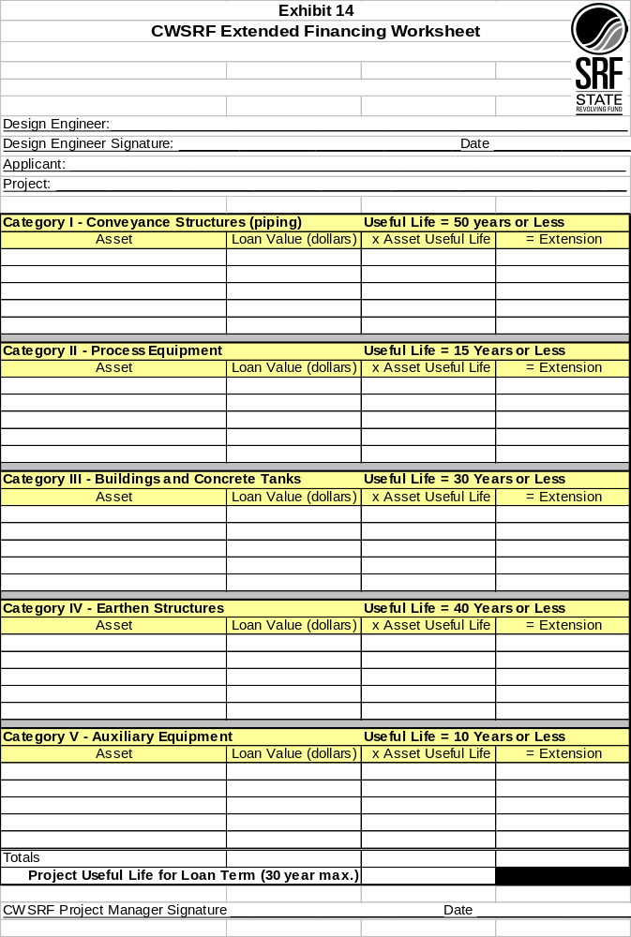
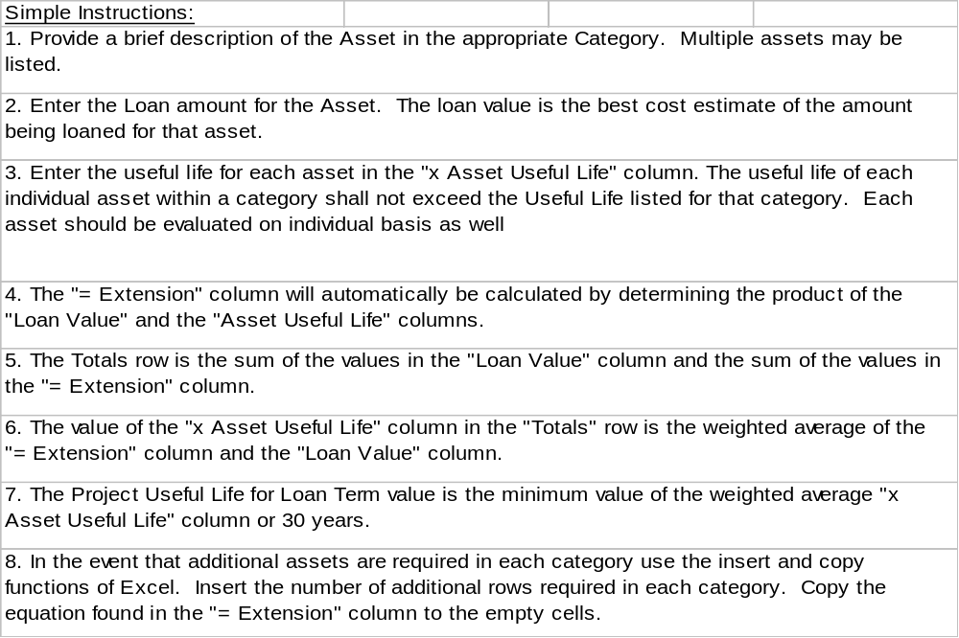

Exhibit 15
SRF Construction Loans
For Wastewater, Storm Water and Drinking Water Infrastructure

Any time after the facility plan or preliminary engineering report is approved, the
applicant may begin the process for an SRF construction loan. The process begins
with:
- SRF staff attending design conference and presenting information, or
- SRF staff contacting community and asking if they are interested in construction loan, or
- Community contacting SRF anytime after the facility plan is approved.

The borrower fills out a loan application. Loan applications are available on the internet at www.iowasrf.com or by calling Lori Beary or Tracy Scebold at 515-725-4900 or toll free at 800-432-7230. Information requested on the application includes user rates, outstanding debt and financial information regarding the system.

SRF reviews the financial information, including:
- 1.1 debt service coverage
- user rate charges as % of AMI
- other outstanding debt – parity issues

SRF either approves the application or contacts the community to work toward approval. When approved, SRF sends a loan commitment letter with the estimated loan amount.

During this time, DNR is approving the plans & specifications for the project. When the construction permit is issued, the applicant will go out for bids for the project.

SRF then sends information to the borrower about closing the loan.
- contact bond counsel -- a public hearing and resolution are required by the city or system to enter into a loan agreement, bond counsel has standard forms
- disbursement process (see below)
- a preliminary debt service schedule

After the city awards the bid for the project, copies of the bid documents must be sent to SRF. DNR engineers will determine eligible expenses from the documents. The bid information will also be used to determine total project costs and the construction schedule.

SRF will examine the bid documents to note subcontractors for Minority and/or Women Business information to report to EPA.

SRF sends award concurrence to city.

Applicant closes loan with its bond counsel and sends loan document to SRF.

Disbursements

Disbursements are made weekly.

The borrower will send the disbursement request to SRF. Disbursement requests can be completed online, faxed or mailed. Invoices will be faxed or mailed.

IFA reviews disbursement requests. Disbursements are checked against eligible expenses. If there is a discrepancy or questions arise, IFA will contact the DNR project engineer and the borrower.

Quarterly, the DNR SRF Coordinator will ask the borrower about MBE/WBE subcontractors.

Change orders -- DNR project engineer will verify acceptable expenses and notifies IFA of the change.

For final loan disbursement:
- borrower sends written notice of “works in operation” with date of initiation of operation
- IFA contacts DNR engineer for final inspection
- IFA sends final disbursement with final loan certificate and revised debt service schedule if necessary with final recap of project expenses and SRF disbursements.
- If total amount of original loan is not disbursed, city fills out request for loan adjustment.
- borrower fills out EPA Form 5700-52A to report utilization of MBE/WBE businesses for DNR SRF Coordinator

City signs final loan certificate and sends to IFA. IFA signs and sends to Trustee.

Loan Servicing

Notices are sent to borrowers semiannually – payments are due in December and June.

IFA sends notices annually to all borrowers requesting audit reports.

Application forms are available at www.iowasrf.com

For more information, contact:

Lori Beary Tracy Scebold
515-725-4965 515-725-4922
lori.beary@iowa.gov tracy.scebold@iowa.gov

