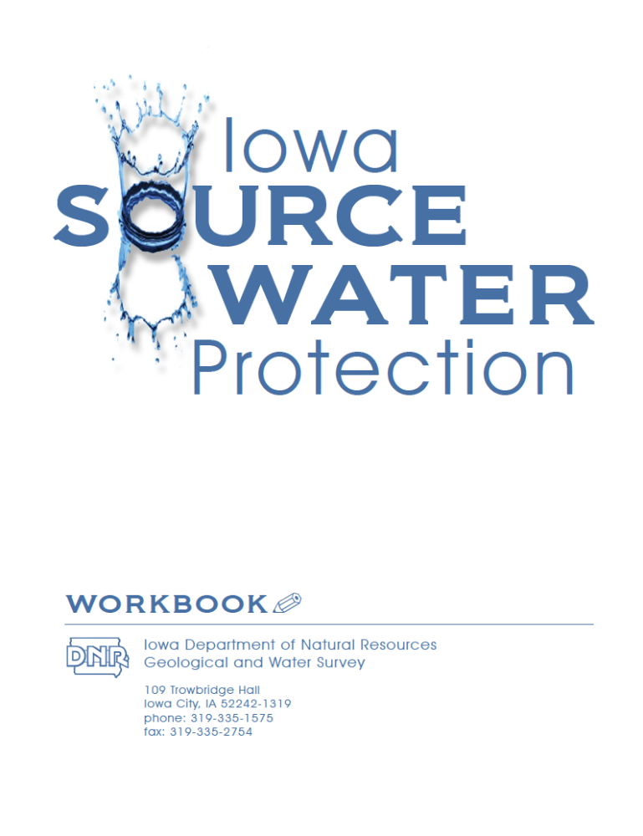
The Source Water Protection Workbook is meant to be used in conjunction with the Source Water Protection Guide to help your community protect its drinking water. The Source Water Protection Guide includes details on each of the steps, including contacts and funding sources, science behind your source water area, and checklist for your Source Water Plan approval. This workbook consists of form-fillable worksheets designed to help with meeting preparation, work assigned, schedules and deliverables. Of course there might be some sheets you wish to modify, leave out, or make up a new one. You are free to do so.
Worksheets
- Pre-Planning
  - Source Water Essentials Checklist
  - Source Water Optionals Checklist

- Step 1 (Organize a Team)
  - Potential SWP Team Member List
  - SWP Team Member & Organization Form
  - Timeline
  - Sample Agenda
  - Meeting Attendees
  - Source Water Issues and Concerns
- Step 2 (Identify Source Water Areas)
  - Checklist of protection areas (
  - Source Water Susceptibility
- Step 3 (Inventory of Contaminant sources)
  - Field Survey Form
  - List of Common Potential Contaminants
  - Local and online resources checklist
  - Potential Contaminant Source Stakeholders
- Step 4 (Assess and rank contaminants)
  - Contaminant Risk Guide
  - Contaminant Risk Form
  - Final Ranking Form
- Step 5 (Develop action plan)
  - Action Plan Template
- Step 6 (Emergency Response Plan)
  - Emergency Response Affidavit
- Step 7 (Submit SWP Plan)
  - Contact information

Source Water Essentials Checklist
There are a few basic fundamentals you need before starting a Source Water Protection project. These include information on your community’s wells (or intakes), aquifer, source water area, and potential contaminants. All of these essential items should be included on your community’s webpage on www.iowasourcewater.org. If you can’t find the information below, please contact the Iowa DNR-Geological and Water Survey at 319-335-1575 for assistance in retrieving the latest information.
- “Phase 1” Source Water Assessment. This editable MS Word© document should include a map of your Source Water Area, along with your aquifer’s susceptibility, with maps and tables of contaminants, wells, and a ranking system for potential contaminants. Fill out the fields below for your system.
Your Aquifer(s) ___________________________________
Aquifer Susceptibility_______________________________
Number of Active Wells_____________________________

- Most Recent Sanitary Survey. Reports are completed roughly every 2-3 years by a regional field office of the Iowa Department of Natural Resources. These reports list the active wells, system production, and also note any deficiencies the system may have.
Number of Active Wells____________________________
Noted Deficiencies________________________________

- Source Water Mapper. An interactive online mapping site that has links to information regarding your source water area, wells, contaminants, and both historical and current system documentation.
- Iowa’s Groundwater Basics. If your drinking water comes from a groundwater source, (like most in Iowa), Iowa’s Groundwater Basics provides an excellent overview of what is known about groundwater in Iowa. This easy to understand book details the sources, movements, and common issues with groundwater in Iowa. The book is available free of charge.
  - Source Water Optionals Checklist
Depending on your community, you might have the need or ability to use Geographic Information Systems (GIS) as a tool to help with contaminant and well inventories. Although not needed, we believe these resources are very helpful for community planning, including infrastructure areas, 100 and 500 year floodplain mapping, and determining resource potential in addition to Source Water Protection efforts.
- GIS Software. Either freeware or commercial software is needed to accurately interact with GIS ‘layers’ for correctly mapping source water, and other spatial information. There are many software options available online. Check which version your community has:
Freeware
  - ArcExplorer (www.esri.com/software/arcgis/explorer) This is a free program available to help explore, visualize and share GIS information. Although editing layers is not included, the program has a great user-interface.
  - Quantum GIS (www.qgis.org) A free, open source GIS software tool that works with many operating systems (Mac, Linux, Windows). Quantum GIS has the ability to convert all AutoCAD files to GIS layers, display a wide variety of data types, and has an easy to use, helpful interface.
  - MapWindow (www.mapwindow.org) Another open source GIS desktop application that is free and has the ability to view and edit many types of GIS data.

Commercial Software
- ArcView and ArcMap (www.esri.com) These are commercial (paid-for) products available from ESRI. These programs can display, manipulate and edit almost all types of GIS information.

- GIS Layers. Many GIS layers available to help you in Source Water Protection. All of the layers below can be downloaded though Iowa’s NRGIS library at www.igsb.uiowa.edu/nrgislibx. The major layers used for Source Water Protection are listed below:
  - Source Water Wells. A spatial coverage of public wells in Iowa, including depth, geology, and hydrology.
  - Source Water Areas. A statewide two-dimensional coverage of areas contributing water to a public water supply.
  - All Contaminants. A spatial coverage of all federal and state monitored potential contaminants as “point” coverages.
  - All Wells. Statewide coverage of all known wells in Iowa, including links to information when available.

Potential SWP Team Member List
A strong SWP Plan relies almost exclusively on a strong SWP Team. Every community’s team will be different, depending on the local politics, infrastructure, and source water area. Depending on these circumstances you may wish to contact one or more of the below agencies to be included in your local SWP Team.
Iowa Rural Water Association (www.iowaruralwater.org)
Iowa Rural Water Association (IRWA) provides training, education, and technical assistance to a wide variety of water and wastewater utilities, including small communities and rural water systems. IRWA has had a long relationship with the Iowa Source Water Program and continues to provide SWP assistance to numerous communities every year.

Iowa Association of Municipal Utilities (www.iamu.org)
The Iowa Association of Municipal Utilities (IAMU) provides members a wide range of educational services and programs. Drinking water concerns such as SWP is one of the cornerstones of IAMUs focus.

Iowa Department of Natural Resources – Field Office (www.iowadnr.gov/fo/fomap.html)
The Iowa DNR Field Office staff are a vital resource in knowing the water quality, infrastructure, and production history of your system. Many have records going back over 40 years.

U.S. Department of Agriculture - Natural Resource Conservation Service (http://offices.sc.egov.usda.gov/locator/)
The NRCS works with landowners to conserve the soil, water, air, plant and animals for productive lands and healthy ecosystems, If your community’s source water area is mostly outside of the city boundary, your local NRCS office is a valuable resource.

NRCS - Resource Conservation and Development Areas (www.ia.nrcs.usda.gov/partnerships/rcanddlist.html)
The Resource Conservation and Development Areas are a subset of the NRCS offices, grouped by counties. They promote the conservation and improvement of land within their region.

Iowa Pheasants Forever Chapter Locator (www.pheasantsforever.org/page/1/FindaChapter.jsp?state=IA)
Pheasants Forever (PF) is a nonprofit organization with the objective to increase bird and wildlife habitat.

Ducks Unlimited – State Contacts (www.ducks.org/iowa/iowa-du/iowa-state-contacts)
Ducks Unlimited is a world leader in wetland and waterfowl conservation, with a simple mission of habitat conservation.
  - Source Water Team Member & Organization list
Source Water Lead Worker
Name: _____________________________________ Phone: ________________________________
Interest/Affiliation: ___________________________ E-mail: ________________________________
Mailing Address: ____________________________________________________________________

Source Water Team
Name: _____________________________________ Phone: ________________________________
Interest/Affiliation/Role: ________________________ E-mail: ________________________________
Mailing Address: ____________________________________________________________________

Name: _____________________________________ Phone: ________________________________
Interest/Affiliation/Role: ________________________ E-mail: _______________________________
Mailing Address: ____________________________________________________________________

Name: _____________________________________ Phone: ________________________________
Interest/Affiliation/Role: ________________________ E-mail: _______________________________
Mailing Address: ____________________________________________________________________

Name: _____________________________________ Phone: ________________________________
Interest/Affiliation/Role: ________________________ E-mail: _______________________________
Mailing Address: ____________________________________________________________________

Name: _____________________________________ Phone: ________________________________
Interest/Affiliation/Role: ________________________ E-mail: _______________________________
Mailing Address: ____________________________________________________________________

Name: _____________________________________ Phone: ________________________________
Interest/Affiliation/Role: ________________________E-mail: _______________________________
Mailing Address: ____________________________________________________________________

Name: _____________________________________ Phone: ________________________________
Interest/Affiliation/Role: ________________________ E-mail: _______________________________
Mailing Address: ____________________________________________________________________
  - Source Water Sample Agenda

City of Cleanwater Source Water Protection Team
Initiation Meeting
9:00 am - 1:00 pm, Tuesday, October 26th, 2015

5:00-5:30 pm - Team Member Introductions
5:30-6:00 pm - Purpose and Goals of Source Water Protection

Source Water Presentations
6:00-6:15 pm - Overview of Your Assessment and SWP – IGWS-DNR rep.
6:15-6:30 pm - History of Cleanwater’s Water
6:30-7:00 pm - Source Water Opportunities

SWP Team
7:00-7:30 pm - SWP Team Role and Vision Discussion
7:30-8:00 pm - SWP Timeline
8:00 pm - Meeting Wrap-up, Next Meeting Date

  - Sample Timeline

Start Date (First Meeting)_______________ Anticipated Plan Submittal Date_______________

Task Date
Form a Source Water Team
Hold Initial Source Water Meeting
Submit Final Source Water Plan to SWAG*
Implement Source Water Plan

*The Source Water Advisory Group (SWAG) is charged with approving SWP Plans in Iowa

  - Source Water Meeting Attendees
Name Agency, email
1.
2.
3.
4.
5.
6.
7.
8.
9.
10.
11.

  - Source Water Issues and Concerns
Issue or Concern | Category
Issue or Concern | Quality | Quantity | Security | Education
High Nitrates | X |  |  | X
Increased Pumping |  | X

Checklist for Protection Areas
Having accurate maps of all of your protection areas is crucial to knowing where your community should focus its source water protection efforts. Please check over your Phase 1 Source Water Assessment to make sure that a) all of your active wells are in the correct location, b) the wells are the right depth, and c) your community’s water pumping rates are accurately represented. Below is a checklist of commonly used protection areas dependant on the information above.
- Source Water Area. Is your delineation a model, or a radial setback distance? If a setback distance, is there any more information that could be used to further refine your source water area? Information in driller’s logs, geology, and pumping rates are generally needed to complete an accurate source water area.
- 200-ft. Zone of Control. The 200-ft. zone of control is required for all public wells constructed after 1979, and is a requirement for wells constructed after 1979. The 200-ft. zone of control is an area that the community is to have absolute control over, and use for the best interest for water quality.
- Public Well Setback Distances.
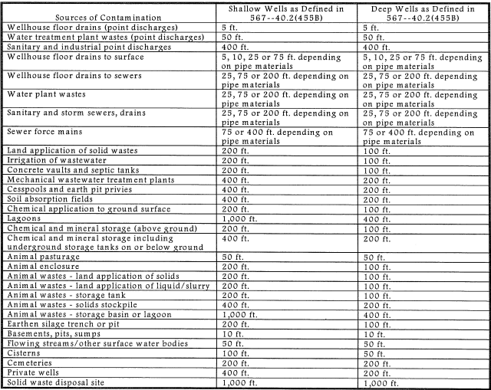

  - Source Water Susceptibility
Your source water has the ability to be naturally protected through confining units. If your community uses more than one source, it is often best to focus on the one with the least amount of confining units. Confining units are often till, shale, or clay. Check below which source water susceptibility applies to your community’s water supply.

Aquifer #1:_____________________________________________
Confining layer thickness |  | Susceptibility designation
- <25 feet |  | Highly susceptible
- 25 to 50 feet | Susceptible
- 50 to 100 feet |  | Slightly susceptible
- >100 feet |  | Low susceptibility

Aquifer #2: (if needed)_____________________________________________
Confining layer thickness |  | Susceptibility designation
- <25 feet |  | Highly susceptible
- 25 to 50 feet | Susceptible
- 50 to 100 feet |  | Slightly susceptible
- >100 feet |  | Low susceptibility

3.1. List of Common Potential Contaminants
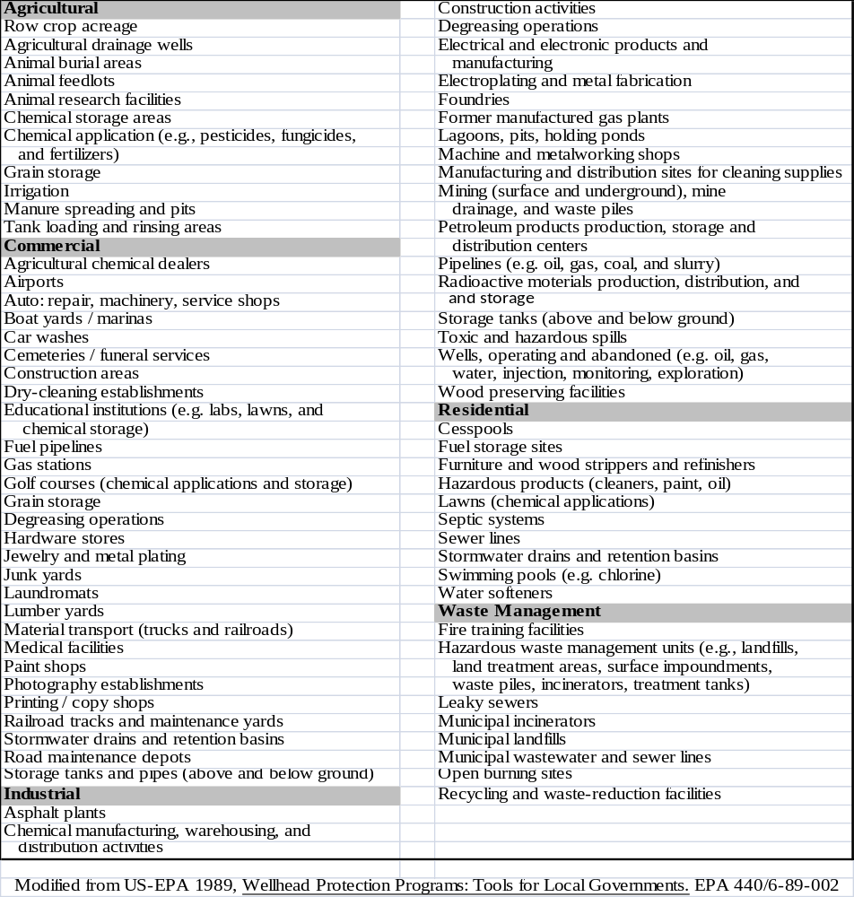
3.2. Local and Online Resources Checklist
The resources below represent some of the databases you can use to help inventory your potential contaminants and pathways. Be sure to check each of them for a full inventory.
- Iowa Source Water Mapper www.iowasourcewater.org An online mapping application is designed to show an online version of your community’s phase 1 report, including the inventory of wells and contaminants listed in the tables. The application also has direct links to many of the online databases listed below.
- Facility Explorer https://facilityexplorer.iowadnr.gov/ An online, spatial data warehouse that collects information in one place for easy access by the public. Information in Facility Explorer ranges from contaminant sources, wells, Field Offices, to parks and recreation areas.
Other online databases for specific potential contaminant sources in your source water area:
- Iowa DNR Contaminated Sites http://programs.iowadnr.gov/contaminatedsites/pages/search.aspx. The contaminated sites online database connects to online documents and historical information for many of Iowa’s point sources of contamination. You can search by city, program, and county to find specific sources in your area.
- Iowa DNR Underground Storage Tanks http://programs.iowadnr.gov/ustlust/ Leaking underground storage tanks for gas and diesel fuels have been a major concern for contamination of drinking water supplies. Many of these sites can be found on the DNR’s link.
Links for potential wells and pathways:
- Geosam www.igsb.uiowa.edu/webapps/geosam/ GeoSam houses well construction, geologic and hydrogeologic information of wells drilled in Iowa that were submitted to the Iowa DNR – Geologic and Water Survey.
- Private Well Tracking System http://programs.iowadnr.gov/pwts/ County Sanitarians enter private well construction, pump test, and geologic data into this database.

3.3. Field Survey Form
Field Survey Form for ________________________________________

Date:__________ Time:___________ Name of person conducting survey:_________________

Map Identification Number:____________ Program Identification Number:___________________

Business Name:__________________________________________ Ph.:__________________________

Owners Name:___________________________________________ Ph.:__________________________

Site Address:__________________________________________________________________________

City:_____________________________________ State:___________ Zipcode:____________________

Location Description:___________________________________________________________________

GPS Coordinates: _______________ºLat. ___________________ºLong.

Legal Description
______1/4, of the ______1/4, of the ______1/4, of the ______1/4, of Section ______,
Township_______N, Range_________ W or E

Description of Site:

3.4. Potential Contaminant Source Stakeholders

Name: _____________________________________ Phone: ________________________________
Interest/Affiliation: ___________________________ E-mail: ________________________________
Mailing Address: ____________________________________________________________________

Name: _____________________________________ Phone: ________________________________
Interest/Affiliation: ___________________________ E-mail: ________________________________
Mailing Address: ____________________________________________________________________

Name: _____________________________________ Phone: ________________________________
Interest/Affiliation: ___________________________ E-mail: ________________________________
Mailing Address: ____________________________________________________________________

Name: _____________________________________ Phone: ________________________________
Interest/Affiliation: ___________________________ E-mail: ________________________________
Mailing Address: ____________________________________________________________________

Name: _____________________________________ Phone: ________________________________
Interest/Affiliation: ___________________________ E-mail: ________________________________
Mailing Address: ____________________________________________________________________

Name: _____________________________________ Phone: ________________________________
Interest/Affiliation: ___________________________ E-mail: ________________________________
Mailing Address: ____________________________________________________________________

Name: _____________________________________ Phone: ________________________________
Interest/Affiliation: ___________________________ E-mail: ________________________________
Mailing Address: ____________________________________________________________________

Name: _____________________________________ Phone: ________________________________
Interest/Affiliation: ___________________________ E-mail: ________________________________
Mailing Address: ____________________________________________________________________

4.1. Iowa Contaminant Risk Guide
Least | Risk Score | Land Use Type
Risk | 1 | Land surrounding a well or reservoir owned by a water company
 | 1 | Permanent open space dedicated to recreation
| | 1 | Federal, state, municipal, or private parks
| | 1 | Woodlands managed for forest products
| | 2 | Field crops: pasture, hay, grains, vegetables
| | 2 | Low-density residential: lots larger than 2 acres
| | 2 | Churches, municipal offices
|  | | 3 | Agricultural production: dairy, livestock, poultry, nurseries, orchards, berries
| | 3 | Golf courses, quarries
| | 3 | Medium-density residential: lots from 1/2 - 1 acre
|  | | 4 | Institutional uses: schools, hospitals, nursing homes, prisons, garages, salt storage, sewage treatment facilities
| | 4 | High-density housing: lots smaller than 1/2 acre
|  | | 4 | Commercial uses: limited hazardous material storage, only sewage disposal, confined animal feeding operations
| | 5 | Improperly abandoned wells in the same aquifer as the supply well
|  |  | | 5 | Retail commercial: gasoline, farm equipment, automotive, sales and services, dry cleaners, photo processor, medical arts, furniture strippers, machine shops, radiator repair, printers, fuel oil distributors
| | 5 | Industrial: all forms of manufacturing and processing, research facilities
 | 5 | Underground storage of chemicals, petroleum
Greatest  Risk | 5 | Waste disposal: pits, ponds, lagoons; injection wells used for waste disposal; landfills; hazardous waste treatment, storage, and disposal sites; agricultural drainage wells

4.2. Contaminant Risk Form
Issue Priority Plan
4.3. Final Ranking Form
Priority Contaminant/Issue Comment

5.1. Action Plan Template
Issue Strategy Target Completion

6.1. Emergency Response Plan Affidavit
The Safe Drinking Water Act amendments of 1986 and 1996 established the concept of wellhead protection, and subsequently the Source Water Protection program. The program is currently overseen by the Iowa Department of Natural Resources (IDNR) and attempts to prevent potential contaminants from entering source waters and prepare for situations in which drinking water may be impaired through contamination, power outage and treatment or distribution system interruptions. In order to ensure a public water supply’s preparedness in such events, a Contingency/Emergency Plan has been required in every approved Source Water Protection Plan (SWPP) or Wellhead Protection Plan (WHPP).
Due to recent and growing concerns over water system security and due to many systems having previously prepared such a plan under the provisions of the 2002 Bioterrorism Act, the IDNR is now allowing an affidavit in lieu of including a completed Contingency/Emergency Plan within the submitted SWPP/WHPP. Although public water supplies do not need to send IDNR completed plans, each must have an accessible and up-to-date plan in case a catastrophic event occurs within their system. It is necessary for the completed water supply Contingency/Emergency Plan to contain the following information, at a minimum:

- Contact information for the city’s mayor, city clerk, water/wastewater operator.
- Contact information for the city’s power company, a professional electrician, a professional plumber and an equipment repair company.
- System’s critical users must be identified and a plan for immediate notification must be created. (i.e. hospitals, nursing homes, schools, etc.)
- Contact information for local media, including newspaper, radio and television.
- Contact information for a certified laboratory, local emergency contacts, state and local public health departments and the National Guard.
- Contact information for the IDNR’s 24 hour emergency contact and the local IDNR field office.

I, ___________________________, representing ____________________________ certify that a Contingency / Emergency Plan has been created for our public water supply system and that this information can be presented to the IDNR upon request.

___________________________________ ________________________
Signature Date

7.1. Source Water Advisory Group Contact Information

Iowa Source Water Advisory Group – 2010-2011

- Mike Anderson – Water Supply Engineering Section, IDNR
Ph: (515-725-0336) Email: (Michael.Anderson@dnr.iowa.gov)
- Chad Fields – Iowa Geological and Water Survey, IDNR
Ph: (319-335-2083) Email: (Chad.Fields@dnr.iowa.gov)
- Mary Howes - Iowa Geological and Water Survey, IDNR
Ph: (319-335-1448) Email: (Mary.Howes@dnr.iowa.gov)
- Rebecca Ohrtman – Contaminated Sites Section, IDNR
Ph: (515-281-0932) Email: (Rebecca.Ohrtman@dnr.iowa.gov)
- Cal Lundberg – Contaminated Sites Section, IDNR
Ph: (515-281-7040) Email: (Cal.Lundberg@dnr.iowa.gov)
- Jeff Vansteenburg - Field Services Bureau, IDNR
Ph: (641-424-4073) Email: (Jeff.Vansteenburg@dnr.iowa.gov)
- Ruth Hummel – LUST /UST Section, IDNR
Ph: (515-281-8997) Email: (Ruth.Hummel@dnr.iowa.gov)
- Jessica Lillie – Iowa Association of Municipal Utilities
Ph: (800-810-4268) Email: (JLillie@iamu.org)
- Jill Soenen – Iowa Groundwater Association
Ph: (800-810-4268) Email: (JSoenen@iamu.org)
- Lisa Walters – Iowa Rural Water Association
Ph: (800-747-7782) Email: (LWalters@iowaruralwater.org)
- Jared Wiklund – Pheasants Forever
Ph: (515-423-4747) Email: (JWiklund@pheasantsforever.org)
- John Whitaker – Farm Service Agency
Ph: (515-254-1540) Email: (John.Whitaker@ia.usda.gov)
- Greg Brennan – H.R. Green Consulting
Ph: (319-841-4000) Email: (GBrennan@hrgreen.com)
- Steve Hopkins – Iowa 319 Program Coordinator
Ph: (515-281-6402) Email: (Stephen.Hopkins@dnr.iowa.gov)
- Martin Adkins – Natural Resource Conservation Service
Ph: (515-284-4135) Email: (Martin.Adkins@ia.usda.gov)

