
General Permit 6 Field Office Notification Form

Wastewater Discharge from Well Construction and Services

Attention DNR Regional Field Office No. |  | See end of form to view a Field Office Map

Date Faxed:
Purpose of well construction/services:
Proposed construction/services start date:
Anticipated date when discharge will begin:
Estimate of length of discharge: |  |  |  |  |  |  |  |  |  |  |  | Hours |  |  |  |  | Days
List streams or waterways that may be affected by discharge:
Distance to nearest waterway or conveyance: |  |  |  |  |  |  |  |  |  |  |  |  |  |  |  |  |  |  | Feet
Amount of discharge anticipated: |  |  |  |  |  |  |  |  |  |  |  |  | GPM |  |  |  |  | GPD
 | OR
Total Volume of |  |  |  |  |  |  | gallons for project

Well Location Information |  |  |  |  |  |  |  |  |  |  | County:
GP S Location: |  |  | Latitude |  |  |  |  |  |  |  | Longitude |  |  |  |  |  |  |  |  | In UTM coordinates
PLS: |  | ¼ Section |  |  |  |  | Section |  |  |  |  | Township |  |  |  | Range |  |  |  |  | E |  | W
Address of well site:
 | OR, if address is not known
Closest intersection to well site: |  |  |  |  |  |  |  |  |  |  |  |  |  |  |  |  | and
Closest city, town or community:

Well Owner (Permittee) Information |  |  |  |  |  |  |  | If PWS, PWS Name:
PWSID#: |  |  |  |  |  | DNR Water Use Permit No.: |  |  |  |  |  | Well ID No.:
Name:
Address:
City: |  |  |  |  |  |  |  |  | State: |  |  |  | Zip:
Telephone Numbers: |  |  |  |  | Daytime: |  |  |  |  | Cell:
Email:

Well Contractor Information |  |  |  |  |  |  |  |  |  | Certification Number:
Company Name:
Certified Contractor Name:
Address:
City: |  |  |  |  |  |  |  | State: |  |  |  | Zip:
Telephone Numbers: |  |  |  |  | Daytime: |  |  |  | Cell:
Email:

Form completed by: |  | Phone Number:
Where will the Well Water Pollution Prevention Plan (WWPPP) be located?
Please fax the completed form to the appropriate Field Services office within 5 days before well services are started or within 24 hours of start. The fax numbers can be found at the end of this form.
Regional Iowa DNR Field Services Offices
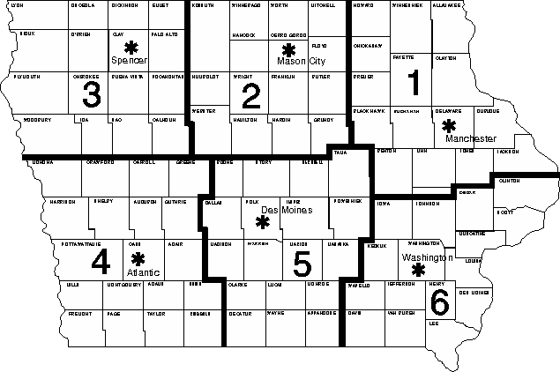
Field Office #1  1101 Commercial St Ste 10  Manchester, IA 52057  Phone: (563) 927-2640  Fax: (563) 927-2075 | http://www.iowadnr.gov/fieldoffice/fo1.html
Field Office #2  2300 15th St SW  Mason City, IA 50401  Phone: (641) 424-4073  Fax: (641) 424-9342 | http://www.iowadnr.gov/fieldoffice/fo2.html
Field Office #3  1900 N Grand Ave  Spencer, IA 51301  Phone: (712) 262-4177  Fax: (712) 262-2901 | http://www.iowadnr.gov/fieldoffice/fo3.html
Field Office #4  1401 Sunnyside Ln  Atlantic, IA 50022  Phone: (712) 243-1934  Fax: (712) 243-6251 | http://www.iowadnr.gov/fieldoffice/fo4.html
Field Office #5  502 E 9th St  Des Moines IA 50319  Phone: (515) 725-0268  Fax: (515) 725-0218 | http://www.iowadnr.gov/fieldoffice/fo5.html
Field Office #6  1023 W Madison St  Washington, Iowa 52353-1623  Phone: (319) 653-2135  Fax: (319) 653-2856 | http://www.iowadnr.gov/fieldoffice/fo6.html

