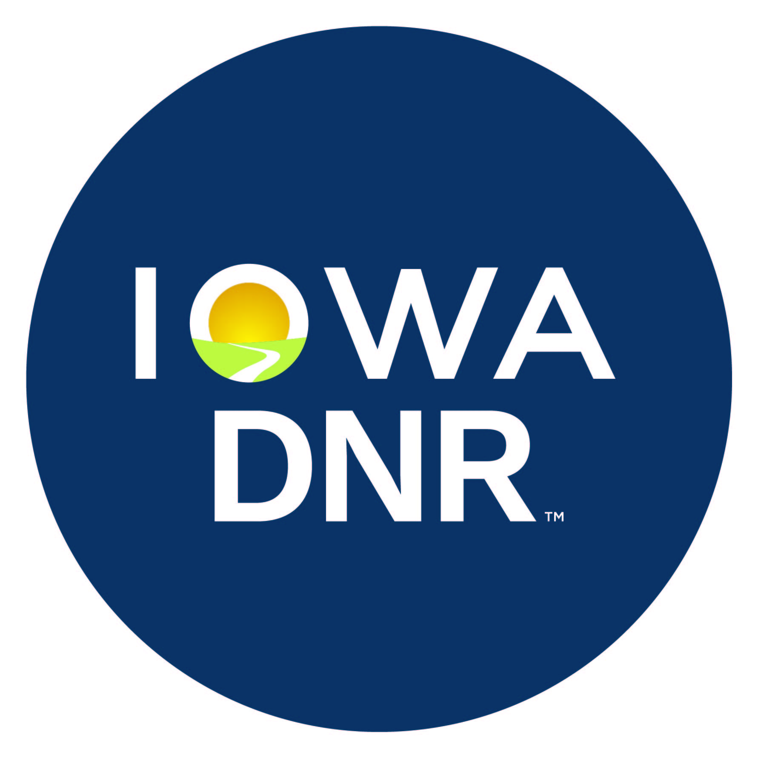 | IOWA DEPARTMENT OF NATURAL RESOURCES  Licensing Section  6200 Park Ave Ste 200, Des Moines IA 50321  (515) 725-8200 | www.iowadnr.gov | CASHIER’S USE ONLY  0233-542-0092-LF-0570  Name
APPLICATION FOR COMMERCIAL TURTLE OR FISHER HELPER
Resident or Non-Resident

Please submit fees with application

If completing online, please use the “TAB” key to navigate your way through this form. Do not press Enter.
APPLICANT INFORMATION:
Full Name: |  |  |  |  |  |  |  |  |  |  |  |  |  |  |  |  | Phone #:
Address:
City/State/Zip: |  |  |  |  |  |  |  |  |  |  |  |  |  |  |  |  | County:
*Social Security #: |  |  |  |  |  |  |  |  |  | Iowa DL/ID #: |  |  |  |  |  |  | Birth Date:
DNR Customer # (If known): |  |  |  |  |  |  |  |  |  |  |  |  |  | Email:
Eye Color: |  |  |  |  |  | Height: |  |  | ft. |  |  | in. | Weight: |  |  | lbs. |  | Gender: |  |  | Male |  | Female
*The Iowa Department of Natural Resources is required to collect social security numbers from all persons obtaining a hunting, fishing or other recreational license under section 252J.8 of the Code of Iowa and 42 US Code 666(a)(13). Your social security number will serve as your principal identification number to determine your eligibility for licenses. It will be provided to law enforcement agencies and the Iowa Child Support Collection Unity to establish, modify, and enforce child support obligations and to collect liabilities owed to the state or a state agency. It WILL NOT appear on your license.

TYPE OF LICENSE | FEE | AMOUNT PAID
Resident Commercial Fisher Helper** | $52.00
Non-Resident Commercial Fisher Helper | $102.00 |  |  |  | OR the amount for the same type of license in the non-resident’s state, whichever is greater. Your state MUST have reciprocity with Iowa.
Resident Commercial Turtle Helper** | $52.00
Non-Resident Commercial Turtle Helper | $102.00 |  |  |  | OR the amount for the same type of license in the non-resident’s state, whichever is greater. Your state MUST have reciprocity with Iowa.
A $2.00 processing fee has been added to all license costs.
** I understand that providing false information on this application will render my application and therefore license invalid and that I may be subject to fines and imprisonment for making a false entry in a public record in violation of Iowa Code 714.8(4), and for hunting, fishing, or trapping without a valid license in violation of Iowa Code 483A.

By signing below, I acknowledge and understand the rules and regulations regarding having this permit and realize that a State Conservation Officer may inspect me at any reasonable time. The Iowa commercial fishing laws can be found in Iowa Code Chapter 482 and the residency laws in Iowa Code Chapter 483A and Iowa Administrative Code Chapter 15.
Signature of Applicant |  |  |  | Date

Please remit application and payment to the address at the top of this page or Email a copy of the form to webmaster@dnr.iowa.gov with the subject line: Credit Card Payment for (Company Name), wait a minimum of 20 minutes after sending, then call 515-725-8200 to make the payment.

